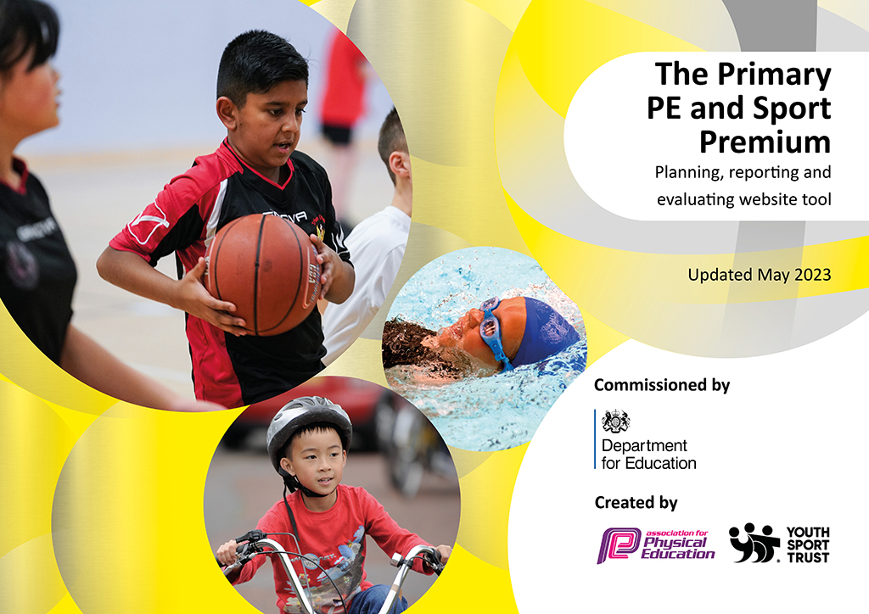
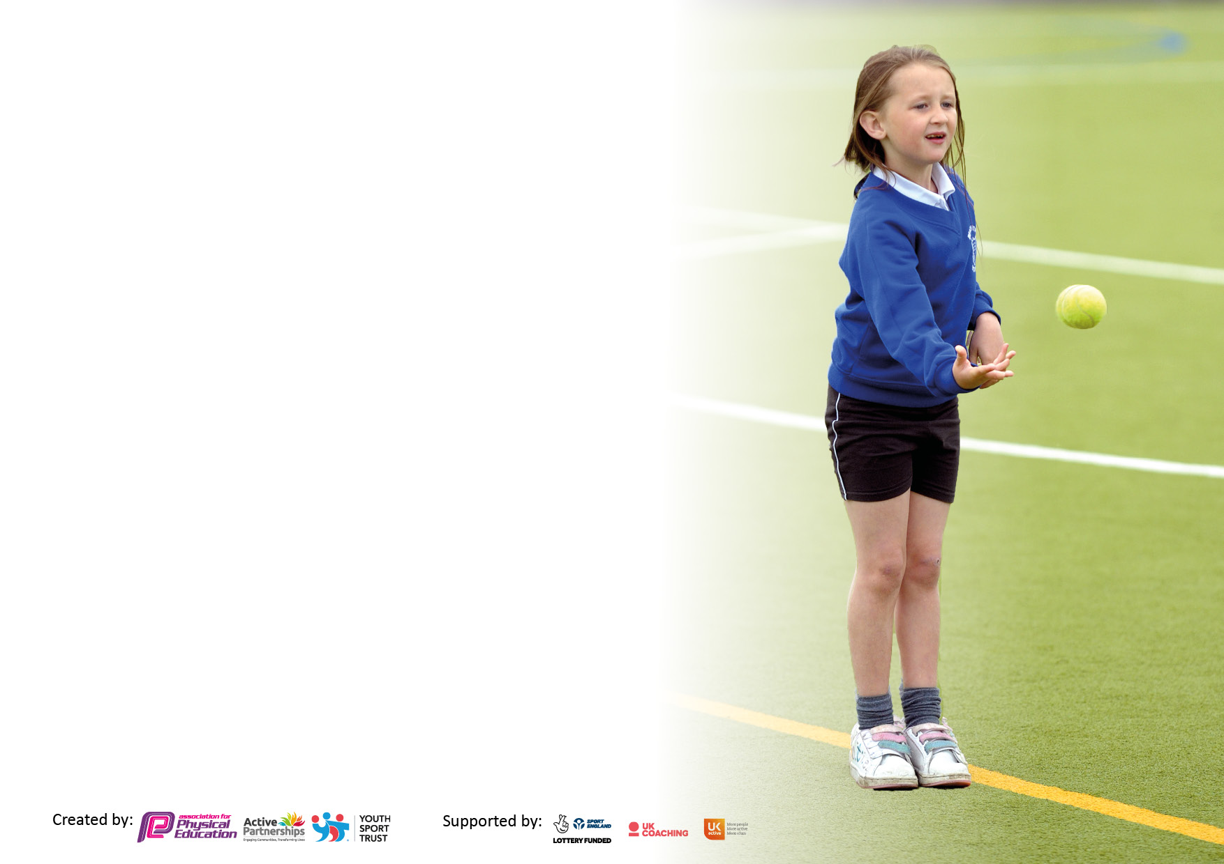

It is important that your grant is used effectively and based on school need. The Education Inspection Framework makes clear there will be a focus on ‘whether leaders and those responsible for governors all understand their respective roles and perform these in a way that enhances the effectiveness of the school’.

Under the Quality of Education Ofsted inspectors consider:
Intent - Curriculum design, coverage and appropriateness
Implementation - Curriculum delivery, Teaching (pedagogy) and Assessment
Impact - Attainment and progress

To assist schools with common transferable language this template has been developed to utilise the same three headings which should make your plans easily transferable between working documents.

Schools must use the funding to make additional and sustainable improvements to the quality of Physical Education, School Sport and Physical Activity (PESSPA) they offer. This means that you should use the Primary PE and sport premium to:

- Develop or add to the PESSPA activities that your school already offer
- Build capacity and capability within the school to ensure that improvements made now will benefit pupils joining the school in future years
- The Primary PE and sport premium should not be used to fund capital spend projects; the school’s budget should fund these.

Pleasevisitgov.ukfortherevisedDfEguidanceincludingthe5keyindicatorsacrosswhichschoolsshoulddemonstrate animprovement.Thisdocumentwillhelpyoutoreviewyourprovisionandtoreportyourspend.DfEencouragesschools to use this template as an effective way of meeting the reporting requirements of the Primary PE and Sport Premium.

We recommend you start by reflecting on the impact of current provision and reviewing the previous spend.

Schools are required to publish details of how they spend this funding, including any under-spend from 2021/2022, as well as on the impact it has on pupils’ PE and sport participation and attainment. All funding must be spent by 31st July 2023.

We recommend regularly updating the table and publishing it on your website throughout the year. This evidences your ongoing self-evaluation of how you are using the funding to secure maximum, sustainable impact. Final copy must be posted on your website by the end of the academic year and no later than the 31st July 2023. To see an example of how to complete the table please click HERE.

Details with regard to funding
Please complete the table below.

Total amount allocated for 2021/22 | £35,651
How much (if any) do you intend to carry over from this total fund into 2022/23? | £0
Total amount allocated for 2022/23 | £21,320
Total amount of funding for 2023/23. To be spent and reported on by 31st July 2023. | £21,320  £1,528.27 carry forward
Swimming Data
Please report on your Swimming Data below.

Meeting national curriculum requirements for swimming and water safety.
N.B. Complete this section to your best ability. For example you might have practised safe self-rescue techniques on dry land which you can then transfer to the pool when school swimming restarts.
Due to exceptional circumstances priority should be given to ensuring that pupils can perform safe self rescue even if they do not fully meet the first two requirements of the NC programme of study
What percentage of your current Year 6 cohort swim competently, confidently and proficiently over a distance of at least 25 metres?  N.B. Even though your pupils may swim in another year please report on their attainment on leaving primary school at the end of the summer term 2022.  Please see note above | 81%
What percentage of your current Year 6 cohort use a range of strokes effectively [for example, front crawl, backstroke and breaststroke]?  Please see note above | 81%
What percentage of your current Year 6 cohort perform safe self-rescue in different water-based situations? | 99%
Schools can choose to use the Primary PE and sport premium to provide additional provision for swimming but this must be for activity over and above the national curriculum requirements. Have you used it in this way? | No

Action Plan and Budget Tracking
Capture your intended annual spend against the 5 key indicators. Clarify the success criteria and evidence of impact that you intend to measure to evaluate for pupils today and for the future.

Academic Year: 2022/23 | Total fund allocated: £21,320 | Date Updated: July 2023
Key indicator 1: The engagement of all pupils in regular physical activity – Chief Medical Officers guidelines recommend that primary school pupils undertake at least 30 minutes of physical activity a day in school |  |  |  | Percentage of total allocation:
 |  |  |  | 68.1%
Intent | Implementation |  | Impact
Your school focus should be clear what you want the pupils to know and be able to do and about  what they need to learn and to  consolidate through practice: | Make sure your actions to achieve are linked to your intentions: | Funding allocated: | Evidence of impact: what do pupils now know and what can they now do? What has changed?: | Sustainability and suggested next steps:
Employing qualified sports coach to work alongside teachers and enhance opportunities to pupils for 50% of the school week.  Sports coach employed to deliver intervention groups across Key Stage 1 and 2.  Establish Sports Holiday Camp during half term breaks. Building on relationships with children throughout school. | CN employed to work alongside staff.  CN employed to deliver extra-curricular clubs to provide opportunity for all children to attend.  Linking team training to competitions, developing skills required for healthy competition to flourish.  CN Active. | £14,540  Pay to attend. | Teachers to apply skills taught to lessons and share good practice with rest of staff.  Teachers to be confident in the delivery of PE lessons - lesson observations and staff audit.  Children will receive high quality PE lessons – Pupil interviews and lesson observations.  Targeted groups of children will engage in regular physical exercise – observations.  Inclusive and working with school to identify need and offer support for PP children. | Teachers to have skills and knowledge that can be applied to lessons in future years.  Teachers have the skills to deliver lessons independently.  CN has developed healthy relationships with all children. He knows their ability and can plan sessions which target specific needs.  Ongoing use of Sports Holiday Camp provides for the school and wider community.
Key indicator 2: The profile of PESSPA being raised across the school as a tool for whole school improvement |  |  |  | Percentage of total allocation:
 |  |  |  | 2.7%
Intent | Implementation |  | Impact
Your school focus should be clear what you want the pupils to know and be able to do and about  what they need to learn and to  consolidate through practice: | Make sure your actions to achieve are linked to your intentions: | Funding allocated: | Evidence of impact: what do pupils now know and what can they now do? What has changed?: | Sustainability and suggested next steps:
Embedding physical activity into the school day with active break and lunchtimes.  PE equipment. | Sports Captains to deliver a lunch time club for KS1 children.  Welfare trained to provide engaging activities.  A range of equipment identified and purchased- School Council to raise the profile and discuss needs and wants to increase activity at lunch time.  Audit provision/stock. | N/A  £594.73 | Sports Captains and staff are trained in delivering lunch time clubs.  Spacesaver Bag  Rugby Balls  PE equipment provided as necessary to meet the need of fulfilling an effective PE curriculum. | Staff and children could lead this training for other year groups eg. Year 5 in preparation for tasking on the role of Sports Captain.  Continue to audit provision and reflect on best practice and further training as suggestions are made for equipment that may move PE delivery forward.

Key indicator 3: Increased confidence, knowledge and skills of all staff in teaching PE and sport |  |  |  | Percentage of total allocation:
 |  |  |  | 4.3%
Intent | Implementation |  | Impact
Your school focus should be clear | Make sure your actions to | Funding | Evidence of impact: what do | Sustainability and suggested
what you want the pupils to know | achieve are linked to your | allocated: | pupils now know and what | next steps:
and be able to do and about | intentions: |  | can they now do? What has
what they need to learn and to |  |  | changed?:
consolidate through practice:
CPD to develop knowledge of new PE lead in best practice to drive school improvement.  PE uniform. | Lancashire PE conference provided training for best practice in:  Lancashire PE Passport for curriculum and assessment  Swimming  Gymnastics  Dance  Safe Practice  Purchased from school shop | £408  £500 | Allows PE leader to be upskilled and provide feedback to staff.  Staff clarity in PE passport use for assessment and in the structure of the curriculum.  Reinforcing the importance of correct PE uniform and routines for good practice.  Support for identified children to continue. | Continue to invest in CPD for subject lead and wider staff to develop good practice.  Support for identified PP children to continue. Review yearly as to replacement uniform.
Key indicator 4: Broader experience of a range of sports and activities offered to all pupils |  |  |  | Percentage of total allocation:
 |  |  |  | 9%
Intent | Implementation |  | Impact
Your school focus should be clear | Make sure your actions to | Funding | Evidence of impact: what do | Sustainability and suggested
what you want the pupils to know | achieve are linked to your | allocated: | pupils now know and what | next steps:
and be able to do and about | intentions: |  | can they now do? What has
what they need to learn and to |  |  | changed?:
consolidate through practice:
Tag Rugby with Fylde Rugby Club  Fylde Coast Cricket Coaching  Hot Foot Dance  After School Tag Rugby Club for Years 5 and 6  Before School Football Training  Before School Netball Training | Fylde Rugby Club  Lancashire Cricket Foundation  Hot Foot Dance  Mr Nay to deliver  Mr Fish to deliver  Mrs Tate to deliver | £910  £899  £100  N/A  N/A  N/A | Children have the opportunity to explore different sports and engage in regular physical exercise.  Children were part of a whole school performance to commemorate the Kings Coronation.  All sessions are popular with boys and girls- fully subscribed. This leads to a wide range of opportunities to represent the school in inter-school matches and tournaments. | These clubs have been a success and will continue.  Option to charge for attendance where outside providers involved.  Continue provision, looking for further ways to represent school, eg mixed boys’ and girls’ netball. B and C team involvement in competitions for football due to the popularity of the clubs.

Key indicator 5: Increased participation in competitive sport |  |  |  | Percentage of total allocation:
 |  |  |  | 8.7%
Intent | Implementation |  | Impact
Your school focus should be clear | Make sure your actions to | Funding | Evidence of impact: what do | Sustainability and suggested
what you want the pupils to know | achieve are linked to your | allocated: | pupils now know and what | next steps:
and be able to do and about | intentions: |  | can they now do? What has
what they need to learn and to |  |  | changed?:
consolidate through practice:
Competition and pupil participation in the School Games.  Intra-school competitions within Year groups. | Sign up to Wyre and Fylde Sports Partnership Offer.  Sporting events organized by Cardinal Allen:  Bee Stringer Netball Comp,  Year 5/6 Orienteering,  Quad kids athletics,  Year 3/4 Multi skills Comp,  Year 3/4 Striking and Fielding Festival  Swimming Festival  Golf Festival  Transport to events  Swimming Gala  Use of House and Sports Captains to promote competition. | £1200  £540  £100  N/A | Children have the opportunity to represent school and experience competition.  Children have the opportunity to represent school and experience intra-school competitions. | Continue to hold competitions at school against other local primary schools.  Investigate B/C team arrangements to include a higher number of pupils being involved.  Continue use of House and Sports Captains to promote competition.

Signed off by
Head Teacher: | Elizabeth Hodgson
Date: | July 2023
Subject Leader: | Charlotte Anderson  Cath Anderson
Date: | July 2023
Governor: | Mike Wiseman
Date: | July 2023

