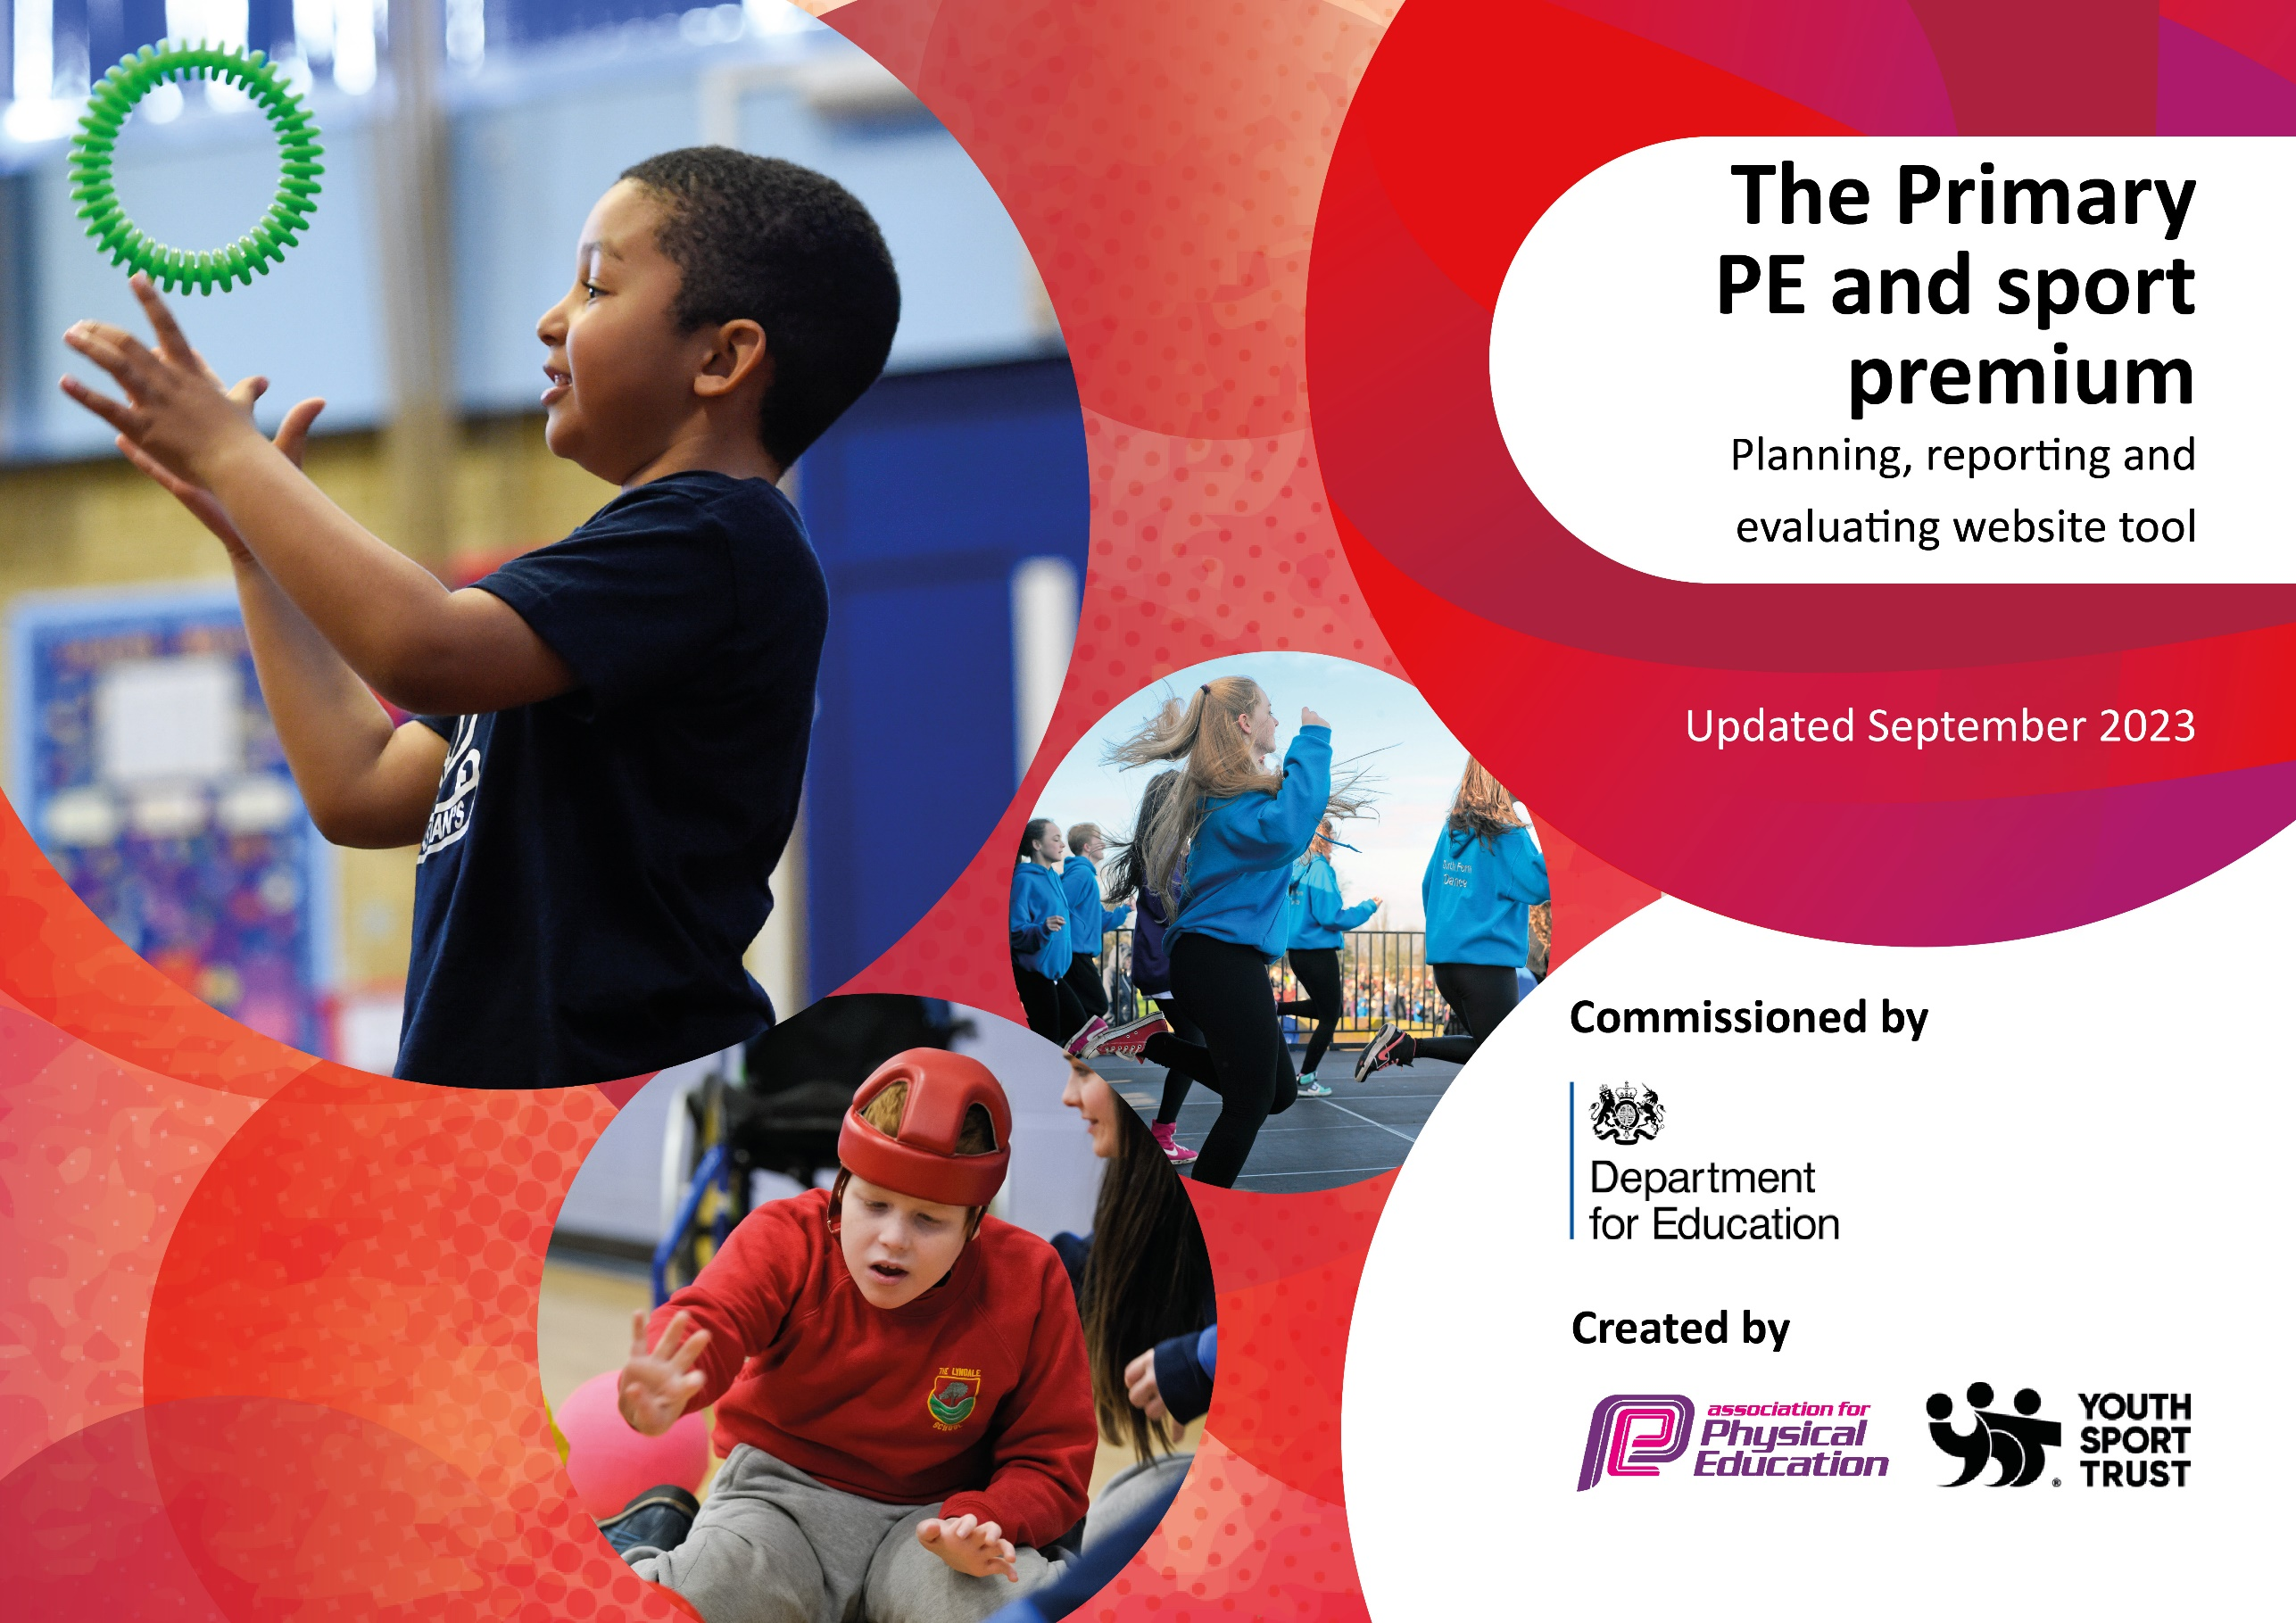

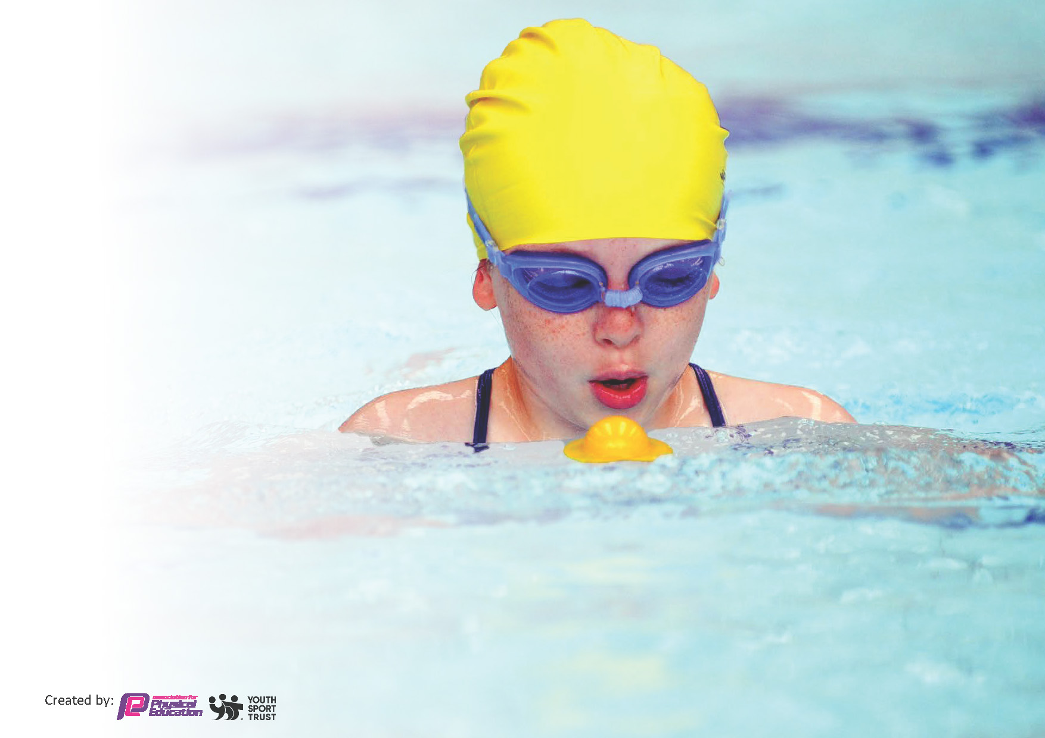
This template can be used for multiple purposes:
by:
- It enables schools to effectively plan their use of the Primary PE and sport premium
- It helps schools to meet the requirements (as set out in guidance) to publish information on their Primary PE and sport premium
- It will be an effective document to support Ofsted inspections enabling schools to evidence progress in Physical Education (PE) and evidence swimming attainment, which forms part of the PE National Curriculum. We would recommend schools consider
the Intent, Implementation and Impact of any spend, as examined within the Education Inspection Framework.

It is important that your grant is used effectively and based on school need.

Schools must use the funding to make additional and sustainable
improvements to the quality of the PE, School Sport and Physical Activity (PESSPA)
they offer. This means that you should use the Primary PE and sport premium to:

- Build capacity and capability within the school to ensure that improvements made now will benefit pupils joining the school in future years
- Develop or add to the PESSPA activities that your school already offers.

The Primary PE and sport premium should not be used to fund capital spend projects; the school’s core budget should fund these. Further detail on capital expenditure can be found in the updated Primary PE and sport premium guidance.

The Primary PE and sport premium guidance, outlines 5 key priorities that funding should be used towards. It is not

Key priorities and Planning
This planning template will allow schools to accurately plan their spending.

Action – what are you planning to do | Who does this action impact? | Key indicator to meet | Impacts and how sustainability will be achieved? | Cost linked to the action
To increase the confidence of teachers in dance teaching throughout the school, as requested by staff in a recent questionnaire.  To continue to develop use of the PE Passport within PE lessons by all staff, for both lesson planning and assessments.  A member of staff to achieve qualification for the benefit of PE and Sports within school.  Coach to work with various teachers to support and develop their knowledge/skills and confidence in delivering the PE and Sport curriculum.  To further develop Fundamental Movement Skills across Reception and KS1-through high quality PE.  To become involved in the Dance Festival in Blackpool. To train a full year group in the dance and take a full class to the festival.  Olympic Day-  Olympic athletes to raise profile of upcoming Olympics in Paris this year.  To provide a variety of different experiences for children including judo, cheerleading, tag rugby, cricket, glowball dodgeball, active mile -all with invited coaches.  Triathlon days for all children to encourage participation in a different activity and sign posting to triathlon club in local area.  Further equipment to be ordered to add to and replace worn. To include badminton racquets for the introduction of this sport into year 5.  To begin a Girls’ football club and team to encourage more girls into sport and to become more involved. (Following the success of the England Lionesses)  To enter inter school competitions.  To participate fully in all inter-school competitions through the Fylde and Wyre Sports Partnership and local cluster offer.  Intra-school sports to involve all children within school. | All staff.  All staff.  Cost of course and release time for member of staff to fulfil requirements of the course within a range of year groups.  CN Active  Targeted Year Groups  Reception and KS 1.  CN Active.  Year 4 children and staff.  Whole school  Wyre and Fylde Sports Partnership Offer. Sporting events organized by Cardinal Allen.  Fylde Rugby Club.  Lancashire Cricket Foundation.  Opportunities spread throughout both Key Stages.  PE lead  KS2 Y5/Y6  Wyre and Fylde Sports Partnership Offer. Sporting events organized by Cardinal Allen.  Use of House and Sports Captains to promote competition. | Key Indicator 1- Increased confidence, knowledge and skills of all staff in teaching PE and Sport.  Key Indicator 3- The profile of PE and Sport is raised across the school as a tool for whole school improvement.  Key Indicator 4-Broader experience of a range of Sports and activities offered to all pupils.  Key Indicator 5-Increased participation in competitive sport. | Allows staff to be upskilled, improving delivery of dance lessons. PE lead to work alongside staff to embed.  Staff clarity in PE passport use for assessment and in the structure of the curriculum. Regular opportunities to revisit as a part of CPD to embed best practice.  Continual learning, reflecting on practice. Through lesson observation and pupil voice.  Teachers to apply skills taught to lessons and share good practice with rest of staff.  Teachers to be confident in the delivery of PE lessons - lesson observations and staff audit.  Children will receive high quality PE lessons – Pupil interviews and lesson observations.  Targeted groups of children will engage in regular physical exercise – observations.  To identify needs and provide for these through interventions within and in addition to PE lessons.  Children perform a choreographed routine to an audience. Year 4 to attend each year.  All children to be involved. Motivational talks/goal setting sessions/to foster a positive mindset and passion for achievement.  Continue to audit provision and reflect on best practice and further training as suggestions are made for equipment that may move PE delivery forward.  Children have the opportunity to represent school and experience competition.  Children have the opportunity to represent school and experience competition.  Children have the opportunity to represent school and experience intra-school competitions. | £200  Staff training lead by PE lead.  Specialist training identified and brought in as required (eg Dance training).  £900  CN Active cost - £14,540  CN Active  £200 coach cost  £1000  Wyre and Fylde Sports Partnership Offer-£1,930  £910  £899  £600  Wyre and Fylde Sports Partnership Offer.  Wyre and Fylde Sports Partnership Offer.

Key achievements 2023-2024
This template will be completed at the end of the academic year and will showcase the key achievements schools have made with their Primary PE and sport premium spending.

Activity/Action | Impact | Comments

Swimming Data
Meeting National Curriculum requirements for swimming and water safety.
Priority should always be given to ensuring that pupils can perform safe self-rescue even if they do not fully meet the first two requirements of the National Curriculum programme of study

Question | Stats: | Further context  Relative to local challenges
What percentage of your current Year 6 cohort can swim competently, confidently and proficiently over a distance of at least 25 metres? | % | Use this text box to give further context behind the percentage.  e.g., 30% - we are struggling to get pool space due to our local pool closing so we have had to use a much smaller local school pool. We have had to limit the number of pupils attending swimming lessons during one term which means some pupils have attended fewer swimming lessons than others.
What percentage of your current Year 6 cohort can use a range of strokes effectively [for example, front crawl, backstroke, and breaststroke]? | % | Use this text box to give further context behind the percentage.  e.g., Even though your pupils may swim in another year please report on their attainment on leaving primary school at the end of the summer term 2024

What percentage of your current Year 6 cohort are able to perform safe self-rescue in different water-based situations? | % | Use this text box to give further context behind the percentage.
If your schools swimming data is below national expectation, you can choose to use the Primary PE and sport premium to provide additional top-up sessions for those pupils that did not meet National Curriculum  requirements after the completion of core lessons. Have you done this? | Yes/No
Have you provided CPD to improve the knowledge and confidence of staff to be able to teach swimming and water safety? | Yes/No

Signed off by:

Head Teacher: | Elizabeth Hodgson
Subject Leader or the individual responsible for the Primary PE and sport premium: | Catherine Anderson and Charlotte Anderson
Governor: | Mike Wiseman
Date: | 21/2/24

