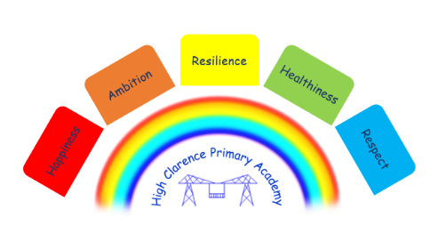




19th November 2024

Dear Parents/Carers

Punctuality
We have noticed that some children are arriving after the start of school and would like to remind everyone that every child needs to be in school by 8.45am. Please could you support us by getting your children to school on time, thank you. See the chart below to see the impact of being even 5 minutes late each day.
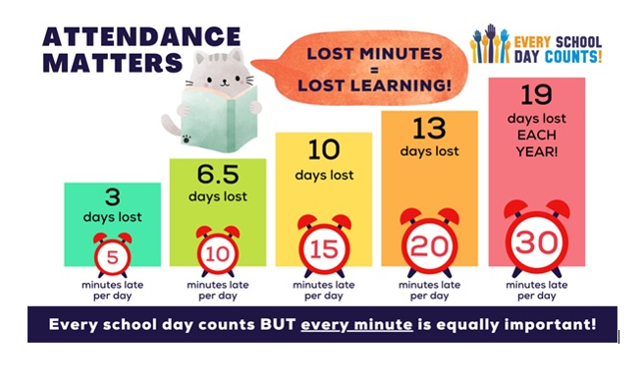

Christmas Jumper day
Christmas Jumper Day is on Thursday, 12th December. Your child will be able to come to school in Christmas jumpers, non-uniform or wearing Christmas accessories on the day!

Christmas Raffle/Coffee Morning
We will be holding the Christmas Raffle in the school hall from 8.45 a.m. on Tuesday, 17th December, therefore the weekly Monday and Wednesday coffee mornings will not be on that week.
Everyone is welcome to come along, the morning will include the Christmas Raffle and other ‘fund’-raising activities which can be paid for on the day! Free refreshments will be provided and raffle tickets will be on sale for £1 a strip from 2nd December.
We hope as many people as possible will attend as part of the Christmas Celebrations in school!

This half term is a very busy one in school. Please see the ‘Dates for your Diary’ overleaf for events to look out for.

Dates for your Diary

Date | Event
Wednesday, 20th November | Class 2 visit to Vue Hartlepool cinema
Wednesday, 20th November | Community meeting in school hall – 1.30 p.m.
Wednesday, 27th November | Class 3 Sports Hall Athletics
Tuesday, 3rd December | Class 3 Speed Stacking Competition
Thursday, 5th December | Class 4 Ice Skating Billingham Forum
Tuesday, 10th December | Class 2 – St Aidans Church ‘The Christmas Story’
Thursday, 12th December | National Christmas Jumper Day – children can come to school in Christmas Jumper/T-shirt
Thursday, 12th December | Crafty Christmas EY 8.45 a.m. Parents of EY children are invited to stay.
Monday, 16th December | KS2 Christmas Party
Tuesday, 17th December | Christmas Raffle and ‘Fund’ Raising Activities in the School Hall – Everyone welcome
Tuesday, 17th December | Christmas Dinner  KS1 Christmas Party
Wednesday, 18th December | KS2 visit to Middlesbrough Theatre to see Snow White and the Seven Dwarfs  EY Christmas Party
Friday, 20th December | Xmas Concert – 1.15 p.m. in School Hall – Everyone welcome  Break up for Christmas holidays
Monday, 6th January 2025 | PD Day
Tuesday, 7th January | School re-opens
Thursday, 16th January | McClarence (McDonalds themed) Lunch
Wednesday, 29th January | Chinese New Year themed lunch
Friday, 14th February | Valentines Day themed lunch
Friday, 21st February | Last day in school before half term
Monday, 3rd March | PD Day
Tuesday, 4th March | School re-opens
Thursday, 6th March | World Book Day
Friday, 11th April | Last day in school before Easter holidays
Monday, 28th April | School re-opens
Monday, 5th May | Bank holiday
Friday, 23rd May | Last day in school before 2 week half term
Monday, 9th June | School re-opens
Friday, 25th July | Last day in school before Summer holidays
Monday, 28th July | PD Day
Tuesday, 29th July | School closed for Summer holidays

N Caraher
Principal

