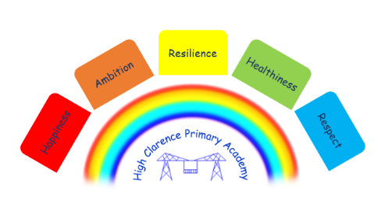


21st February 2025

Dear Parents/Carers

School Holidays
We break up today for a week for February half term. School is closed for a PD day on Monday, 3rd March and the children will return to school on Tuesday, 4th March 2025.

Wake up and Shake up
Wake up and Shake up has been really popular with the children and has had a positive effect on punctuality. This will continue every day at 8.30 a.m. in the school hall after the half term holiday.

World Book Day
It is World Book Day on Thursday, 6th March 2025. Your child can come to school dressed up as a character from a book or in their pyjamas to celebrate a bedtime story. We have added a few links below with simple costume ideas (A copy of this letter will be on the school website in order for you to easily access the links):
https://www.theschoolrun.com/cheap-and-easy-ideas-last-minute-world-book-day-costumes
https://www.madeformums.com/toddler-and-preschool/last-minute-easy-world-book-day-costumes/
https://www.manchestereveningnews.co.uk/whats-on/family-kids-news/easy-costumes-world-book-day-17813704

Book Fair
There will be a Book Fair in school the week commencing Monday, 17th March 2025. The children will be able to visit the Book Fair all week and will have the chance to purchase a book/books of their choice. More details will follow nearer the time.

Easter Raffle
On Tuesday, 8th April 2025 we will be holding an Easter raffle/Coffee Morning. More details will follow nearer the time.

N Caraher
Principal

PTO

Dates for your Diary

Date | Event
Monday, 3rd March | School closed PD Day
Tuesday, 4th March | School re-opens
Thursday, 6th March | World Book Day
Monday, 17th March | Book Fair Week
Wednesday, 2nd April – Friday, 4th April | Class 3 children staying in Whitby for 3 days Residential Visit
Tuesday, 8th April | Easter Raffle/Coffee Morning
Friday, 11th April | Last day in school before Easter holidays
Monday, 28th April | School re-opens
Monday, 5th May | Bank holiday
Monday, 12th May | Year 6 Sats week
Friday, 23rd May | Last day in school before 2 week half term
Monday, 9th June | School re-opens
Friday, 25th July | Last day in school before Summer holidays
Monday, 28th July | PD Day
Tuesday, 29th July | School closed for Summer holidays

