


23rd January 2025

Dear Parents/Carers

Punctuality
Punctuality has improved slightly but there is still a large group of children who are frequently late for school. As you can see from the chart below being just 3 minutes late everyday is the same as being absent for 3 days.

In KS1 and KS2 maths is the first lesson and some children are frequently 10-15 minutes late which is 10 days. That is a lot of lost learning especially in the same subject.

We would like to remind everyone that every child needs to be in school by 8.45am. Please could you support us by getting your children to school on time, thank you.

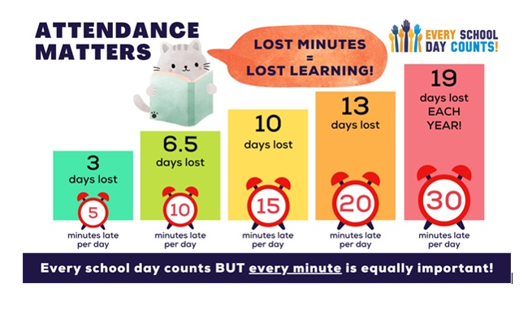

N Caraher
Principal

PTO

Dates for your Diary

Date | Event
Monday, 27th January – Friday, 31st January | 8 KS2 children staying at Derwent Hill for 5 days Residential Visit
Wednesday, 29th January | Chinese New Year themed lunch
Friday, 14th February | Valentines Day themed lunch
Friday, 21st February | Last day in school before half term
Monday, 3rd March | PD Day
Tuesday, 4th March | School re-opens
Thursday, 6th March | World Book Day
Wednesday, 2nd April – Friday, 4th April | Class 3 children staying in Whitby for 3 days Residential Visit
Friday, 11th April | Last day in school before Easter holidays
Monday, 28th April | School re-opens
Monday, 5th May | Bank holiday
Friday, 23rd May | Last day in school before 2 week half term
Monday, 9th June | School re-opens
Friday, 25th July | Last day in school before Summer holidays
Monday, 28th July | PD Day
Tuesday, 29th July | School closed for Summer holidays

