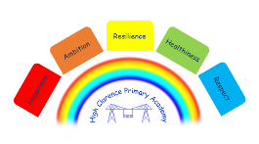


4th November 2025

Dear Parents/Carers

Drop off and Punctuality
For the safety and wellbeing of all children, we kindly ask parents and carers to drop off their children at their door in order for us to maintain a secure environment!
We have noticed that some children are arriving after the start of the school day.
Children are welcome to come into the school hall from 8:30 a.m. to take part in ‘Just Dance’. They may also enter the school from 8:40 a.m. to be in their classrooms ready for registration at 8:45 a.m., which marks the official start of the school day. Please support us by ensuring your children arrive on time. Thank you for your cooperation.
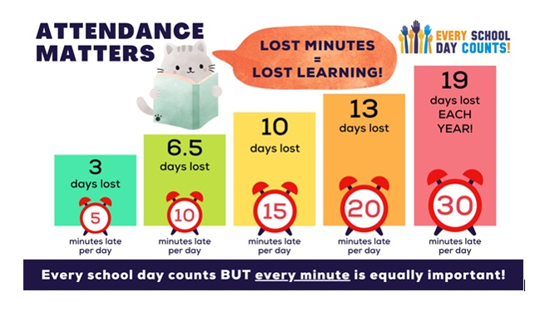
See the chart below to understand the impact of being even 5 minutes late each day.

Remembrance Day
We would like to invite you and the children to join the Remembrance Service at The Clarences Cenotaph this Sunday, 9th November at 1.30 p.m. As part of the service, the children have been invited to take part in reciting our special poem 'Poppy, Poppy', to honour those who have served and sacrificed.

Miss Reay will be at the Cenotaph from 1.10pm to meet the children, please accept our apologies for the previous notes which incorrectly stated the service time as 11 a.m. The correct time is 1.30 p.m.

After School Clubs
Roller Skating Club will begin next week on Wednesday, 12th November, and will run every Wednesday thereafter from 3:15 to 4:00 p.m.
Children who will be attending this half term will be sent home with a permission slip this week.
Those who are not attending this term will be placed on a waiting list to take part after the Christmas holidays.

Children in Need

To help raise funds for Children in Need, we are inviting children to take part in a non-uniform day on Friday, 14th November. We kindly ask that children bring in a donation to support this worthwhile cause.
Children are welcome to come dressed in non-uniform, pyjamas, or their favourite dressing-up clothes.
We hope you will encourage your child to take part and help us support this important charity.
Every penny counts!

Ice Skating
Class 4 pupils will be taking part in a free ice-skating session at Billingham Forum on the afternoon of Wednesday, 3rd December 2025.

Thirteen Drop In sessions
Drew, the Housing Services Co-ordinator for The Clarences, is in school every month to help with any housing issues you may have. The next drop-in session is Thursday, 4th December from 9 – 11 a.m.

Christmas Dinner
School Christmas Dinner will be on Wednesday, 10th December 2025.

Christmas Jumper day
Christmas Jumper Day is on Thursday, 11th December. Your child is welcome to come to school wearing a Christmas jumper, non-uniform, or festive accessories on the day!

Christmas Concert Performance
The Christmas Concert will be held on Friday, 12th December at 1.15 p.m. in the school hall.

Christmas Raffle/Coffee Morning
We will be holding the Christmas Raffle in the school hall from 8:45 a.m. on Wednesday, 17th December.
Everyone is welcome to come along! The morning will include the Christmas Raffle and other fundraising activities, which can be paid for on the day. Free refreshments will be provided, and raffle tickets will be on sale for £1 per strip starting from 1st December.
We hope as many people as possible will join us as part of the school’s Christmas celebrations!

Christmas Parties and Non-Uniform Day
Children can come to school in non-uniform on their Christmas Party Day, Thursday, 18th December and the last day in school, Friday, 19th December 2025.
- EY party – Thursday, 18th December a.m.
- KS1 party – Thursday, 18th December a.m.
- KS2 party - Thursday, 18th December p.m.
- Blossom Room party – Thursday, 18th December

HAF (Holidays Are Fun) Christmas Club
This year, a HAF club will be running during the Christmas holidays, delivered by Active Future Teesside. The sessions will take place on:
- Monday 22nd and Tuesday 23rd December
- Monday 29th and Tuesday 30th December
Activities will include a Christmas party, craft sessions, and sports.
The HAF club is open to all children, but please note that spaces are limited. Unlike previous HAF programmes, children who are not eligible for free school meals will be able to attend for a set fee.
More details will be shared closer to the time.

Christmas holidays
School breaks up for the Christmas holidays on Friday, 19th December and we return to school on Tuesday, 6th January 2026.

PD Days
School will be closed on:
Monday, 5th January 2026
Monday, 27th July 2026
Tuesday, 28th July 2026

Dates for your Diary

Please see a list of dates on the next page

Date | Event
Sunday, 9th November | Remembrance service at The Clarences Cenotaph 1.30 p.m.
Friday, 14th November | Children in Need Day
Wednesday, 3rd December | Class 4 Ice Skating p.m.
Thursday, 4th December | Thirteen Housing Drop-in session 9-11 a.m.
Wednesday, 10th December | School Christmas Dinner
Thursday, 11th December | Christmas Jumper Day
Friday, 12th December | Christmas Concert 1.15 p.m. in the school hall
Wednesday, 17th December | Christmas Raffle/Coffee morning from 8.45 a.m. in the school hall
Thursday, 18th December | Christmas party day – non uniform
Friday, 19th December | Last day in school before Christmas holidays – non uniform
Monday, 22nd and Tues 23rd December | HAF in school hall
Monday, 29th and Tues 30th December | HAF in school hall
Monday, 5th January 2026 | PD Day
Tuesday, 6th January | School re-opens
Friday, 20th February | Last day in school before half term
Monday, 2nd March | School re-opens
Thursday, 2nd April | Last day in school before Easter holidays
Friday, 3rd April | Bank Holiday
Monday, 20th April | School re-opens
Monday, 27th April – Friday, 1st May | Year 5 Residential trip to Derwent Hill
Monday, 4th May | Bank holiday
Friday, 22nd May | Last day in school before 2 week half term
Monday, 8th June | School re-opens
Mondy, 6th July – Wed 8th July | Class 3 Residential trip to Whitby
Friday, 24th July | Last day in school before Summer holidays
Monday, 27th July | PD Day
Tuesday, 28th July | PD Day

N Caraher
Principal

