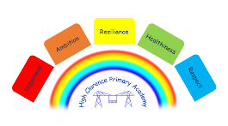

17th February 2026
🌼 Blossom Class Sensory Experience 🌼
Dear Parents,
We are excited to share that our Blossom Class has been given a wonderful opportunity to explore the Sensory Adapted Ambulance on Friday 13th March.
This immersive and engaging experience will be set up on our school site for the morning, allowing our children to:
✨ Touch, feel and hear a range of specialist sensory equipment
✨ Explore a unique mobile sanctuary designed to support sensory needs
✨ Take part in calming, hands-on activities throughout the visit
This visit has been kindly funded by Tyler – Loki’s dad, and we are extremely grateful for his generosity in making this possible for our children.
We are really looking forward to a special and memorable morning for our Blossom Class.
Thank you for your continued support,
N Woodall
Class Teacher

