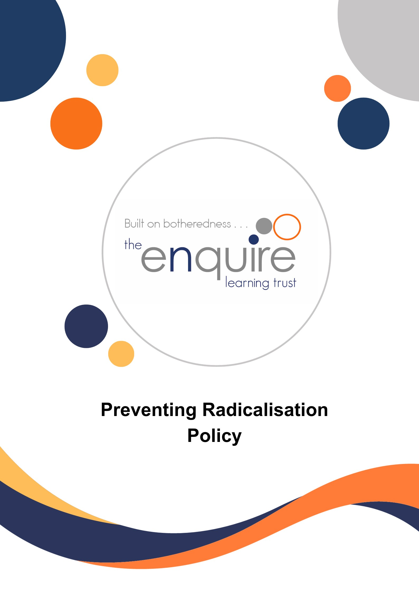

Contents
Section | Title | Page
1 | Background | 3
2 | Ethos | 3
3 | Statutory Duties and non – statutory Guidance | 3
4 | Related Policies | 4
5 | Definitions | 4
6 | Roles and Responsibilities | 4
7 | Curriculum | 5
8 | Internet Safety | 5
9 | Signs of Susceptibility | 6
10 | Recognising Extremism | 7
11 | Referral Process | 7
12 | Monitoring and Review | 7

Version History
Approved by: | Trustees
Last reviewed: | May 2025
Next review due by: | May 2026

Date | Author | Version | Comment
August 2019 | LT
July 2021 | JH
July 2023 | JH
May 2024 | RCo |  | Updated guidance and new terminology 2024.
May 2025 | RCo |  | Reviewed – no changes required
1. Background
This ‘Preventing Radicalisation Policy’ is part of our commitment to keeping children safe. Since the ‘Education and Inspections Act 2006’ academies have a duty to promote community cohesion. Over the last few years, global events have led to a growth of extremist viewpoints, including advocacy of violent extremism.
Academies have an important part to play in both educating children and young people about extremism and recognising when pupils start to become radicalised. In March 2015, new statutory duties were placed on academies by the Counter Terrorism and Security Act (2015) which means they must work to prevent children being drawn into extremism.
Safeguarding children from all risks of harm is an important part of an academy’s work and protecting them from extremism is one aspect of that.
2. Ethos

At the Enquire Learning Trust we ensure that through our academy vision, values, rules, diverse curriculum and teaching we promote tolerance and respect for all cultures, faiths and lifestyles. The Academy Improvement Committee also ensures that this ethos is reflected and implemented effectively in academy policy and practice and that there are effective risk assessments in place to safeguard and promote students’ welfare.
We have a duty to prepare our children for life in modern Britain and to keep them safe.
Pupils who attend our academy have the right to learn in safety. We do not tolerate bullying of any kind and will challenge derogatory language and behaviour towards others.
3. Statutory Duties
The duty to prevent children and young people being radicalised is set out in the following documents.
- Counter Terrorism and Security Act (2015) Counter-Terrorism and Security Act - GOV.UK (www.gov.uk)
- Keeping Children Safe in Education (2024) Keeping children safe in education 2024 (publishing.service.gov.uk)
- Prevent Duty Guidance (2023) Prevent duty guidance: Guidance for specified authorities in England and Wales (print-ready PDF) (publishing.service.gov.uk)
- Working Together to Safeguard Children (2023) Working together to safeguard children 2023: statutory guidance (publishing.service.gov.uk)
- Keeping children safe in education 2025
Non-statutory Guidance
- Improving the spiritual, moral, social and cultural (SMSC) development of pupils: supplementary information (DfE 2014) Advice template (publishing.service.gov.uk)

4. Related Policies

- Information Governance Policy
- Online Safety
- Behaviour Policy
- Safeguarding Policy
- Equality Policy
- Personal, Social and Health Education (PSHE) Policy
- Spiritual, Moral, Social, Cultural (SMSC) Policy
- Staff Code of Conduct
- Teaching and Learning Policy
- Visitors Policy
- Whistle-blowing Policy
5. Definitions

Extremism is defined in the 2011 Prevent strategy as vocal or active opposition to fundamental British values, including democracy, the rule of law, individual liberty and mutual respect and tolerance of different faiths and beliefs. We also include in our definition of extremism calls for the death of members of our armed forces, whether in this country or overseas.
Radicalisation refers to the process by which a person comes to support terrorism and extremist ideologies associated with terrorist groups.
British Values are democracy, the rule of law, individual liberty and mutual respect and tolerance of those with different faiths and beliefs.

6. Roles and Responsibilities

Role of the Academy Improvement Committee
It is the role of the Academy Improvement Committee to ensure that the academy meets its statutory duties with regard to preventing radicalisation.
Role of the Principal
It is the role of the Principal to be the named lead for Prevent and:
- ensure that the academy and its staff respond to preventing radicalisation on a day-to-day basis,
- ensure that the academy’s curriculum addresses the issues involved in radicalisation
- ensure that staff conduct is consistent with preventing radicalisation
Role of Designated Safeguarding Lead
It is the role of the designated safeguarding lead to:
- ensure that staff understand the issues of radicalisation, are able to recognise the signs of susceptibility or radicalisation and know how to refer their concerns
- receive safeguarding concerns about children and young people who may be susceptible to the risk of radicalisation or are showing signs of radicalisation
- make referrals to appropriate agencies with regard to concerns about radicalisation
- liaise with partners, including the local authority and the police
- report to the Academy Improvement Committee on these matters
Role of staff
It is the role of staff to understand the issues of radicalisation, are able to recognise the signs of susceptibility or radicalisation and know how to refer their concerns.

7. Curriculum

We are committed to ensuring that our pupils are offered a broad and balanced curriculum that aims to prepare them for life in modern Britain. We encourage our pupils to be inquisitive learners who are open to new experiences and are tolerant of others.
These values support the development of the whole child as a reflective learner within a calm, caring, happy and purposeful atmosphere. Teaching the academy’s core values alongside the fundamental British Values supports quality teaching and learning, whilst making a positive contribution to the development of a fair, just and civil society.

8. Internet Safety
The internet provides children and young people with access to a wide-range of content, some of which is harmful. Extremists use the internet, including social media, to share their messages. The filtering systems used in our academy blocks inappropriate content, including extremist content.
We also filter out social media, such as Facebook. Searches and web addresses are monitored, and the principals are alerted where there are concerns and prevent further access when new sites that are unblocked are found.
Where staff, students or visitors find unblocked extremist content they must report it to a senior member of staff.
We are aware that children and young people have access to unfiltered internet when using their mobile phones and staff are alert to the need for vigilance when pupils are using their phones.
The Acceptable Use of ICT Policy (AUP) refers to preventing radicalisation and related extremist content. Pupils and staff are asked to sign the AUP annually to confirm they have understood what is acceptable.
Pupils and staff know how to report internet content that is inappropriate or of concern.
Staff Training

Staff will be given training to help them understand the issues of radicalisation, are able to recognise the signs of susceptibility or radicalisation and know how to refer their concerns. This information also forms part of induction safeguarding training. Staff are updated as necessary in weekly safeguarding briefings.

Safer Recruitment

We ensure that the staff we appoint to the academy are suitable, our recruitment procedures are rigorous and we follow the statutory guidance published in Keeping Children Safe in Education (2023). Vetting and barring checks are undertaken on relevant people, including the School Improvement Committee and volunteers.
Visitors

Visitors to the academy are made aware of our safeguarding and child protection policies on arrival at the academy and are given information about what to do if they are concerned about any aspect of child welfare.
Visitors who are invited to speak to pupils will be informed about our preventing extremism policy and relevant vetting checks are undertaken. We undertake due diligence to ensure that visiting speakers are appropriate. Speakers will be supervised at all times and will not be allowed to speak to children without a member of staff being present.
Staff must not invite speakers into academy without first obtaining permission from the Principal.

‘No platform for extremists’

The academy is vigilant to the possibility that out-of-hours hire of the academy premises may be requested by people wishing to run an extremist event. The academy does not accept bookings from individuals or organisations that are extremist in their views.

9. Signs of susceptibility

There are no known definitive indicators that a young person is susceptible to radicalisation, but there are number of signs that together increase the risk. Signs of susceptibility include:
- underachievement
- being in possession of extremist literature
- poverty
- social exclusion
- traumatic events
- global or national events
- religious conversion
- change in behaviour
- extremist influences
- conflict with family over lifestyle
- confused identify
- victim or witness to race or hate crimes
- rejection by peers, family, social groups or faith
10. Recognising Extremism

Early indicators of radicalisation or extremism may include:

- showing sympathy for extremist causes
- glorifying violence, especially to other faiths or cultures
- making remarks or comments about being at extremist events or rallies outside academy
- evidence of possessing illegal or extremist literature
- advocating messages similar to illegal organisations or other extremist groups
- out of character changes in dress, behaviour and peer relationships (but there are also very powerful narratives, programmes and networks that young people can come across online so involvement with particular groups may not be apparent.)
- secretive behaviour
- online searches or sharing extremist messages or social profiles
- intolerance of difference, including faith, culture, gender, race or sexuality
- graffiti, art work or writing that displays extremist themes
- attempts to impose extremist views or practices on others
- verbalising anti-Western or anti-British views
- advocating violence towards others

11. Referral Process

Staff and visitors to the academy must refer all concerns about children and young people who show signs of susceptibility or radicalisation must be passed to the Designated Safeguarding Lead using the usual methods for reporting other safeguarding concerns.
When there are significant concerns about a pupil, the Designated Safeguarding Lead in liaison with the Principal will make a referral to the appropriate body.

12. Monitoring and Review

This policy will be monitored by the Trustees at least annually. This is not a statutory policy and will be reviewed at an appropriate time not later than two years after ratification by the Trustees.

