
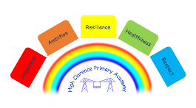

World Book Day 2026

It is World Book day on Thursday 5th March and your child can come to school dressed up as a character from their favourite book or in non-uniform.
To make this day even more special the Children’s Bookshow are running events which will promote a love of reading, writing and poetry. These will be online LIVE performances from the author/illustrator Marta Altes for Years 1, 2 and 3.

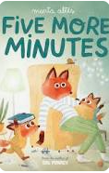
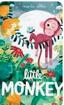
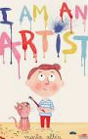

The children in Years 4, 5 and 6 will have the opportunity to meet award winning poet Kwame Alexander for a live Q&A session.

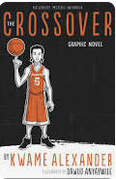
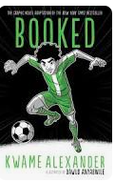

The children in Early Years will be taking part in exciting and fun ‘Story Themed’ activities throughout the day.

The whole school will also be able to take part in a Zoom session with the writer Annabelle Sami.

We have added a link below with simple costume ideas (A copy of this letter will also be on the school website for you to easily access the link)

https://www.madeformums.com/toddler-and-preschool/last-minute-easy-world-book-day-costumes/

L Brown
Vice Principal

