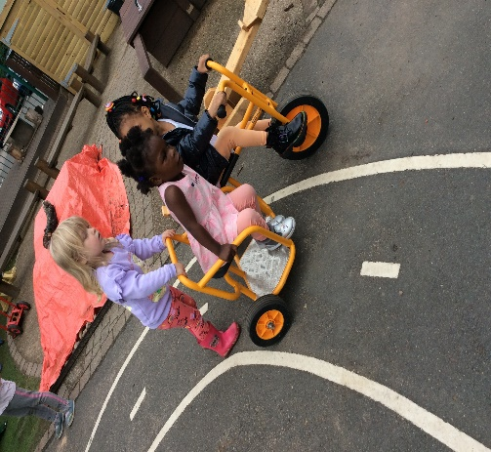
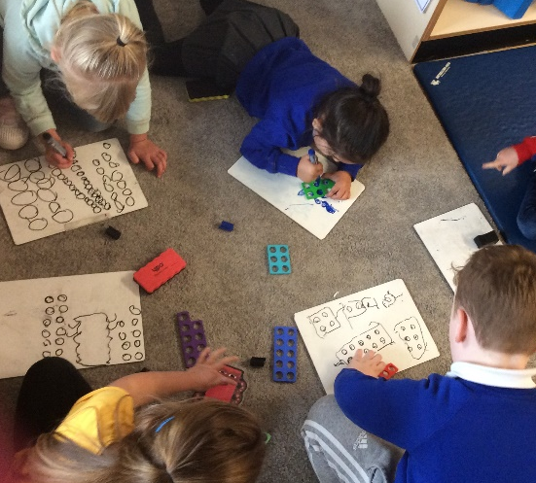
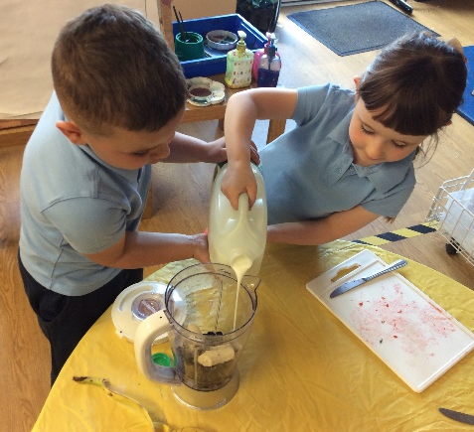
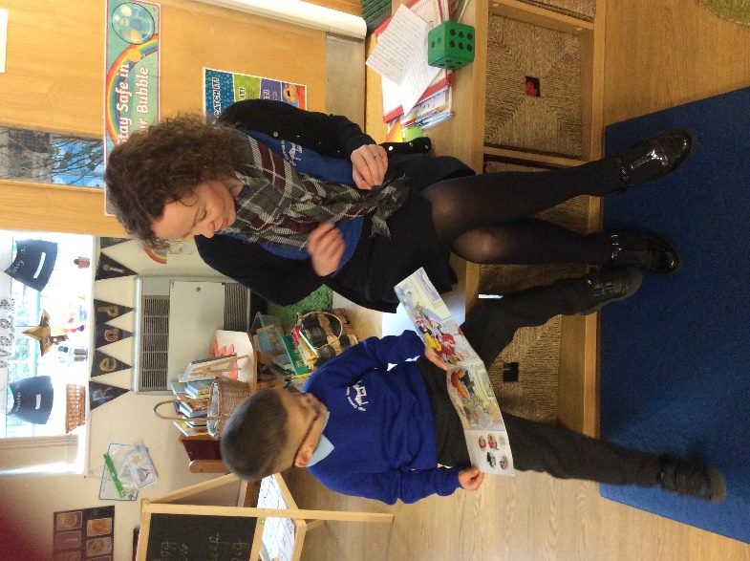
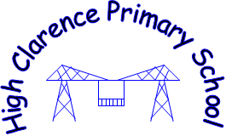
Early Years Curriculum Framework
We intend learning for our young children to be a rewarding and enjoyable experience in which they explore, investigate, discover, create, practise, rehearse, repeat, revise and consolidate their developing knowledge, skills, understanding and attitudes. Our environment primarily supports our children to develop their communication skills through calming neutral spaces, cosy areas to talk and open-ended resources to spark imagination.
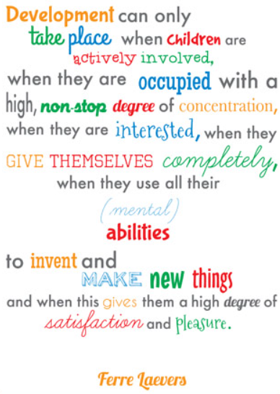
In the Early Years we are committed to giving our children the best start in their school life by making learning exciting and engaging, enabling children to reach their full potential. We support the children to develop a positive image of themselves as competent and independent learners. We facilitate this through nurturing and supporting each individual to achieve and learn by providing a safe, stimulating and challenging environment, enhancing their interests and exploiting all learning opportunities.
This document outlines our Universal Curriculum Offer and is based around guidance from Development Matters 2020 and Birth to 5 matters. Some children in Early Years may receive a more Targeted Curriculum Offer suited to their needs and may involve the support of interventions such as NELI or outside agencies such as Speech and Language and the Educational Psychologist. Some children may also remain within Early Years beyond their Reception year. This is to develop the skills and knowledge necessary to prepare them for the challenges of Year 1.
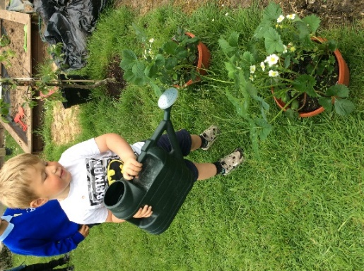
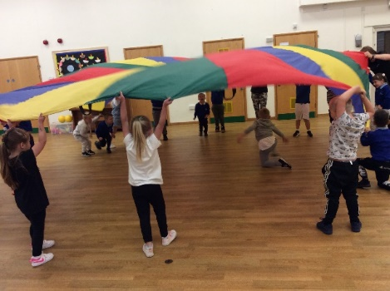

High Clarence Primary School
Early Years Curriculum Framework
Year A
Autumn 1 | Autumn 2 | Spring 1 | Spring 2 | Summer 1 | Summer 2
Me and My Community  Exploring Autumn | Big Wide World  Sparkle and Shine | Once Upon a Time: journeys  Winter Wonderland | Why do you love me so much? | Why do Ladybirds have Spots? | Who lives in a rock pool?
Possible Themed Books
*The Colour Monster  *The Great Big Book of Families  *What do I Look Like?  *Starting School/ Goat Goes to Playgroup  *Pip and Posy- The New Friend  *The Baby’s Catalogue  *People who Help Us  *The Gruffalo  *Bear Snores On  *Leaf Man / Tree  *Pumpkin Soup / Five Little Pumpkins | *Our World  *The Journey  *Let’s Build  *Handa’s Surprise  *Granny Went to Market  *How to Say.. I Love You in Five Languages  *Under the Same Sky  *You Choose  *Tidy! / Clean up!  *Rumble / Commotion in…  *Little Glow  *Stick Man  *We’re going on an Elf Chase | *Jack and the Beanstalk  *The Three Billy Goats Gruff  *We’re Going on a Bear Hunt  *The Train Ride  *The Gingerbread Man  *Hansel and Gretel  *Mr Gumpy’s Outing  *And Tango Makes Three  *Once Upon a Time  *The Gruffalo’s Child  *The Foggy Foggy Forest  *One Snowy Night  *Polar Bear Polar Bear | *Paper Dolls  *Rosie’s Hat  *Love Monster  *Oliver’s Vegetables  *Oliver’s Fruit Salad  *Sometimes  *Guess How Much I Love you (Seasons)  *Where’s My Teddy?  *My Mum / My Dad  *How Are You Feeling Today?  *The Invisible String  *Monkey Puzzle  *Does a Kangaroo have….? | *Mad about Minibeasts  *The Crunching Munching Caterpillar  *The Very Lazy Ladybird  *What the Ladybird Heard  *Superworm  *Over in the Meadow  *A Dot  *Mix it Up  *The Bad Tempered Ladybird  *The Very Busy Spider  *Doug the Bug  *Norman the Slug | *Barry the Fish with Fingers  *Seaside Poems  *Sally and the Limpet  *First Book of the Seashore  *Lost on the Beach  *Sharing a Shell  *Secret Seahorse  *Sand Sister  *Toddle Waddle  Look What I’ve Found  *At the Beach  *Come Away from the Water, Shirley!
*This bank of themed books will be used to ‘hook in’ and engage our children in our half termly topics. It is flexible and varied to suit the different stages of our children within Early Years. Activities and learning experiences will be planned based on these books to explore vocabulary, build understanding and develop imagination.
Focus Rhymes/Songs
Two Little Dicky Birds  I’m a Little Teapot  Heads, Shoulders, Knees and Toes | Hey Diddle Diddle  Twinkle Twinkle  Down in the Jungle | The Wheels on the Bus  Pussy Cat Pussy Cat  Down at the Station | Rock- A-Bye-Baby  Miss Polly had a Dolly  Five in the Bed | Incy Wincy  There’s a Worm…  Round and Round the Garden | Row, Row, Row your Boat  1,2,3,4,5 Once I Caught  Jack and Jill
*These are focus rhymes all Nursery children will learn across the year through rhyme time and dough disco. Children will also have opportunities to learn and perform songs, nursery rhymes and poetry linked to themes, their interests, curiosities and passions.
Possible Lines of Enquiry
-Settling in  -New rules/routines  -Making new friends  - Being helpful, kind and thoughtful  -Friendships  - Important People in the community  - My Home  - People who help us  -Seasonal Changes  - Hibernation | -Caring for our community  -Our World  -Oceans, deserts and jungles  -Flags and maps  -Roads, bridges and tunnels  -Holidays/ special outings  -Buildings around the world  -Road Safety  -Transport  - Celebrations from Home and around the World | - Journeys  - Places we have visited/ holidays  - Maps  - Different types of Transport  - Seasonal Changes  - Places that have snow all year round – polar regions | - Feelings  - Families  - All about me  - When I was a baby  - My Body  - Toys (simple forces/ magnetism)  -My History | - Minibeasts in the local environment  -Similarities and differences  - Growth and change  - Patterns and colours  - Plants and flowers | - Seashore plants and animals  - Features of the seashore  - Water safety  - Properties of natural materials  - Art using found materials  - Pollution
These possible lines of enquiry and learning enhancements maybe adapted at various points to allow for children’s interests to flow through the provision and to deepen knowledge and skills when needed.
Memorable Moments/ Enrichments/ Parent Partnership
- Visit from Emergency Services / People who help us in the community  - Park Visit (Autumn Walk)  - Harvest  -Bonfire Night  -Proud Clouds | - Fantastic journey to school- scooters, bikes and skateboards  -Connecting with a school far away (Children in Need)  -Nativity  - Christmas / Christingle  - Diwali  - Remembrance Sunday | - Pantomime  - Visit from an Author/library visit  -Street Walk (homes)  -Valentine’s Day  -Chinese New Year  - Pancake Day  - World Book Day | -‘Family Morning’ (invite parents: teddy bears picnic, planting seeds)  - Easter  -Mother’s Day  -Stay and Read Morning | -Butterfly Hatching  - Zoolab visit  -Wormery  -Ant Farm  -Messy Maths | - Visit to the Seaside  - Father’s Day  - Sports Day  -Pirate Day and Ice Creams
Memorable moments and enrichment activities are planned to offer our children active, hands on experiences to bring their learning to life and to develop our children’s cultural capital. We will prepare our children with the knowledge and skills for what comes next in their learning journey. We want our children to experience awe and wonder of the world in which they live. It is important for us to have a strong and respectful partnership with parents. This sets the scene for children to thrive in the early years and beyond.

Year B
Autumn 1 | Autumn 2 | Spring 1 | Spring 2 | Summer 1 | Summer 2
Me and My Community  Exploring Autumn | Starry Night  Sparkle and Shine | Once Upon a Time: Traditional Tales  Winter Wonderland | Are Eggs alive? | Why can’t I have chocolate for breakfast? | Sunshine and Sunflowers  Shadows and Reflections:
Possible Themed Books
*The Colour Monster Goes to School  *Starting School /  Goat goes to Playgroup  *The Friendship Quilt  *When I was Little  /Once there were Giants  *Five Minutes Peace  *The Gruffalo  *Leaf Man / Tree  *Pumpkin Soup / Five Little Pumpkins | *Whatever Next!  *Peace at Last  *Owl Babies /Wow said the Owl  *How to Catch a Star  *Goodnight Harry  *Night Monkey Day Monkey  *Shark in the Dark  *Little Glow  *Stick Man  *We’re going on an Elf Chase | *Goldilocks and the Three Bears  *Little Red Riding Hood  *There is No Dragon in this Story  *The Three Little Pigs  *Cinderella  *And Tango Makes Three  *The Gruffalo’s Child  *Once Upon a Time  *The Foggy Foggy Forest  *One Snowy Night  *Polar Bear Polar Bear | *Nine Ducks Nine  *Farmer Duck  *Pig in the Pond  *We’re Going on an egg Hunt  *Wriggle and Roar!  *Fantastic First Poems  *Oi Frog  *The Odd Egg  *Handa’s Hen  *Farmyard Hullabaloo | *Kitchen Disco  *Love Monster and the Last Chocolate  *Twinkle Twinkle Chocolate Bar  *Chocolate Mousse for Greedy Goose  *Ketchup on your Cornflakes  *Handa’s Surprise  *Eat your Greens Goldilocks  *The Tiger Who came to Tea | *Shark in the Park  *The Tiny Seed  *The Very Hungry Caterpillar  *I can grow a Sunflower  *Mad about Minibeasts  *Sun (Whatever the Weather)  *Summer (Childsplay)  *Little Beaver and the Echo  *Through the Magic Mirror  *Princess Mirror-belle
*This bank of themed books will be used to ‘hook in’ and engage our children in our half termly topics. It is flexible and varied to suit the different stages of our children within Early Years. Activities and learning experiences will be planned based on these books to explore vocabulary, build understanding and develop imagination.
Focus Rhymes / Songs
Twinkle Twinkle  Incy Wincy Spider  Grand Old Duke of York | Hickory Dickory  Tommy Thumb  Teddy Bear Teddy Bear | Baa Baa Black Sheep  This Little Piggy  When Goldilocks went.. | Five Little Ducks  Humpty Dumpty  Little Bo-Peep | Five Currant Buns /Five Fat Sausages  The Muffin Man  Pat a Cake | Mary Mary Quite Contrary  Here is the Beehive  Planting Flowers (Fere Jacques) / Five Flowers Tall (Five Little Ducks)
*These are focus rhymes all Nursery children will learn across the year through rhyme time and dough disco. Children will also have opportunities to learn and perform songs, nursery rhymes and poetry linked to themes, their interests, curiosities and passions.
Possible Lines of Enquiry
-Settling in  -New rules and routines of school  - My Home  -Making new friends  - Being helpful, kind and thoughtful  -Friendships  - Important People in the community  - People who help us  -Seasonal Changes  - Hibernation | - Differences in the world at night compared to during the day.  - Importance of a good night’s sleep  -What happens while we are sleeping  - Nocturnal animals.  - Celebrations from Home and around the World | - Developing a love of stories and reading.  - Learn, retell and act out familiar and traditional tales  - Seasonal Changes  - Places that have snow all year round; types of animals that live there | - Ducks and ducklings  - Frogs and frogspawn  - Eggs  - Easter celebrations  - Blossom and spring flowers  - Weather  - Seasonal Changes  - Lifecycles | - Different types of food  - Sensory properties of food  - Healthy and unhealthy food  - Cooking and baking  - Changing States of Matter | - How to care for the plants and animals  - Sun safety  - Growth and change  - Natural phenomena, including shadows, reflections and echoes.  - How shadows are formed and how they can change.
These possible lines of enquiry and learning enhancements maybe adapted at various points to allow for children’s interests to flow through the provision and to deepen knowledge and skills when needed.
Possible Memorable Moments/ Enrichments
- Visit from Emergency Services  - Street Walk (visiting each other’s homes)  - Park Visit (Autumn Walk)  - Harvest  -Bonfire Night | - ‘School at Night’ (Pyjama evening)  -Book at Bed  -Nativity  -Singalong  - Christmas  - Diwali  - Remembrance Sunday | - Pantomime  - Visit from an Author/ library visit  - World Book Day  -Share a Story  -Valentine’s Day  -Chinese New Year  - Pancake Day | - Egg hatching: ducks/chicks  - Visit to a Farm  - Planting seeds  - Easter  - Mother’s Day | - Breakfast at school  - Visit to a Supermarket  - Cake Sale  -Cooking with our own fruit/vegetables | -‘Outside Explorers’ (visit to allotment/gardens)  - Father’s Day  -Sports Day  -‘Booknic’- picnic and story
Memorable moments and enrichment activities are planned to offer our children active, hands on experiences to bring their learning to life and to develop our children’s cultural capital. We will prepare our children with the knowledge and skills for what comes next in their learning journey. We want our children to experience awe and wonder of the world in which they live. It is important for us to have a strong and respectful partnership with parents. This sets the scene for children to thrive in the early years and beyond.
Companion topics may run at the end of a topic and across the half terms where necessary (seasonal based)

Communication and Language: Listening, Attention and Understanding
Educational Programme
The development of children’s spoken language underpins all seven areas of learning and development. Children’s back-and-forth interactions from an early age form the foundations for language and cognitive development. The number and quality of the conversations they have with adults and peers throughout the day in a language-rich environment is crucial. By commenting on what children are interested in or doing, and echoing back what they say with new vocabulary added, practitioners will build children's language effectively. Reading frequently to children, and engaging them actively in stories, non-fiction, rhymes and poems, and then providing them with extensive opportunities to use and embed new words in a range of contexts, will give children the opportunity to thrive. Through conversation, story-telling and role play, where children share their ideas with support and modelling from their teacher, and sensitive questioning that invites them to elaborate, children become comfortable using a rich range of vocabulary and language structures.
Listening, Attention and Understanding
Early Learning Goal
- Listen attentively and respond to what they hear with relevant questions, comments and actions when being read to and during whole class discussions and small group interactions;
- Make comments about what they have heard and ask questions to clarify their understanding;
- Hold conversation when engaged in back-and-forth exchanges with their teacher and peers.
Knowledge and Skills development to reach Early Learning Goal
Nursery | Reception
- Respond to instructions (with increasing complexity) and follow directions (if not intently focused)  - Listen to others when conversation interests  - Begin to understand ‘how’ and ‘why’ questions  - To take part in short exchanges with others  - Take turns in conversation  - Join in with repeated refrains in stories and rhymes  - Retell familiar stories with increasing detail  - Recite familiar rhymes, chants or songs  - Begin to pay attention to more than one thing at a time | - To understand why it is important to listen  - Listen attentively, for a sustained period, when being read to or during small group or whole class discussions  - To respond appropriately in conversation with others, talking ‘with’ and not just ‘to’, peers.  - To follow more complex instructions involving 3+ parts.  - To ask appropriate questions of others with the aim of finding out new things or to check for understanding  - Able to follow a story without pictures or props  - Understands questions such as who; why; when; where and how  - To learn poems, rhymes and songs and engage in non-fiction books
Speaking
Early Learning Goal
- Participate in small group, class and one-to-one discussions, offering their own ideas, using recently introduced vocabulary;
- Offer explanations for why things might happen, making use of recently introduced vocabulary from stories, non-fiction, rhymes and poems when appropriate;
- Express their ideas and feelings about their experiences using full sentences, including use of past, present and future tenses and making use of conjunctions, with modelling and support from their teacher.
Knowledge and Skills development to reach Early Learning Goal
Nursery | Reception
- Articulate and speak clearly to the listener  - To speak in sentences of 4-6 words  - To start and begin to take turns in conversation with a friend or adult.  - To explain feelings in simple terms and express wants and needs  - Use simple conjunctions to connect ideas (e.g and/because)  - Use some positional language  - Recount or retell a story or event (sometimes not in correct order)  - Join in with repeated refrains in stories and rhymes  - To use manners when necessary, sometimes with prompt.  - To begin to use newly learnt vocabulary when speaking with others. | - Join in with small group, class and 1-1 discussions, offering ideas and opinions in a clear, audible voice.  - To use newly learnt vocabulary, derived from fiction and non-fiction books, without prompt of an adult  - Use manners and respond to social phrases without prompt  - Beginning to use more complex sentences to link thoughts (e.g. using and, because).  - Use a range of tenses in speech  - To retell a story, showing they have deep understanding, through their use of story specific language and phrases  - To look at and listen carefully to the person they are speaking to.

‘Learning too soon our limitations, we never learn our powers.’
Mignon Mc Laughlin

Personal, Social and Emotional Development: Self-Regulation
Educational Programme
Children’s personal, social and emotional development (PSED) is crucial for children to lead healthy and happy lives, and is fundamental to their cognitive development. Underpinning their personal development are the important attachments that shape their social world. Strong, warm and supportive relationships with adults enable children to learn how to understand their own feelings and those of others. Children should be supported to manage emotions, develop a positive sense of self, set themselves simple goals, have confidence in their own abilities, to persist and wait for what they want and direct attention as necessary. These attributes will provide a secure platform from which children can achieve at school and in later life.

Early Learning Goal (Self-Regulation)
- Show an understanding of their own feelings and those of others, and begin to regulate their behaviour accordingly;
- Set and work towards simple goals, being able to wait for what they want and control their immediate impulses when appropriate;
- Give focused attention to what the teacher says, responding appropriately even when engaged in activity, and show an ability to follow instructions involving several ideas or actions.

Early Learning Goal (Managing self)
- Be confident to try new activities and show independence, resilience and perseverance in the face of challenge;
- Explain the reasons for rules, know right from wrong and try to behave accordingly;
- Manage their own basic hygiene and personal needs, including dressing, going to the toilet and understanding the importance of healthy food choices.
Knowledge and Skills development to reach Early Learning Goal
Nursery | Reception
Resilience  - Take risks and try new things or new social situations | Resilience  - Shows confidence in choosing resources and perseverance in carrying out a chosen activity.  - Develop confidence in trying new experiences and giving things a go.  - Show resilience in the face of challenge  - Set and work towards own goals, identifying the steps they need to take to achieve.

Behaviour and Self-Control  - To understand that some actions and words can hurt others’ feelings.  - Talk about how they and others might be feeling, showing concern and offering comfort to others  - Be more able to adapt their behaviour with changes of routine  - Express their needs and ask adults for help.  - Recognise the impact of their choices and behaviours/actions on others and knows that some actions and words can hurt others’ feelings.  Following Rules  - Begin to understand right from wrong and follow classroom rules  Self-Care  - Dresses with help (aprons and coat) and manages own basic hygiene (drinking, toileting, washing hands)  - Talks about likes and dislikes and expresses a preference.  - Can tell adults when hungry, full up or tired or when they want to rest, sleep, go to the toilet or play. | Behaviour and Self-Control  - Regulate behaviour and attempt to repair a situation where they have caused upset, understanding how their actions impact other people.  - Be able to manage their feelings and tolerate situations in which their wishes cannot be met.  - Begin to negotiate in regards to sharing and compromise  - To be able to put hand up and not shout out during whole class or  group sessions  Following Rules  - Follow the rules and guide others, understanding and explaining the reason for rules, knowing right from wrong.  Self-Care  - Be fully independent with fastening button and zips.  - Be dry and clean during the day and manage own hygiene without reminders.  - Understand need for variety in food and the importance of exercise  - Shows some understanding that good practices with regard to exercise, eating, drinking water, sleeping and hygiene can contribute to good health.

Building Relationships
Early Learning Goal
- Work and play cooperatively and take turns with others;
- Form positive attachments to adults and friendships with peers;
- Show sensitivity to their own and to others’ needs.
Knowledge and Skills development to reach Early Learning Goal
Nursery | Reception
- Seeks out adults and other children to share experiences with  - Begin to take turns, sometimes with adult support  - Shows increasing thought for other people’s needs and feelings, e.g. beginning to share toys when playing  - Shows empathy and concern to the feelings of others and comfort them when they are upset  - Shows some understanding that other people have perspectives, ideas and needs that are different to theirs  - To identify that they belong to their class community | - Take steps to resolve conflicts with other children by negotiating and finding a compromise, increasingly without adult intervention.  - Can work with another child to complete a task, taking turns where necessary, with little direction needed from and adult  - Work and play cooperatively as they are more able to understand other people’s needs, wants and behaviours  - Form a positive bond with familiar adults and peers  - Initiate and respond to conversation from an unfamiliar adult e.g. PE coach, school visitor.  - To show empathy to the feelings of others and offer comfort and care when they are upset

‘Children are like wet cement. Whatever falls on them makes an impression.’
Dr Hiam Ginnot

Physical Development
Educational Programme
Physical activity is vital in children’s all-round development, enabling them to pursue happy, healthy and active lives. Gross and fine motor experiences develop incrementally throughout early childhood, starting with sensory explorations and the development of a child’s strength, co-ordination and positional awareness through tummy time, crawling and play movement with both objects and adults. By creating games and providing opportunities for play both indoors and outdoors, adults can support children to develop their core strength, stability, balance, spatial awareness, co-ordination and agility. Gross motor skills provide the foundation for developing healthy bodies and social and emotional well-being. Fine motor control and precision helps with hand-eye co-ordination, which is later linked to early literacy. Repeated and varied opportunities to explore and play with small world activities, puzzles, arts and crafts and the practice of using small tools, with feedback and support from adults, allow children to develop proficiency, control and confidence.
Gross Motor Skills
Early Learning Goal
- Negotiate space and obstacles safely, with consideration for themselves and others;
- Demonstrate strength, balance and coordination when playing;
- Move energetically, such as running, jumping, dancing, hopping, skipping and climbing.
Knowledge and Skills development to reach Early Learning Goal
Nursery | Reception
- Runs with spatial awareness and negotiates space successfully, adjusting speed or direction to avoid obstacles  - Explore movement skills inc rolling, walking, running, skipping, galloping, crawling, jumping, hopping and climbing  - Use large muscle movements to create up and down, side to side and circular motions  - Can balance on one foot or squat momentarily, shifting body weight to improve stability and using hands and body to stabilise  - Climb stairs, steps and move across climbing equipment using alternate feet, jumping off with support. | - Negotiates space, speed and obstacles successfully when running and using equipment  - Refine movement skills inc rolling, walking, running, skipping, crawling, jumping, hopping and climbing  - Use core muscle strength to gain secure posture when sitting on the carpet or on a chair  - Shows increasing control over an object in hitting (bat and ball) throwing, passing, catching or kicking it.  - Be able to climb up, walk/move across and jump off climbing equipment confidently and unsupported

- Walks down steps or slopes whilst carrying a small object, maintaining balance and stability  - Can grasp and release with two hands to throw and catch a large ball, beanbag or an object  - Use two hands to pick up heavy objects and seek assistance to move heavier objects.  - Be able to sit on balance bikes and scoot self along | - Move with developing control, fluency and grace  - Use a range of large and small apparatus with control and safety  - Use balance bikes and scooters confidently

Fine Motor Skills
Early Learning Goal
- Hold a pencil effectively in preparation for fluent writing – using the tripod grip in almost all cases;
- Use a range of small tools, including scissors, paint brushes and cutlery;
- Begin to show accuracy and care when drawing.
Knowledge and Skills development to reach Early Learning Goal
Nursery | Reception
- Uses simple tools to effect changes to materials  - Hold a knife to spread.  - Make snips in paper with scissors.  - Begin to use a developing pincer grip to hold a pencil  - Accurately manipulate digits for an action i.e. to show 3 fingers or trace a letter in sand.  - Manipulates a range of tools and equipment in preferred hand (e.g. paintbrushes, toothbrush, ribbons…..)  - Use hands to manipulate a range of malleable materials.  - Use mark making equipment with increasing accuracy and control | - To use scissors to accurately cut increasingly complex shapes  - Use a range of tools competently, safely and confidently, including pencils, paintbrushes, scissors.  - Uses a pencil and holds it effectively to form recognisable letters, most of which are correctly formed and draw pictures with accuracy  - Use a tripod grip to hold a pencil.  - To use a knife, fork and spoon with accuracy, control and independence whilst eating.

Literacy
Educational Programme
It is crucial for children to develop a life-long love of reading. Reading consists of two dimensions: language comprehension and word reading. Language comprehension (necessary for both reading and writing) starts from birth. It only develops when adults talk with children about the world around them and the books (stories and non-fiction) they read with them, and enjoy rhymes, poems and songs together. Skilled word reading, taught later, involves both the speedy working out of the pronunciation of unfamiliar printed words (decoding) and the speedy recognition of familiar printed words.
Comprehension
Early Learning Goal
- Demonstrate understanding of what has been read to them by retelling stories and narratives using their own words and recently introduced vocabulary;
- Anticipate – where appropriate – key events in stories;
- Use and understand recently introduced vocabulary during discussions about stories, non-fiction, rhymes and poems and during role-play.
Knowledge and Skills development to reach Early Learning Goal
Nursery | Reception
Vocabulary Acquisition  - Hears and uses new vocabulary from stories, rhymes, poems and non-fiction books (age appropriate)  Retelling and Recalling  - Sequence stories/ events (not always in right order)  - Identify characters, settings and events in stories  Prediction  - Joins in with familiar rhymes and stories  - Begin to talk about what might happen next  Physical Book Skills  - Know that print carries meaning and is read, in English, from left to right and top to bottom.  - Holds books the correct way up and knows where to begin reading.  - Knows the difference between the print and pictures. | Vocabulary Acquisition  - Hear, identify and use new vocabulary from stories, rhymes, poems and non-fiction books (age appropriate)  Retelling and Recalling  - Sequence stories and narratives in their own words, using recently introduced vocabulary or key phrases/features from the text Identify characters, setting, problems and solutions  Prediction  - Make a suggestion about what might happen next or at the end.  - Join in with key phrases form predictable stories  Comprehension  - Answer questions about what they have read (who, what, when, why, how?)

Word Reading
Early Learning Goal
- Say a sound for each letter in the alphabet and at least 10 digraphs;
- Read words consistent with their phonic knowledge by sound-blending;
- Read aloud simple sentences and books that are consistent with their phonic knowledge, including some common exception words.
Knowledge and Skills development to reach Early Learning Goal *Please refer to Schools Phonic Progression Map for specific details*
Nursery | Reception
Phonological Awareness  - Clap or count syllables in words  - Have an awareness of rhyme and alliteration  - Begin to identify logos and ‘important’ letters by sound, e.g. letters in their names/ friends and family names.  - To identify some letters by sound (Summer 2)  - To hear initial sounds of words  - Recognises rhythm in spoken words, songs, poems and rhymes. | Grapheme/ Phoneme Correspondence  - Recognise all Set 1 sounds and some Set 2 sounds (at least 10+ digraphs)  - Use and apply sound knowledge with increasing accuracy.  - To identify single letters by name and sound.  Segmenting and Blending  - Identify sounds in words and up to 10+ digraphs (ss, ch, ee…..)  - Segment the sounds in simple words and blend them together and knows which letters represent them.  - Read books which match their phonic ability
Tricky Words
- To read, by sight, a variety of common exception words and notice them within text when reading aloud to an adult
Fluency
- Re-read simple phrases and sentences with increasing fluency
- Re-read familiar books with increasing fluency, understanding and enjoyment.

Writing
Early Learning Goal
- Write recognisable letters, most of which are correctly formed;
- Spell words by identifying sounds in them and representing the sounds with a letter or letters;
- Write simple phrases and sentences that can be read by others.
Knowledge and Skills development to reach Early Learning Goal
Nursery | Reception
Letter Knowledge  - Can copy or write their own name  - Begin to use letters to identify meaning (e.g. drawing mummy and writing ‘m’)  Writing Process  - Give meaning to marks as they draw, write or paint  - Begin to write for a range of purposes, (e.g. labelling a picture, writing a shopping list)  Fine Motor Skills  - May write some letters accurately (e.g. letters from their name)  - Shows preference for a dominant hand  - Use the basis of a 3-finger pencil grip, ideally, tripod grip | Grapheme/ Phoneme Correspondence  - Identify, use and apply accurately individual sounds and 10+ digraphs when writing  Segmenting and Blending  - Identify and write sounds in order using phonic skills accurately  Tricky Words  - To write, from memory, a variety of common exception words and use them when writing captions and sentences  Sentence Construction  - Say aloud the sentence they are going to write  - Write sentences and captions which can be read by others  - Begin to use finger spaces to separate words  - Show an awareness of the correct use of capital letters and full stops.  - To re-read own writing to check for sense  - To independently use resources to support the writing process (e.g. handwriting cards, word mats)  Fine Motor Skills  - Use a tripod grip to hold writing tools, using a dominant hand  - Form most letters correctly

Mathematics
Educational Programme
Developing a strong grounding in number is essential so that all children develop the necessary building blocks to excel mathematically. Children should be able to count confidently, develop a deep understanding of the numbers to 10, the relationships between them and the patterns within those numbers. By providing frequent and varied opportunities to build and apply this understanding – such as using manipulatives, including small pebbles and tens frames for organising counting – children will develop a secure base of knowledge and vocabulary from which mastery of mathematics is built. In addition, it is important that the curriculum includes rich opportunities for children to develop their spatial reasoning skills across all areas of mathematics including shape, space and measures. It is important that children develop positive attitudes and interests in mathematics, look for patterns and relationships, spot connections, ‘have a go’, talk to adults and peers about what they notice and not be afraid to make mistakes.

Early Learning Goal (Number)
- Have a deep understanding of number to 10, including the composition of each number;
- Subitise (recognise quantities without counting) up to 5;
- Automatically recall (without reference to rhymes, counting or other aids) number bonds up to 5 (including subtraction facts) and some number bonds to 10, including double facts.
Early Learning Goal (Numerical Patterns)
- Verbally count beyond 20, recognising the pattern of the counting system;
- Compare quantities up to 10 in different contexts, recognising when one quantity is greater than, less than or the same as the other quantity;
- Explore and represent patterns within numbers up to 10, including evens and odds, double facts and how quantities can be distributed equally.
Knowledge and Skills development to reach Early Learning Goal
Nursery | Reception
Numbers to 5  - Explore simple composition of number and through number rhymes and stories  - Count reliably to 5, beginning to count beyond  - Begin to recognise numerals to 5  - Subitise amounts to 3  - Say one number name for each item in order, touching objects as they count  - Know the last number reached tells you how many there are (cardinality)  - Use fingers to show ‘how many’.  - Experiments with own symbols and marks as well and numerals  Comparing Quantities  - Compares two small groups of objects, saying when there are the same  - Begin to use language of comparison to describe amounts (more, less, fewer, same)  - Solve real world mathematical problems up to 5  - Sort objects by a variety of criteria.  - Compare objects by size, length, weight and height  Composition and Number Patterns  - Separates a group of three or four objects in different ways, beginning to recognise that the total is still the same.  - Explores using a range of their own marks and signs to which they ascribe mathematical meaning.  - Beginning to use understanding of number to solve practical problems in play and meaningful activities.  Shape and Space  - Identify and talk about patterns in the environment and make own arrangements and repeating patterns (AB), correcting errors.  - Understand and use positional language  - Select appropriate shapes during play (e.g. a circle for a wheel)  - Talk about 2D and 3D shapes using informal and mathematical language.  - Discuss position and locations using words such as ‘next to’ and ‘behind.’ | Numbers to 10/20  - Explore composition of number and mathematical concepts through number rhymes and stories  - Count reliably to 10 and beyond  - Recognises numerals to at least 10  - Subitise amounts to 5  - Order numbers to 10 (ordinality)  - Estimates amounts, showing understanding of comparative size  - Count amounts and match to numeral (cardinality)  - Counts out up to 10 objects from a larger group  - Counts objects, actions and sounds to and beyond 10  - Begins to record using own symbols and marks and including numerals  Comparing Quantities  - Compare quantities and amounts using vocabulary including ‘ more than, less than, fewer than and equal to’  - Compare length, weight and capacity using a widening range of vocabulary.  - Share practically between varying groups  Composition and Number Patterns  - Begins to explore mathematical problems including sharing, using signs and strategies of their own choice, including (when appropriate) standard numerals, tallies and “+” or “-“  - Recall some doubling facts.  - Recall number bonds to 5 including subtraction facts.  - Recall some number bonds to 10.  - Begin to recognise odds and evens.  - Identify one more and one less than a number to 10 and understand the relationship between consecutive numbers  - Use subitising skills to begin to identify larger numbers, e.g. sees six raisins on a plate as three and three  Shape and Space  - Explore, continue and create patterns using numbers, shapes colours and objects (including AB, ABB and ABBC)  - To use and investigate shapes through play, developing spatial reasoning skills  - Compose and decompose shapes, combining shapes to create others and making the link between that and number.  - Begin to use directional and positional language with accuracy

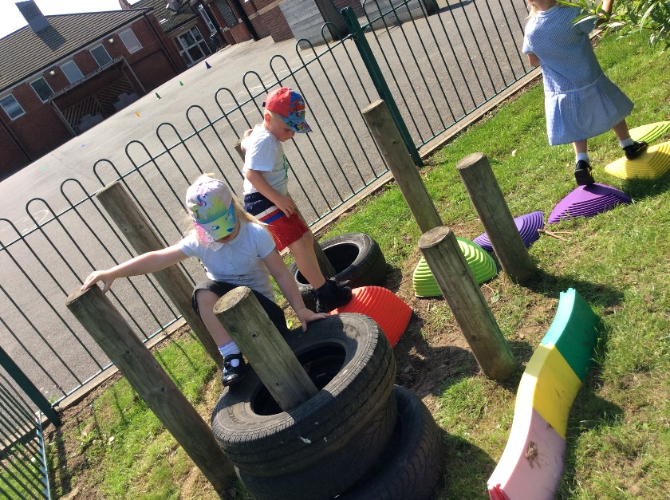
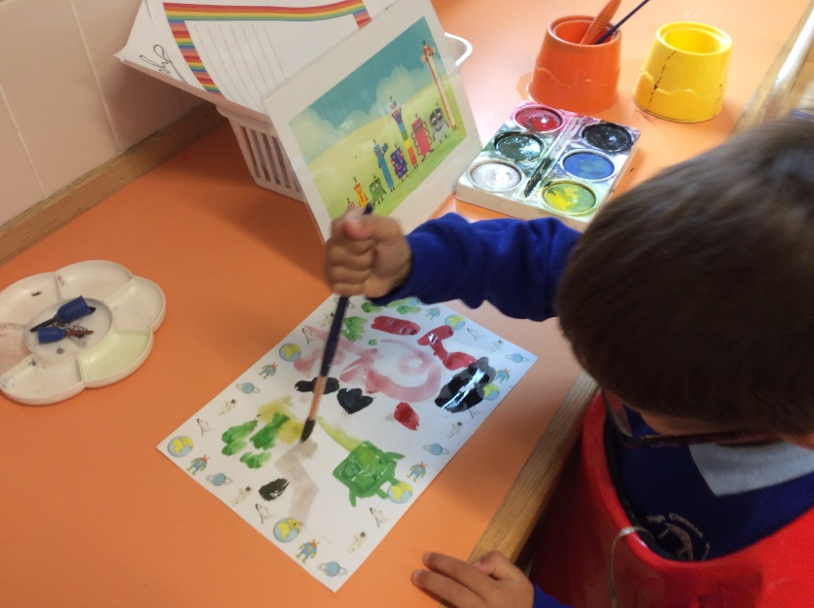

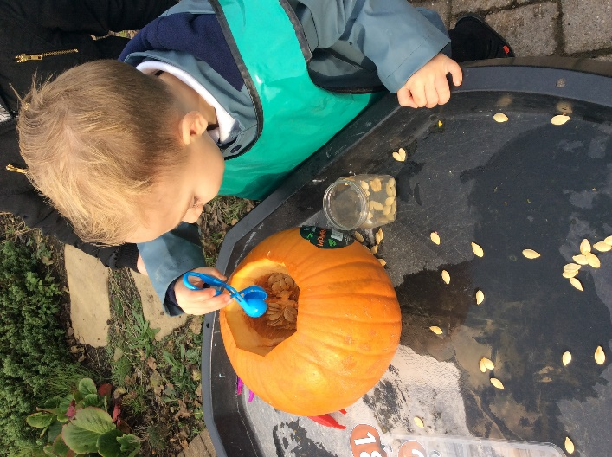

‘The first 5 years have so much to do with how the next 80 turn out’
Bill Gates
Understanding the World
Educational Programme
Understanding the world involves guiding children to make sense of their physical world and their community. The frequency and range of children’s personal experiences increases their knowledge and sense of the world around them – from visiting parks, libraries and museums to meeting important members of society such as police officers, nurses and firefighters. In addition, listening to a broad selection of stories, non-fiction, rhymes and poems will foster their understanding of our culturally, socially, technologically and ecologically diverse world. As well as building important knowledge, this extends their familiarity with words that support understanding across domains. Enriching and widening children’s vocabulary will support later reading comprehension.
Past and Present (History)
Early Learning Goal
- Talk about the lives of the people around them and their roles in society.
- Know some similarities and differences between things in the past and now, drawing on their experiences and what has been read in class.
- Understand the past through settings, characters and events encountered in books read in class and storytelling.
Knowledge and Skills development to reach Early Learning Goal
Nursery | Reception
History  - Talk about who they are and who they live with  - Talk about wider members of the family  - Notice similarities and differences between themselves and others in real life and fictional characters in stories  - Talk about experiences in their own lives from pictures and memory | - Talk about similarities and differences between jobs  - Identify different emergency situations and know what to do.  History  - Talk about past (within living memory) and present events in the lives of family members.  - Discuss similarities and differences between people in their family  - Compare and contrast characters from stories, including figures from the past.  - Compare and contrast historical figures and objects, discussing similarities and differences.
‘Curiosity is the wick in the candle of learning’
William Arthur Ward

People, Culture and Communities (RE/Geography)
Early Learning Goal
- Describe their immediate environment using knowledge from observation, discussion, stories, non-fiction texts and maps;
- Know some similarities and differences between different religious and cultural communities in this country, drawing on their experiences and what has been read in class;
- Explain some similarities and differences between life in this country and life in other countries, drawing on knowledge from stories, non-fiction texts and – when appropriate – maps.
Knowledge and Skills development to reach Early Learning Goal
Nursery | Reception
Geography  - Talk about and explore different houses; know the number of their own home  - Awareness that we live in England and that it is part of the world.  - Explore different countries through stories, songs and pictures  - Explore mapping, direction and positional language through physical skills and stories  RE/RSE/Celebrations  - Show an interest and talk about different familiar occupations (teacher, doctor, hairdresser)  - Talk about recent celebrations in their own life through pictures or from memory.  - Develop positive attitudes about the differences between people | Geography  - Identify and remember the name of their street and the number of their house.  - Know that we live in Port Clarence in England and show an awareness of other countries of the world  - Draw information from simple maps including immediate environment and from stories.  - Create simple maps including simple features of their environment or from stories.  - Talks about the features of their own immediate environment and how it may differ in other towns and countries around the world  RE/RSE/Celebrations  - Knows about similarities and differences between themselves and others, and among families, communities, cultures and traditions.  - Knows that other children do not always enjoy the same things, and is sensitive to this.  - Enjoys joining in with family customs and routines  - Begin to talk about different celebrations from around the world  - Talk about and explore special places (temple, church)

The Natural World (Science/Geography)
Early Learning Goal
- Explore the natural world around them, making observations and drawing pictures of animals and plants;
- Know some similarities and differences between the natural world around them and contrasting environments, drawing on their experiences and what has been read in class;
- Understand some important processes and changes in the natural world around them, including the seasons and changing states of matter.
Knowledge and Skills development to reach Early Learning Goal
Nursery | Reception
Geography  - Show respect and care for the environment around them  - Talk about their own environment at home and school  - Begin to understand the effect their behaviour can have on the environment (e.g. throwing litter)  Science  - Use their senses to explore  - Explore and talk about collections of objects and use widening vocabulary to describe what they see and feel.  - Show awareness of how to care for living things and how they change over time (e.g. planting seeds, hatching chicks)  - Explore how things work  - Talk about and observe changing states of matter (melting, freezing, cooling)  - Explore weather and the changing seasons; share stories and non-fiction books showing contrasting environments | Geography  - Recognise that some environments are different to Port Clarence; share stories and non-fiction books showing contrasting environments, discussing similarities and differences.  Science  - Use senses to describe what they see, hear, feel and smell using a widening range of vocabulary  - Explore the natural world around them through curiosity, observation and interaction  - Identify and name the four seasons and their associated weather patterns and key changing features  - Explore and experiment with and discuss changing states of matter (melting/cooling, floating/sinking)  - Identify the stages of some animal lifecycles (e.g. duck, butterfly) and of plants

Expressive Arts and Design
Educational Programme
The development of children’s artistic and cultural awareness supports their imagination and creativity. It is important that children have regular opportunities to engage with the arts, enabling them to explore and play with a wide range of media and materials. The quality and variety of what children see, hear and participate in is crucial for developing their understanding, self-expression, vocabulary and ability to communicate through the arts. The frequency, repetition and depth of their experiences are fundamental to their progress in interpreting and appreciating what they hear, respond to and observe.

Early Learning Goal (Creating with Materials) Art and Design/DT
- Safely use and explore a variety of materials, tools and techniques, experimenting with colour, design, texture, form and function;
- Share their creations, explaining the process they have used;
- Make use of props and materials when role playing characters in narratives and stories.
Early Learning Goal (Being Imaginative and Expressive) Music/Dance/Role Play
- Invent, adapt and recount narratives and stories with peers and their teacher;
- Sing a range of well-known nursery rhymes and songs;
- Perform songs, rhymes, poems and stories with others, and – when appropriate – try to move in time with music.
Knowledge and Skills development to reach Early Learning Goal
Nursery | Reception
Art and Design/ DT  - Name colours and use them for a purpose  - Explore the capacity of colour and colour mixing  - Use marks to create closed shapes and begin to represent objects.  - Explore the potential of different materials and develop ideas about what to make  - Use a variety of tools and media to make marks (e.g., sponges, stamps, chalks, pens)  - Explore and describe different textures  - Draw with increasing complexity, adding detail and features. | Art and Design/DT  - Explore a range of artistic effects (e.g. mix primary colours to create secondary colours, alter further by creating tints (white) and tones (black))  - Control and use finer materials to add detail (e.g. thin paintbrush, fine liner)  - Experiment by painting of different surfaces (e.g. fabric, stones)  - Draw with increasing detail and complexity (e.g. adding eyebrows or fingernails to a picture of a person)  - Make with a clear purpose and intention with the ability to describe the making process to others.  - Create collaboratively, sharing ideas, resources and skills

- Join materials using a variety of methods (e.g. glue sticks, glue spreaders, Sellotape)  - Creates art and give it a meaning.  Music  - Listen with increasing attention to sounds and music  - Begin to talk about how music makes them feel.  - Sing songs and rhymes from memory.  - Sing in a group and try to keep to the time/ pitch and melodic shape of the tune.  - Explore and name a range of percussion instruments and begin to play to a simple beat.  Dance  - Copy a basic action and begins to learn short dance routines.  - Moves independently to music, expressing their feelings through dance.  Imaginative Play  - Take part in simple pretend play pretending an object represents something else (e.g. using stones as play food)  - Begin to develop ‘stories’ based around small world play, based on own experiences, familiar stories or own imagination.  - Create own small world play using bricks to create a zoo or Lego to make a house | - Return to work to edit, adapt and improve  - Join materials in a variety of ways (e.g. masking tape, string, split pins)  - Create models and objects with increasing realism using a variety of media (e.g. clay, junk modelling, plasticine)  Use developing vocabulary to describe the feel and texture of materials (e.g. rough, flexible)  Music  - Listen attentively to a range of musical genres, talk about what they have heard, expressing feelings.  - Sing songs and rhymes from memory  - Sing in a group and by themselves, matching pitch, tempo and following melody of the tune.  - Select an instrument and play appropriately, keeping in time to the music or beat and changing the dynamics or tempo whilst playing.  Dance  - Learn some dance routines, matching pace with others.  - Move to music with more rhythm  - Explore and engage in music making and dance, performing solo or in groups  Imaginative Play  - Adapt and use familiar narratives and experiences to develop storylines  - Use or make props to support role-play  - Enhance and add to small world play (e.g. add blue fabric to make water)
‘Art is too important not to share.’ Romero Britto

