

Financial Information

School Budget 2021/22

Outturn Plan 2020/21

Annual Private Fund Statement 2020/21

School Budget 2021/22
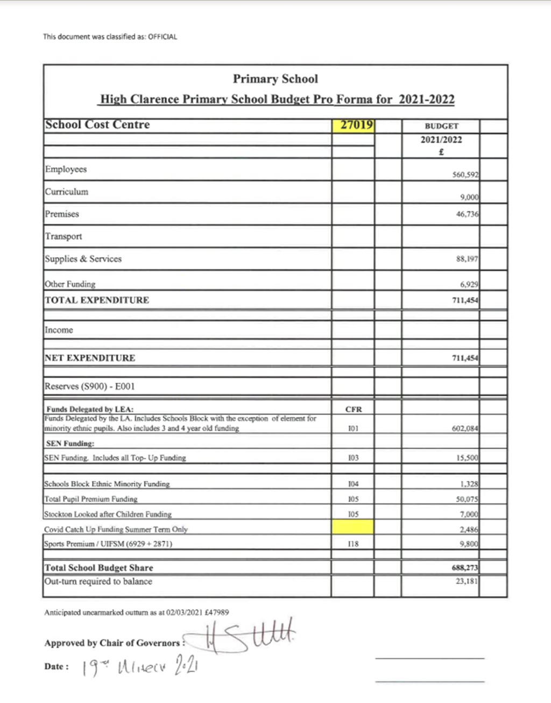

Outturn Plan 2020/21
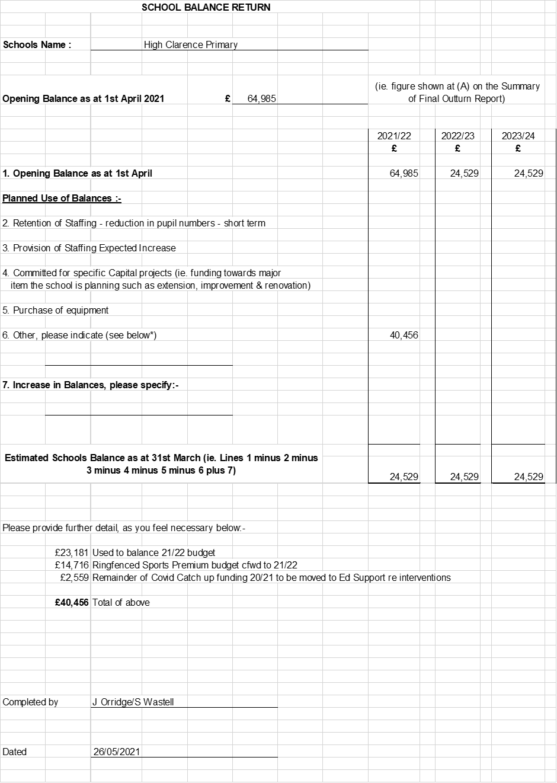

Annual Private Fund Statement 2020/21

