

Financial Information

School Budget 2022/23

Outturn Plan 2021/22

Annual Private Fund Statement 2021/22

School Budget 2022/23

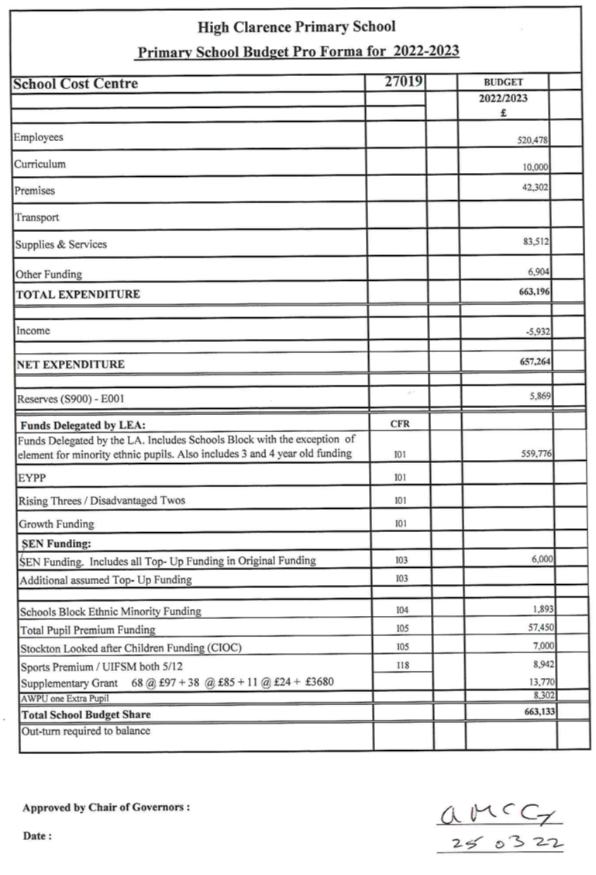

Outturn Plan 2021/22

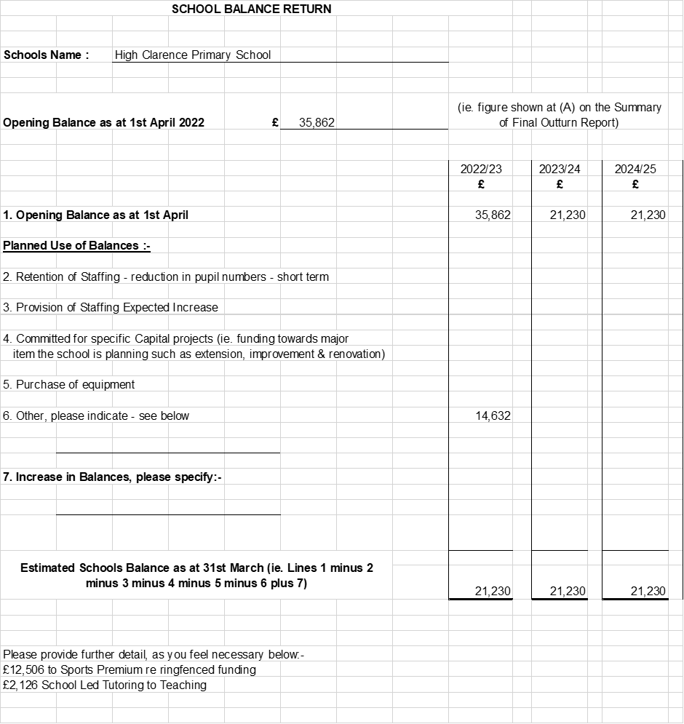

Annual Private Fund Statement 2021/22

