23rd January 2025

Dear Parents/Carers

**Punctuality**

Punctuality has improved slightly but there is still a large group of children who are frequently late for school. As you can see from the chart below being just 3 minutes late everyday is the same as being absent for 3 days.

In KS1 and KS2 maths is the first lesson and some children are frequently 10-15 minutes late which is 10 days. That is a lot of lost learning especially in the same subject.

We would like to remind everyone that every child needs to be in school by 8.45am. Please could you support us by getting your children to school on time, thank you.

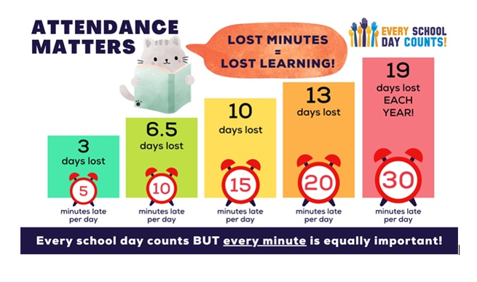

N Caraher

Principal

PTO

**Dates for your Diary**

|  |  |
| --- | --- |
| **Date** | **Event** |
| Monday, 27th January – Friday, 31st January | 8 KS2 children staying at Derwent Hill for 5 days Residential Visit |
| Wednesday, 29th January | Chinese New Year themed lunch |
| Friday, 14th February | Valentines Day themed lunch |
| Friday, 21st February | Last day in school before half term |
| Monday, 3rd March | PD Day |
| Tuesday, 4th March | School re-opens |
| Thursday, 6th March | World Book Day |
| Wednesday, 2nd April – Friday, 4th April | Class 3 children staying in Whitby for 3 days Residential Visit |
| Friday, 11th April | Last day in school before Easter holidays |
| Monday, 28th April | School re-opens |
| Monday, 5th May | Bank holiday |
| Friday, 23rd May | Last day in school before 2 week half term |
| Monday, 9th June | School re-opens |
| Friday, 25th July | Last day in school before Summer holidays |
| Monday, 28th July | PD Day |
| Tuesday, 29th July | School closed for Summer holidays |