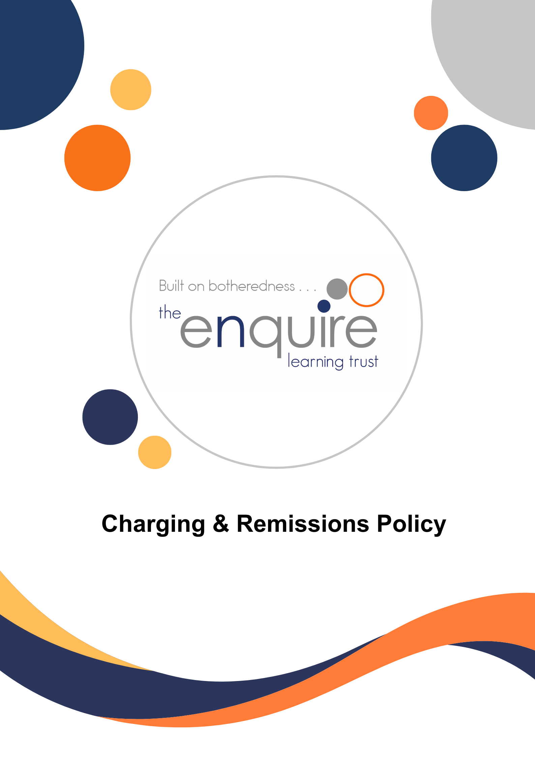

Contents

Section | Title | Page
1 | Aims | 3
2 | Legislation and guidance | 3
3 | Definitions | 3
4 | Roles and responsibilities | 3
5 | Where charges cannot be made | 4
6 | Where charges can be made | 5
7 | Voluntary contributions | 6
8 | Activities we charge for | 6
9 | Remissions | 6
10 | Monitoring arrangements | 7

Version History

Approved by: | Trustees
Last reviewed: | September 2023
Next review due by: | September 2026

Date | Author | Version | Comment
Sept 2023 |  | 1 | New Policy / format

1. Aims
Our school aims to:
- Have robust, clear processes in place for charging and remissions
- Clearly set out the types of activity that can be charged for and when charges will and will not be made
- Offer a range of activities and visits whilst minimising the financial barriers that may prevent some pupils from taking full advantage of these opportunities

2. Legislation and guidance
This policy is based on advice from the Department for Education (DfE) on charging for school activities and the Education Act 1996, sections 449 to 462 of which set out the law on charging for school activities in England. Academies are required to comply with this Act through their funding agreements.
It’s also based on guidance from the DfE on statutory policies for schools and academy trusts.

3. Definitions
- Charge: a fee payable for specifically defined activities
- Remission: the cancellation of a charge which would normally be payable

4. Roles and responsibilities
4.1 The Principal
The Principal has overall responsibility for approving the charging and remissions policy.
The Principal and Academy Business manager also has overall responsibility for monitoring the implementation of this policy.
4.2 Staff
Staff are responsible for:
- Implementing the charging and remissions policy consistently
- Notifying the headteacher of any specific circumstances which they are unsure about or where they are not certain if the policy applies
The school will provide staff with appropriate training in relation to this policy and its implementation.
4.3 Parents
Parents are expected to notify staff or the headteacher of any concerns or queries regarding the charging and remissions policy.

5. Where charges cannot be made
Below we set out what we cannot charge for:
5.1 Education
- Admission applications
- Education provided during school hours (including the supply of any materials, books, instruments or other equipment)
- Education provided outside school hours if it is part of:
- The National Curriculum
- A syllabus for a prescribed public examination that the pupil is being prepared for at the school
- Religious education
- Instrumental or vocal tuition, for pupils learning individually or in groups, unless the tuition is provided at the request of the pupil’s parent
- Entry for a prescribed public examination if the pupil has been prepared for it at the school
- Examination re-sit(s) if the pupil is being prepared for the re-sit(s) at the school
5.2 Transport
- Transporting registered pupils to or from the school premises, where the local authority has a statutory obligation to provide transport
- Transporting registered pupils to other premises where the governing board or local authority has arranged for pupils to be educated
- Transport that enables a pupil to meet an examination requirement when he or she has been prepared for that examination at the school
- Transport provided in connection with an educational visit
5.3 Residential visits
- Education provided on any visit that takes place during school hours
- Education provided on any visit that takes place outside school hours if it is part of:
- The National Curriculum
- A syllabus for a prescribed public examination that the pupil is being prepared for at the school
- Religious education
- Supply teachers, covering for teachers who are absent from school, accompanying pupils on a residential visit

6. Where charges can be made
Below we set out what we can charge for:
6.1 Education
- Any materials, books, instruments or equipment, where the child’s parent wishes him or her to own them
- Optional extras (see section 6.2)
- Music and vocal tuition, in limited circumstances (see section 6.3)
- Certain early years provision
- Community facilities
- Examination re-sit(s) if the pupil is being prepared for the re-sit(s) at the school and the pupil fails, without good reason, to meet any examination requirement for a syllabus
6.2 Optional extras
We are able to charge for activities known as ‘optional extras’. In these cases, schools can charge for providing materials, books, instruments or equipment. The following are optional extras:
- Education provided outside of school time that is not part of:
- The National Curriculum
- A syllabus for a prescribed public examination that the pupil is being prepared for at the school
- Religious education
- Examination entry fee(s) if the registered pupil has not been prepared for the examination(s) at the school
- Transport (other than transport that is required to take the pupil to school or to other premises where the local authority or governing board has arranged for the pupil to be provided with education)
- Board and lodging for a pupil on a residential visit
- Extended day services offered to pupils (such as breakfast clubs, after-school clubs, tea and supervised homework sessions)
When calculating the cost of optional extras, an amount may be included in relation to:
- Any materials, books, instruments or equipment provided in connection with the optional extra
- The cost of buildings and accommodation
- Non-teaching staff
- Teaching staff engaged under contracts for services purely to provide an optional extra (including supply teachers engaged specifically to provide the optional extra)
- The cost, or an appropriate proportion of the costs, for teaching staff employed to provide tuition in playing a musical instrument, or vocal tuition, where the tuition is an optional extra
Any charge made in respect of individual pupils will not be greater than the actual cost of providing the optional extra activity, divided equally by the number of pupils participating.
Any charge will not include an element of subsidy for any other pupils who wish to take part in the activity but whose parents are unwilling or unable to pay the full charge.
In cases where a small proportion of the activity takes place during school hours, the charge cannot include the cost of alternative provision for those pupils who do not wish to participate.
Parental agreement is necessary for the provision of an optional extra which is to be charged for.

6.3 Music tuition
Schools can charge for vocal or instrumental tuition provided either individually or to groups of pupils, provided that the tuition is provided at the request of the pupil’s parent.
Charges may not exceed the cost of the provision, including the cost of the staff giving the tuition.
Charges cannot be made:
- If the teaching is an essential part of the National Curriculum
- If the teaching is provided under the first access to the Key Stage 2 instrumental and vocal tuition programme
- For a pupil who is looked after by a local authority

6.4 Residential visits
We can charge for board and lodging on residential visits, but the charge must not exceed the actual cost.

7. Voluntary contributions
As an exception to the requirements set out in section 5 of this policy, the school is able to ask for voluntary contributions from parents to fund activities which would not otherwise be possible.
Some activities for which the school may ask parents for voluntary contributions may include: school trips, sports activities.
There is no obligation for parents to make any contribution, and no child will be excluded from an activity if their parents are unwilling or unable to pay.
If the school is unable to raise enough funds for an activity or visit then it will be cancelled.

8. Activities we charge for
The school will charge for the following activities:
Wrap around care – this is to cover the cost of staffing and resources (including breakfast and a snack)
For regular activities, the charges for each activity will be determined by the governing board and reviewed in July each year. Parents will be informed of the charges for the coming year in July each year.

9. Remissions
In some circumstances, the school may not charge for items or activities set out in sections 6 and 8 of this policy. This will be at the discretion of the Principal and will depend on the activity in question.
9.1 Remissions for residential visits
Parents who can prove they are in receipt of any of the following benefits will be exempt from paying the cost of board and lodging for residential visits:
- Income Support
- Income-based Jobseeker’s Allowance
- Income-related Employment and Support Allowance
- Support under part VI of the Immigration and Asylum Act 1999
- The guaranteed element of Pension Credit
- Child Tax Credit – provided you’re not also entitled to Working Tax Credit and have an annual gross income of no more than £16,190
- Working Tax Credit run-on – paid for 4 weeks after you stop qualifying for Working Tax Credit
- Universal Credit – if you apply on or after 1 April 2018, your household income must be less than £7,400 a year (after tax and not including any benefits you get)

10. Monitoring arrangements
The ABM monitors charges and remissions, and ensures these comply with this policy.
This policy will be reviewed by the Principal annually.

