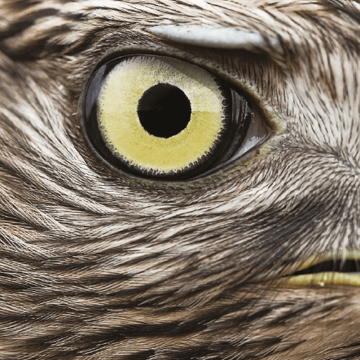
Class 3 Homework Autumn 2 - Predator!
This half term has a Science focus
The activities below are optional, each one you complete you will earn a raffle ticket which will be put into a raffle to win a prize.
Maths | English | Topic
Pinpoint Maths to practise times tables– https://www.themathsfactor.com/times-tables-check/pinpoint/#/menu  link can be found on Seesaw  Y3 – 4 X Tables/ 8 X Table(Revise 3, 2, 5, 10)  Y4 – 6x, 4x, 8x (Revise 3x) | Complete any of the activities from Predator! home learning booklet.  Two of my favourites are below: | I am a Predator!  If you could be a predator for the day, what kind of predator would you be, and why? Where would you live? What features would help you hunt, catch and kill your prey? Record your ideas on paper and bring them in to share with the class. You could even make your predator using any materials of your choice!
Log onto Times Table Rockstars to practise your times tables.  Practise your tables on Hit the Button so you can move up the Scoreboard! | A kenning is a type of poem that can describe people, animals and objects. A kenning consists of a list of compound nouns. Compound nouns are nouns made up of two or more separate words put together. Write a kenning poem about a predator that you find interesting. Plan your poem first by listing compound nouns that describe your chosen predator. Choose your favourite and most appropriate compound nouns and use them to write your kenning. Illustrate your kenning and bring to school to share with the class. | What am I?  Devise a ‘What am I?’ quiz about predators and try it out on your friends and family. How many questions does it take for them to get to the right answer?
Wildcard | Make a non-fiction book about a predatory animal – maybe your pet cat? | Design a Predator!  Can you design and make the ultimate predator? It may be the best bits of different predators or your very own invention. You can use any materials to make it – natural, junk, food, lego. Where does your predator live? What features help it survive? Who are its prey?
You need to complete a Times Table Me sheet and spelling activities each week.
The wildcard is a new idea where the children can choose their own piece of homework that they would like to do. This is to encourage children to do some homework about their hobbies or places they have recently been. Choice is up to the children! (It could be making, writing, drawing, cooking etc)
UPLOAD HOMEWORK TO

