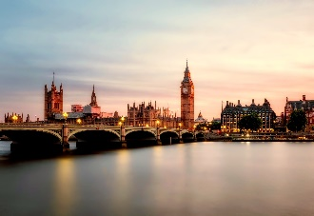
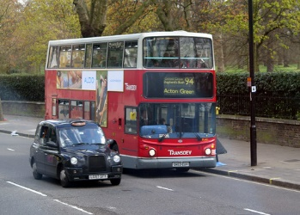
Class 2 Homework Autumn 2 – Bright Lights, Big City
You need to complete at least ONE each week.
This half term has a Geography focus
Maths | English | Topic
Create a 2-D city shape picture. Can you label the shape names? What are the properties of the shapes in your picture? | Visit your local library or search the web with an adult to find out about different cities in the world. Create a scrapbook of your favourite cities and include pictures, labels and captions. Can you find and record a short fact about each city? | Make a cityscape artwork and take it into school to share with the class.
Log onto Numbots and see how many levels you can complete. Logins are in the Homework Folders. | Wildcard | Create and label a picture or map of a fantasy city. What type of buildings would be in your city and what would they look like? What transport would people use in this city?
Wildcard | Research about our new king, HRH King Charles III. Can you write a fact file about him and include some pictures with captions? | Can you build a London landmark with junk modelling? Try to include as much detail as possible.
Draw a map of a city and direct a toy car or figure using words such as forwards,  backwards, straight ahead, left, right, up, down, under and over. You can use numbers too if you like. | Log onto Spelling Frame using your Online Passport, practise using the games and take the test. | Wildcard
Weekly Spellings are sent home for the children to practise for a spelling test the following week.
Maths worksheets will be sent in the Homework Folder each week.
The wildcard is where the children can choose their own piece of homework that they would like to do. This is to encourage children to do some homework about their hobbies or places they have recently been. Choice is up to the children! (It could be making, writing, drawing, cooking etc)
If you require any resources to help you complete please come to see me or send a message through Seesaw and I will be happy to help!

