

**Financial Information**

**School Budget 2021/22**

**Outturn Plan 2020/21**

**Annual Private Fund Statement 2020/21**

**School Budget 2021/22**

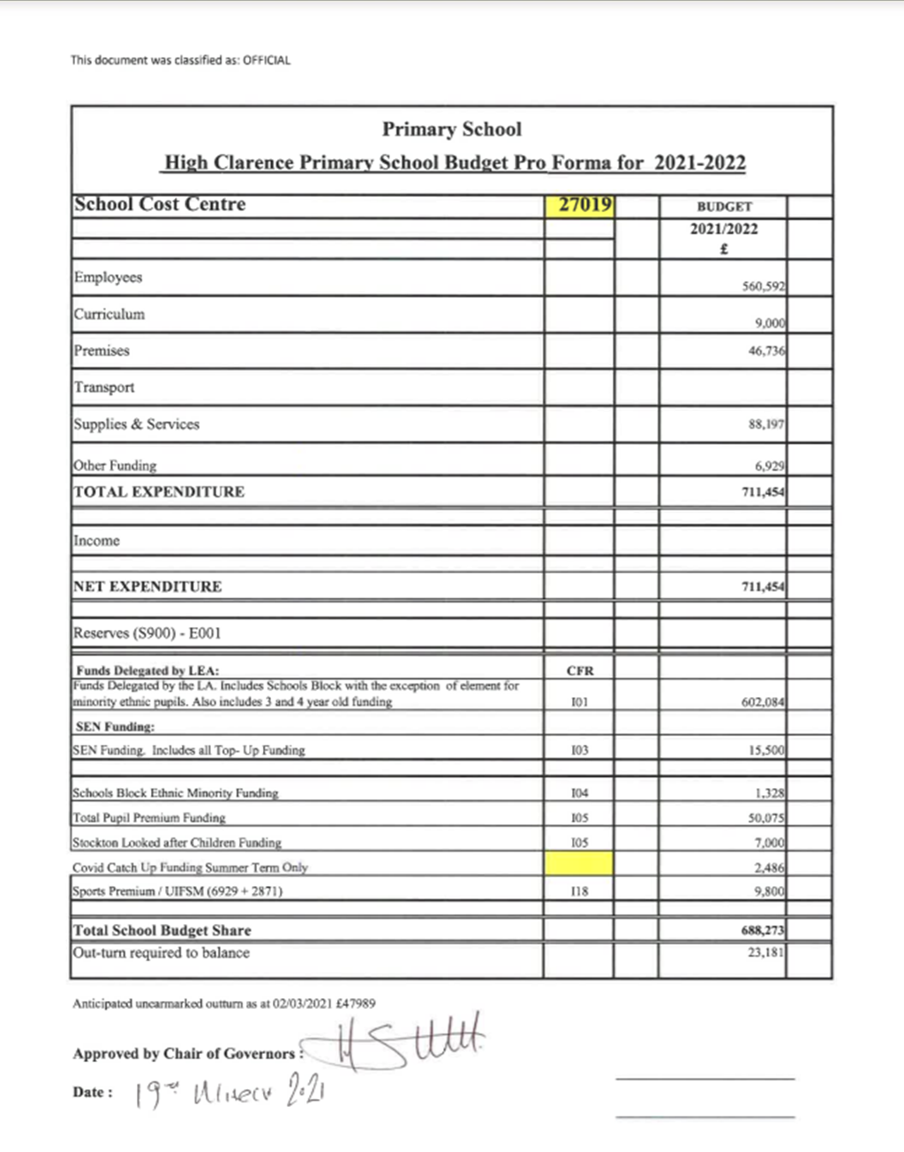

**Outturn Plan 2020/21**

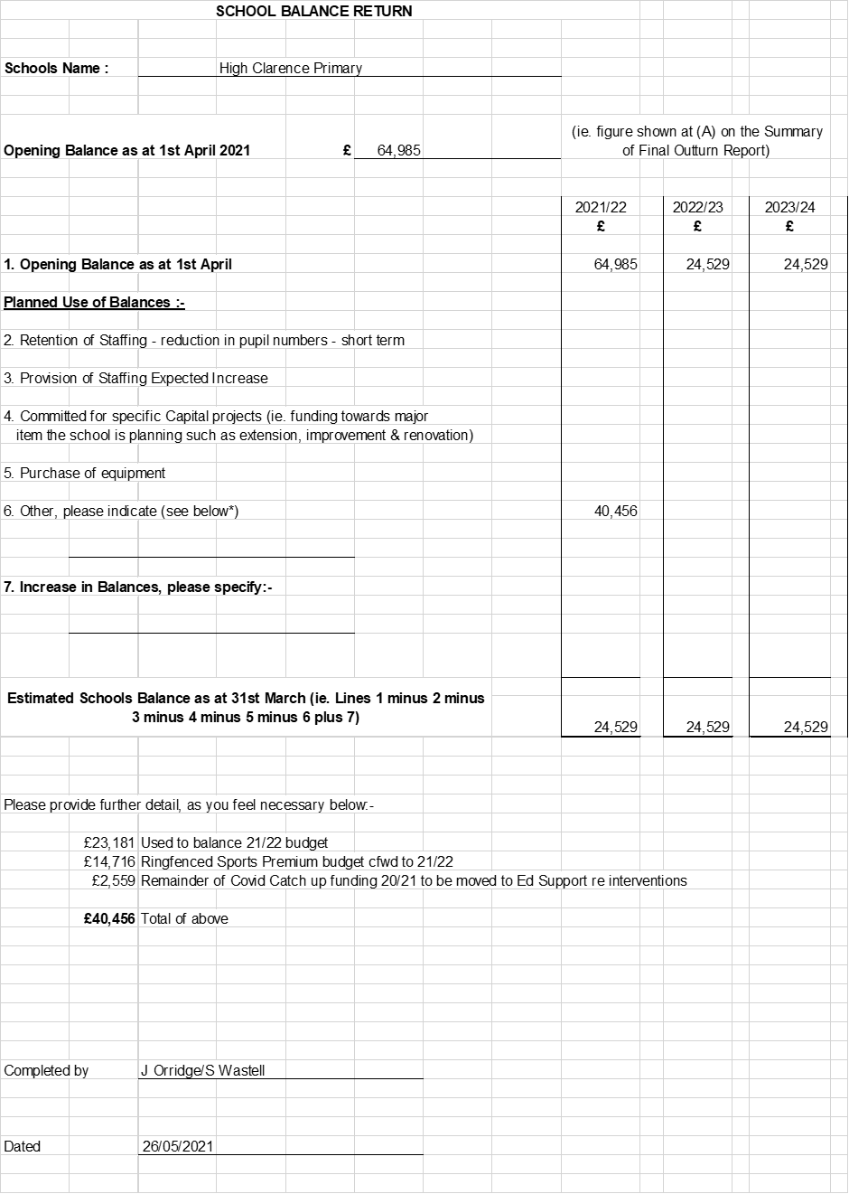

**Annual Private Fund Statement 2020/21**

