

**Financial Information**

**School Budget 2022/23**

**Outturn Plan 2021/22**

**Annual Private Fund Statement 2021/22**

**School Budget 2022/23**

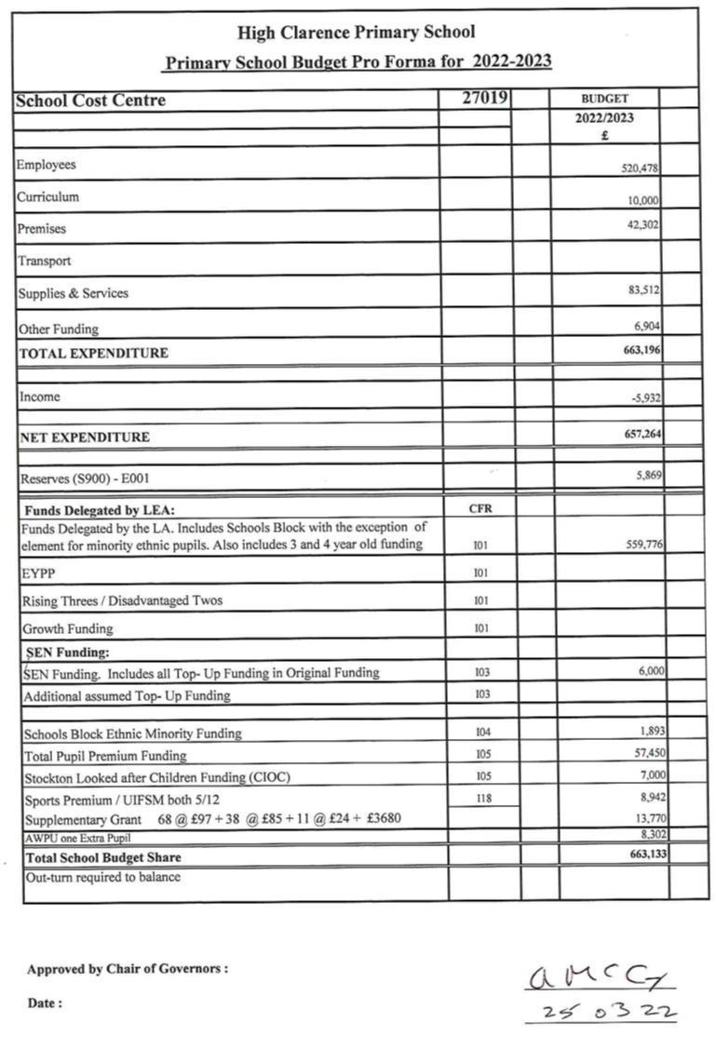

**Outturn Plan 2021/22**

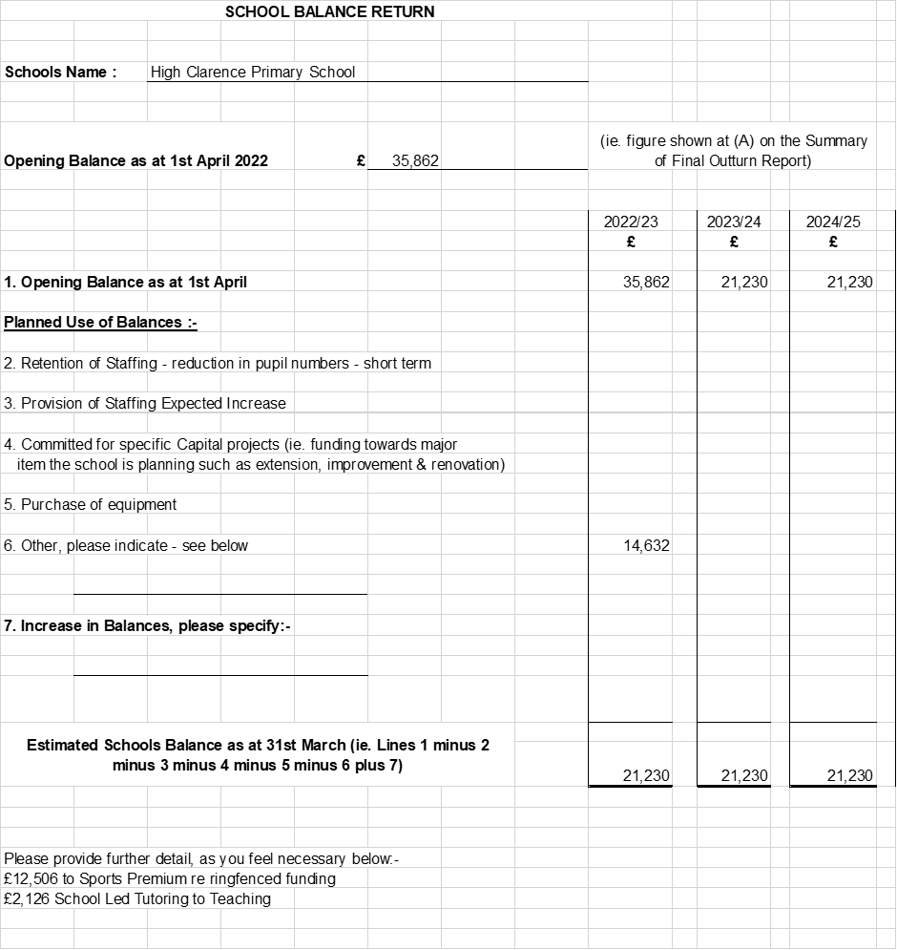

**Annual Private Fund Statement 2021/22**

