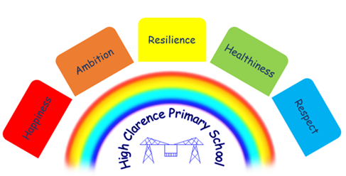

19th May 2023

Dear Parents/Carers

Tests and Assessments
The year 6 children took part in their SATs tests last week and showed an excellent attitude and commitment all week. They finished the week off with a treat at Jump 360 on the Friday afternoon!!

Year 2 children will be assessed for the KS1 SATs between the dates of 22nd May and 26th May 2023.
Year 4 children will take part in the Multiplication Tables check between the dates of 5th June and 23rd June.
Year 1 children will be taking part in their Phonics test on 14th and 15th June 2023.

All other children in school will be assessed this term.

Coffee Morning/Jumble Sale
At our coffee morning next Thursday, 25th May there will be a jumble sale. All proceeds from this will go towards the school trips that the children take part in over the school year. It will be lovely to see you all there! Alternatively if you cannot make it you can send a little bit of money in with your child to go to the jumble sale on the day. Thank you.

Half term holiday
The last day in school this half term is Friday, 26th May 2023. School is closed for a week and will re-open on Monday, 5th June 2023.

School Meals
We have been advised from Stockton Council that the school meals charge will be increasing to £2.50 per day from Monday, 5th June 2023. This equates to £12.50 per week.

Sports Day
Sports Day will be held on 20th June 2023 at 1.30 p.m. on the school field, weather permitting. Everyone is welcome to come along to support the children. Don’t forget to bring along your running shoes for the adult races!!!

Leavers Service
The year 6 Leavers service will be held on Friday, 7th July 2023 at 1.30 p.m. in the school hall. All parents/carers are welcome to come along to celebrate and remember their time here before they move onto their Secondary schools.

N Caraher
Headteacher

PTO for dates

Dates for your Diary
Date | Event
Monday, 22nd May | KS1 SATs assessments take place all week
Thursday, 25th May | Coffee morning/Jumble Sale in school hall from 8.45 a.m.
Friday, 26th May | Last day in school before we break up for half term.
Monday, 5th June | School re-opens
Thursday, 8th June | Coffee morning in school hall 8.45 a.m. – 10.45 a.m. (every Thursday morning)
Wednesday, 14th June | Jewellery making course starts 1- 3 p.m.
Wednesday, 14th June | Y1 Phonics tests take place today and tomorrow
Thursday, 15th June | Crafts course starts 9.30 – 11.30 a.m.
Tuesday, 20th June | Sports Day 1.30 p.m. school field
Friday, 7th July | Leavers Service 1.30 p.m. school hall
Thursday, 20th July | School closed for PD day
Friday, 21st July | Summer holidays begin
Monday, 4th September | School closed for PD day
Tuesday, 5th September | School re-opens

