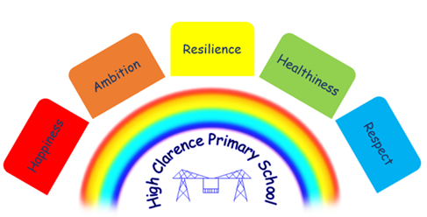

6th December 2022

Dear Parents/Carers

Jumble Sale
Thank you for all your support at the jumble sale last week we raised the grand total of £300!! This money will go towards the cost of the Christmas pantomime on 20th December 2022.

Christmas Jumper day
A parent has advised us that Christmas Jumper day is Thursday, 8th December and not the 9th as we previously informed you. We apologise for this and hope that your child will be able to come to school in Christmas jumpers, non-uniform or wearing Christmas accessories on Thursday!

Christmas Raffle
Everyone is welcome to come along to the special Christmas Raffle on Monday, 12th December. Refreshments will be available and raffle tickets are currently on sale for £1 a strip.
It will take place in the school hall and doors will open from 8.45 a.m. The raffle will be drawn at 9.30 a.m. and the children will be performing a Carol Concert for you all from 10 a.m.
We hope as many people as possible will attend as it will be a lovely start to the Christmas Celebrations in school!

50p a go!!
From tomorrow we will have 4 guessing games running in school. Whoever guesses correctly will win the prize! Children can bring money into school and have a go!! Winners will be announced at the Christmas raffle.
- Guess the name of the unicorn to win a very large rainbow unicorn
- Guess the name of the baby doll to win a doll
- Guess the football team to win a world cup football
- Guess how many slam dunks Mrs Wastell can shoot out of 26 balls to win a Dunk 4 game

All proceeds will go towards trips and Christmas parties for the children.

Guidance on the outbreak of Scarlet Fever
We would like to re-assure parents/carers that school has put measures in place to reduce the risk of the spread of Scarlet Fever.
- Increased hand washing
- Use of hand sanitiser
- Daily deep clean of all surfaces including taps, handles, table tops, chairs etc.
- If any symptoms are noticed in school, parents/carers will be contacted immediately

If you have any concerns about your child’s health please ring 111. Symptoms to look out for are shown overleaf.

N Caraher
Headteacher

Dates for your Diary – changes shown in red

Date | Event
Thursday, 8th December | Community Coffee morning/raffle 8.45 – 10.45 a.m.  Christmas jumper day – children jumpers or accessories can be worn
Monday, 12th December | Christmas coffee morning/raffle and Carol concert in the school hall  Everyone welcome from 8.45 a.m. onwards. Children will start to sing at 10 a.m.  EY Crafty Christmas -11 a.m.  Class 2 Christmas party p.m.
Tuesday, 13th December | School Christmas dinner - children can wear Christmas jumpers or accessories.
Thursday, 15th December | Early Years Christmas party a.m.
Friday, 16th December | Whole school Christmas concert – School hall 1.30 p.m. Everyone welcome.
Monday, 19th December | Classes 3 and 4 Christmas party p.m.
Tuesday, 20th December | Santa visits school a.m.  Non-uniform/Christmas jumper day  Theatre visit to see Beauty and the Beast for children in years Reception to Year 6.  Break up for Christmas holidays
Wednesday, 4th January | School closed for PD day
Thursday, 5th January | School re-opens

