9th January 2023

Dear Parents/Carers

Welcome back to school after the Christmas break. It was lovely to see all the children returning last week, they all looked very smart and happy! We nearly had 100% attendance for the Thursday and Friday which was a really positive start to the New Year.
Please ensure that your child gets the best possible start to the day by arriving on time. Our school day starts at 8.45 a.m. and the main gates open a few before minutes before this.

One of the most important things affecting a child’s progress at school is regular attendance. For a child to gain most benefit from education, it is vital that parents work in partnership with the school to encourage good attendance and punctuality.
Good punctuality at school is essential for children to achieve their full educational potential. It is also vital for children to form good habits for later life. Therefore, it is really important that your child arrives at school on time. As the table below shows every minute at school counts and we don’t want any child to miss out.

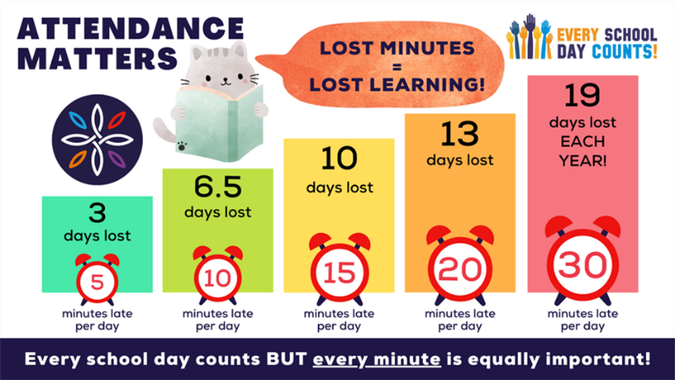

Christmas Raffle
We had a fantastic turnout to the Christmas Raffle/Coffee morning on Monday, 12th December 2022, thank you so much for your support. The children enjoyed singing to all who attended and we think you will agree they did a fantastic job!
From all of the fund raising – Jumble Sale, 50p a go, Secret Auction and the Raffle - we raised the grand total of £912 which is our highest ever total!!

Christmas Pantomime
Money raised from the above events went towards paying for the Christmas Pantomime on the last day of term. All the children really enjoyed this experience and were excellently behaved! We hope to do this again this year.

After School Clubs
If your child attends any After School Clubs, they will recommence this week. Days and times are:
Gymnastics Club – Monday, finish at 3.45 p.m.
Football Club – Tuesday, finish at 4.15 p.m.

Ofsted
We have now received the final report from OFSTED following our inspection on 16th and 17th November 2022.
I would like to thank the children, parents and staff for their continued efforts to improve the school. Although we are disappointed the school hasn’t reached a ‘Good’ overall rating and remains at ‘Requires Improvement’, we believe the school has undergone huge improvements since our last inspection and we’re confident we are moving in the right direction.
The inspectors found many positives within the school:
‘The Headteacher, along with other leaders, has made a positive start in strengthening the school’
‘Pupils, including children in the Early Years, enjoy a range of exciting activities to enrich their learning.’
‘Children get off to a strong start in early years. Adults are both caring and supportive.’
‘Pupils’ behaviour is a strength of the school. They are focused on learning and are fully engaged in their lessons.’
Inspectors identified a few areas for improvement:
- ‘The phonics scheme is extremely new. Some staff do not have the expertise’, leaders had recognised this and had planned training which was delivered at the earliest possible date available 4.1.22.
- ‘Leaders have developed an ambitious and well sequenced curriculum’ however we need to ensure ‘that activities in lessons are clearly focused on what staff want pupils to learn and remember’. We have recently introduced new ‘take aways’ which are key pieces of knowledge the children need to remember, we are embedding this to ensure children can retrieve learning.
- ‘The PHSE curriculum is new’ but greater focus on a deeper understanding of cultural differences and British values is needed. Changes to the PHSE has already started to ensure British values and protected characteristic are more explicit.
- ‘Leaders need to monitor the quality of education more rigorously’ to ensure that children are remembering their learning across the curriculum. Staff have started to tweak their lessons to follow a similar format to maths, as maths was a strength of the school. All maths lessons start off with retrieval practice.
I am new to the headteacher post myself and would of course preferred the inspection to occur once some of the changes I have implemented had begun to make more of an impact.
For all that, I was pleased to read that I have an ‘accurate view of the school’s priorities’, I am committed to leading High Clarence Primary School to a rating of good. We will continue to work and embed the improvements we have put in place.
A full copy of the report is available to read on our school website and will be published on the OFSTED website on Monday 16th January.
If you wish to discuss the report or have any questions, please do not hesitate to contact me.

Uniform/PE Reminder
Please could you ensure that your child wears a school sweatshirt/royal blue sweatshirt over the top of their sports shirt on the days they have PE.
PE days are as follows:
Early Years Tuesday
Class 2 Wednesday and Thursday
Class 3 Monday and Friday
Class 4 Monday and Friday

If a child does not come to school wearing a royal blue or school sweatshirt they will be offered one to wear for the day from our pre-loved uniform.
Could they also wear dark leggings or tracksuit bottoms, brightly coloured leggings/tracksuits are not acceptable.

We would just like to remind everyone that our school uniform consists of:

- White or light blue collared polo shirt (with or without school logo) – Required
- Royal Blue sweatshirt/cardigan ( with or without school logo) - Required
- Grey/Black trousers/leggings/skirt/culottes/shorts/pinafore dress - Required
- Light blue and white checked dress for summer if desired - Optional
- Sensible school shoes/trainers or boots in winter - Required

If parents wish to purchase sweatshirts/cardigans or polo shirts with the school logo on these can be ordered from the school office. Alternatively supermarket non-branded clothing can be worn in the school colours.

School also has a ‘pre-loved’ uniform section which is readily available for any parent to access for no charge.

Coffee Morning/Stay and Play
Coffee morning will be starting again this week. It will run every Thursday morning from 8.45 – 10.45 a.m.
Everyone is welcome to come along and we would love to encourage parents who have younger pre-school children to ‘Stay and Play’.
There are toys for toddlers/babies to play with and it is an ideal environment to chat, access a lovely warm, friendly environment and have refreshments free of charge.
A free raffle ticket is given per person on arrival and a prize is won every week. A range of services have been coming along to give advice about housing, energy bills, health etc. which has proved to be very successful.

Generic consent form
A generic consent form for school trips and other offsite activities is being sent home with your child today. This form gives permission for them to take part in school trips and replaces the need for individual letters of consent. School will send you information about each trip or activity before it takes place.
Please could you ensure that this form is completed, signed and returned to school as soon as possible.

RSPB Saltholme Community Writing Project
As you are aware we have been taking part in an exciting new writing project in collaboration with RSPB Saltholme and local poet Bob Beagrie. The project continues to take place across this school year and a different class is involved each half term.
This half term has been set aside for you, the local community, to take part in the workshops at RSPB, Saltholme (free transport provided) commencing this Thursday, 12th January from 1 – 3 p.m. For this first workshop you will meet in school and take part in a short walk as an introduction to the project. Please let school know if you would like to take part.
At the end of the year, the school will come together with Saltholme and the local community to celebrate the children’s and the adults work.

N Caraher
Headteacher

Dates for your Diary

Date | Event
Thursday, 12th January and every Thursday thereafter | Coffee morning/Stay and Play in the school hall  Everyone welcome from 8.45 a.m. onwards.
Thursday, 12th January | Enquire Learning Trust Consultation Meeting 2 p.m.
Monday, 30th January | Year 5 Residential Week at Derwent Hill. Monday - Friday
Friday, 17th February | Break up for February half term
Monday, 27th February | School re-opens
Friday, 31st March | Break up for Easter holidays
Monday, 17th April | School re-opens
Monday, 1st May | May Bank holiday
Monday, 8th May | King Charles III Coronation
Friday, 26th May | Break up for half term
Monday, 5th June | School re-opens
Wednesday, 20th July | School closed for PD day
Thursday, 21st July | Summer holidays commence

