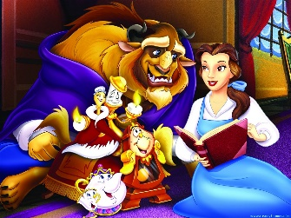

Beauty and the beast

7th December 2022

Dear Parents,

As a special Christmas treat for the children from Reception through to Year 6 we are going to see a live theatre performance of ‘Beauty and the Beast’ at Princess Alexandra Auditorium, Yarm on the afternoon of Tuesday, 20th December 2022.

We will be leaving school at 12 noon after an early lunch and returning at approximately 3.45 p.m. We will be travelling by coach and the children will be accompanied by the teaching and support staff in school.

The children can come to school in non-uniform/Christmas jumpers and can bring snacks and drinks with them for during the performance. Please note that drinks should be in cartons or plastic containers only – no glass bottles or cans.

The cost of this trip is £1,107 however there will be no charge to yourselves as we aim to pay for this from funds raised from jumble sales, raffles etc.

If you would like your child to go to see this performance please complete the slip below and return it to school as soon as possible.

N Caraher
Headteacher
……………………………………………………………………………………………………………………………………………………………………………

I hereby give permission for my child……………………………………………… class …………… to go to see ‘Beauty and the Beast’ at Princess Alexandra Auditorium, Yarm on Tuesday 20th December 2022.

Signed…………………………………………………………………………….Parent/Guardian

My child has a medical condition Yes/No (If yes please give details below)

Emergency contact number……………………………………………………………..
