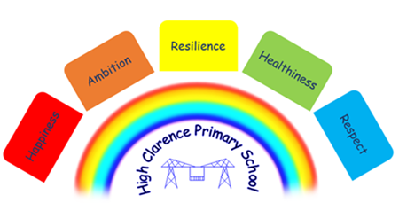

6th January 2023

Dear Parents and Carers,

The Governors of High Clarence Primary School have decided to seek the permission of the DfE to convert to academy status and join the Enquire Learning Trust. We’re hopeful that this exciting change will take place on September 1st 2023.

We took this decision to secure and sustain high quality education for the Clarences into the future. Specifically, our partnership with the Trust will:

- Provide us with high quality professional support so that we can enhance the curriculum and further develop teaching at High Clarence,
- Create opportunities for additional capital investment in the school to enhance learning environments and facilities,
- Enable the school to work with a broad and nationwide network of likeminded schools,
- Add to our expertise to meet the needs of all pupils,
- Protect our status as a school that is committed to working with parents and carers and maintain our position at the heart of the Clarence’s community.

The Enquire Learning Trust is a large and successful MAT serving communities across the north of England. The Trust has a focus on, and specialism in, the provision of high-quality primary education. All pupils within the Trust attend a school that is judged by Ofsted to be good or better and the Trust has demonstrated a very strong track record of improvement in provision and educational outcomes for pupils.

The success of the Trust is founded upon common and consistent approaches to educational provision: effective school to school collaboration, high quality professional development and robust school oversight, improvement and organisational development that is orchestrated by a high-capacity central team.
All schools benefit from excellent leadership at all levels, high quality teaching and learning, a strong a carefully sequenced curriculum planned with reference to an agreed framework, excellent and expansive opportunities for personal development and enrichment. Schools have ready access to an array of expertise, including finance, human resources, safeguarding, IT, assets, health and safety and catering.

We would appreciate your comments on this development. Please forward any representations by email to hcncaraher@sbcschools.org.uk
Alternatively, please forward written responses to the school office (mark envelopes FAO headteacher/academy conversion).

There will be an opportunity to ask questions and receive further information at a consultation event which will be held at the school on Tuesday 12th January 2023 at 2.00pm. Trust CEO, Darren Holmes will be available at this meeting.

Please note that the consultation will close on Monday 16th January 2023.

N Caraher
Headteacher

