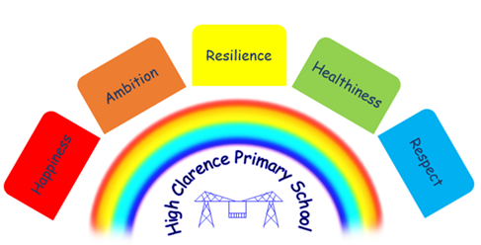

22nd March 2023

Dear Parents,

Easter Raffle Coffee Morning
There will be an Easter Raffle Coffee Morning in the school hall on Thursday, 30th March 2023. Entry to the hall will be from 8.45 a.m. and the raffle will be drawn at 9.30 a.m. Raffle tickets will be sent home this week for you to buy. If you want to purchase anymore they will be available anytime in the school office or in the school hall on the day of the raffle. We look forward to seeing you all on the day.

Please remember that we hold a ‘warm space’ coffee morning every Thursday and everyone is welcome to come along between the times of 8.45 – 10.45 a.m.

Easter Holidays
The last day in school will be Friday, 31st March 2023 and we re-open on Monday, 17th April 2023.

Comic Relief
Thank you for your support with Comic Relief. We raised £70.70 on the day.

After School Club
Current ‘After School Clubs’ running in school are:

Gymnastics KS2 – Mondays, 2.45 - 3.45 p.m.
Football KS2 – Tuesdays, 3.15 - 4.15 p.m.
Evolve Year 6 children – Wednesdays, 3.15 – 4.15 p.m.
Multi-Sports KS1 – Thursdays, 3.15 – 4.15 p.m.
Multiplication Year 4 – Thursdays, 3.15 – 4.15 p.m.

Holiday Clubs
Family Action
Family Action are running a ‘Family food and fun session’ in school on Monday 3rd April and Tuesday, 4th April. These will be fun sessions for you and your child/ren. This is open to 20 people in total. A leaflet is attached to this letter with more details. Please contact school or family action on 01642 721952 to register your interest.

BCT Aspire
BCT Aspire are also running a holiday club which will be for children only to attend (please see HAF leaflets attached). If your child has previously attended during the school holidays you will be receiving a notification from BCT to register your child online. If your child has not previously accessed this provision you can register them on this link https://www.stockton.gov.uk/haf or by using the QR code below.

PTO for upcoming Dates

Dates for your Diary
Date | Event
Wednesday, 22nd March | KS1 trip to Hardwick Park
Thursday, 23rd March | Coffee morning in school and every Thursday thereafter
Friday, 24th March | 12 children in Gymnastics competition
Friday, 31st March | Break up for Easter holidays  Weekly sessions at Stainsby Grange Riding Centre for KS2 children  10 children to RSPB Playground opening
Monday, 17th April | School re-opens
Thursday, 20th April | EY trip to Newham Grange Farm
Monday, 1st May | School closed for May Bank holiday
Tuesday, 2nd May | KS1 Tests to be administered during May
Monday, 8th May | School closed for King Charles III Coronation
Tuesday, 9th May | Year 6 SATS start
Friday, 26th May | Break up for half term
Monday, 5th June | School re-opens
Monday, 12th June | Year 1 Phonics start
Wednesday, 28th June | Enquire Learning Trust photoshoot day for new website photos
Wednesday, 20th July | School closed for PD day
Thursday, 21st July | Summer holidays commence

Nicola Caraher
Headteacher

