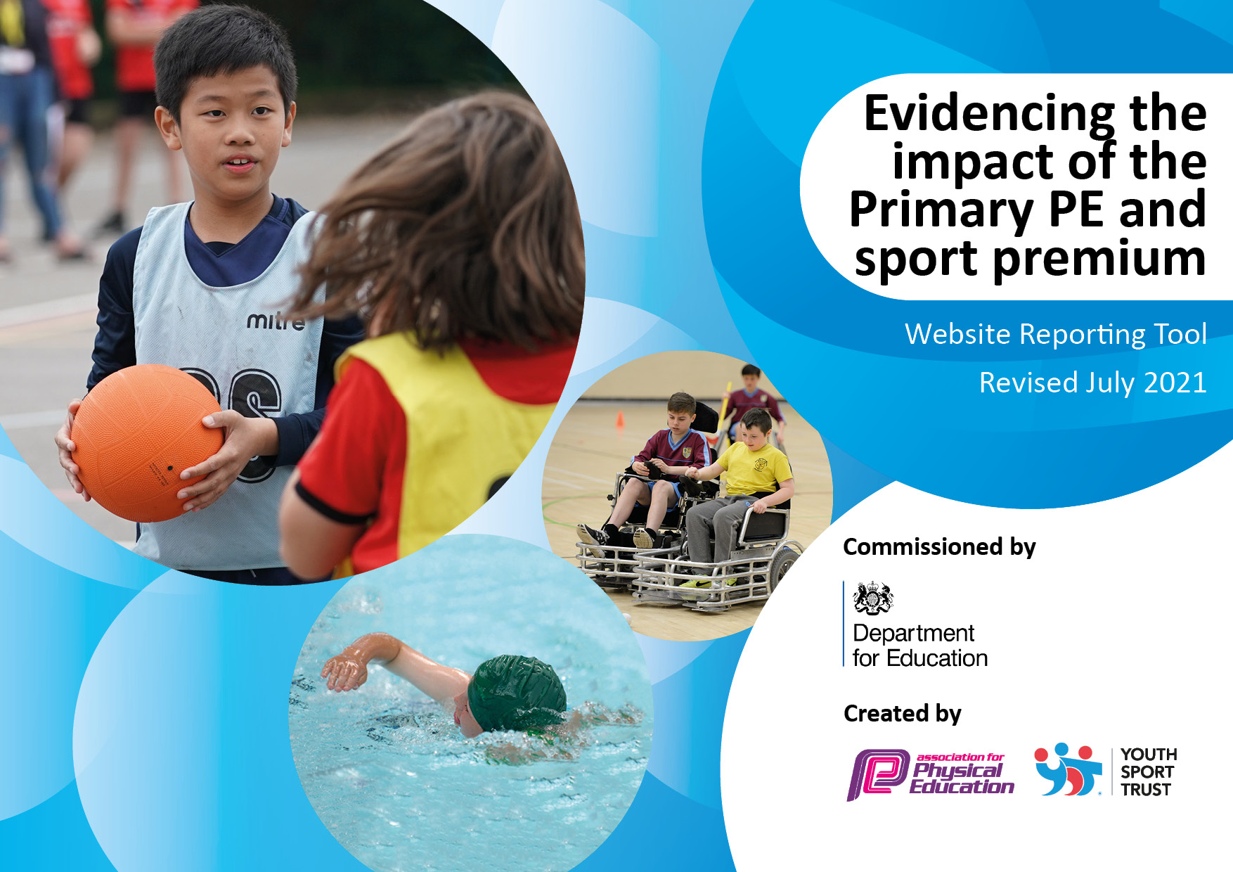
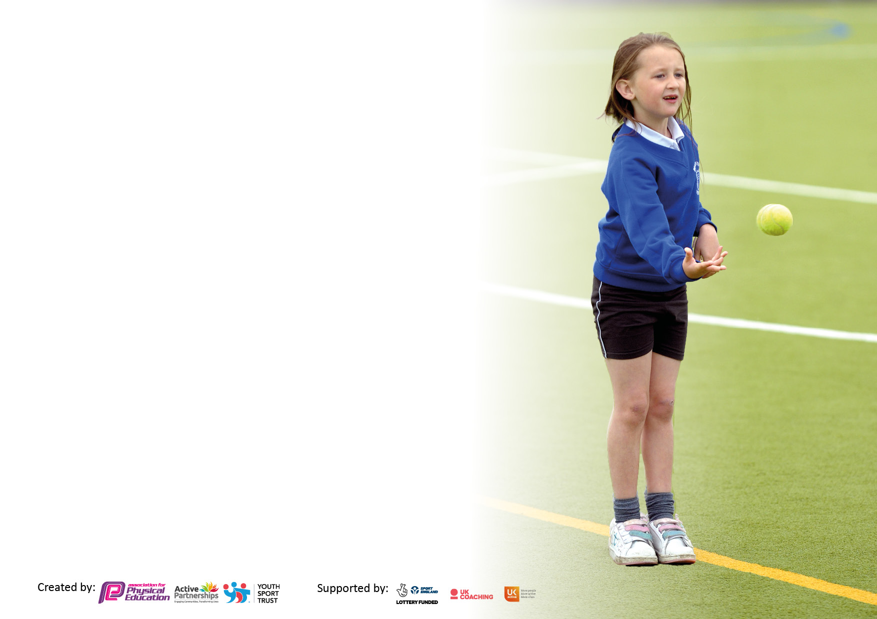

It is important that your grant is used effectively and based on school need. The Education Inspection Framework makes clear there will be a focus on ‘whether leaders and those responsible for governors all understand their respective roles and perform these in a way that enhances the effectiveness of the school’.

Under the Quality of Education Ofsted inspectors consider:
Intent - Curriculum design, coverage and appropriateness
Implementation - Curriculum delivery, Teaching (pedagogy) and Assessment
Impact - Attainment and progress

To assist schools with common transferable language this template has been developed to utilise the same three headings which should make your plans easily transferable between working documents.

Schools must use the funding to make additional and sustainable improvements to the quality of Physical Education, School Sport and Physical Activity (PESSPA) they offer. This means that you should use the Primary PE and sport premium to:

- Develop or add to the PESSPA activities that your school already offer
- Build capacity and capability within the school to ensure that improvements made now will benefit pupils joining the school in future years
- The Primary PE and sport premium should not be used to fund capital spend projects; the school’s budget should fund these.

Pleasevisitgov.ukfortherevisedDfEguidanceincludingthe5keyindicatorsacrosswhichschoolsshoulddemonstrate animprovement.Thisdocumentwillhelpyoutoreviewyourprovisionandtoreportyourspend.DfEencouragesschools to use this template as an effective way of meeting the reporting requirements of the Primary PE and sport premium.

We recommend you start by reflecting on the impact of current provision and reviewing the previous spend.

Schools are required to publish details of how they spend this funding, including any under-spend from 2019/2020, as well as on the impact it has on pupils’ PE and sport participation and attainment. All funding must be spent by 31st July 2022.

We recommend regularly updating the table and publishing it on your website throughout the year. This evidences your ongoing self-evaluation of how you are using the funding to secure maximum, sustainable impact. Final copy must be posted on your website by the end of the academic year and no later than the 31st July 2021. To see an example of how to complete the table please click HERE.

Details with regard to funding
Please complete the table below.

Total amount carried over from 2019/20 | £ 3,723
Total amount allocated for 2020/21 | £17,803
How much (if any) do you intend to carry over from this total fund into 2021/22? | £13,500
Total amount allocated for 2021/22 | £17,801
Total amount of funding for 2021/22. To be spent and reported on by 31st July 2022. | £31,301
Swimming Data
Please report on your Swimming Data below.

Meeting national curriculum requirements for swimming and water safety.

N.B. Complete this section to your best ability. For example you might have practised safe self-rescue techniques on dry land which you can then transfer to the pool when school swimming restarts.
Due to exceptional circumstances priority should be given to ensuring that pupils can perform safe self rescue even if they do not fully meet the first two requirements of the NC programme of study
What percentage of your current Year 6 cohort swim competently, confidently and proficiently over a distance of at least 25 metres?  N.B. Even though your pupils may swim in another year please report on their attainment on leaving primary school at the end of the summer term 2020.  Please see note above | 42%
What percentage of your current Year 6 cohort use a range of strokes effectively [for example, front crawl, backstroke and breaststroke]?  Please see note above | 24%
What percentage of your current Year 6 cohort perform safe self-rescue in different water-based situations? | 97%
Schools can choose to use the Primary PE and sport premium to provide additional provision for swimming but this must be for activity over and above the national curriculum requirements. Have you used it in this way? | No

Action Plan and Budget Tracking
Capture your intended annual spend against the 5 key indicators. Clarify the success criteria and evidence of impact that you intend to measure to evaluate for pupils today and for the future.

Academic Year: 2021/22 | Total fund allocated: | Date Updated:
Key indicator 1: The engagement of all pupils in regular physical activity – Chief Medical Officers guidelines recommend that primary school pupils undertake at least 30 minutes of physical activity a day in school |  |  |  | Percentage of total allocation:
 |  |  |  | 48.26%
Intent | Implementation |  | Impact
Your school focus should be clear what you want the pupils to know and be able to do and about  what they need to learn and to  consolidate through practice: | Make sure your actions to achieve are linked to your intentions: | Funding allocated: | Evidence of impact: what do pupils now know and what can they now do? What has changed? | Sustainability and suggested next steps:
- Every child to experience, on average, at least 60 minutes of activity every day.  - Provide activities which focus on developing motor competence and fundamental movement skills.  - Provide activities to enable children to practice, refine and master procedural knowledge. | - Alter whole school timetable to ensure time for active breaks.  - Plan for a range of activities to support development of fundamental skills across the week.  - Break time resources  - Active Break Shed £1845.82  - CPD (in-house) for all staff to understand rationale behind active breaks.  - Introduced Walk to school Once a Week campaign (WOW) | £15,676.32 | - Pupil feedback evidences children understand the positives of being active.  - Improved relationships & friendships  - Wider opportunities throughout the week allowing children to practice different skills.  - Wider range of opportunities for children to give different things a go. | Next Steps  - CPD – whole school staff -a active breaks September 22.  - Equipment audit.  - Restock equipment for autumn term.  - Review break cover rota.  - Access to SUFC support for active breaks - £1, 656 per term. Including after school club to focus on girl's football. (Autumn term)
Key indicator 2: The profile of PESSPA being raised across the school as a tool for whole school improvement |  |  |  | Percentage of total allocation:
 |  |  |  | 5.77%
Intent | Implementation |  | Impact
Your school focus should be clear what you want the pupils to know and be able to do and about  what they need to learn and to  consolidate through practice: | Make sure your actions to achieve are linked to your intentions: | Funding allocated: | Evidence of impact: what do pupils now know and what can they now do? What has changed? | Sustainability and suggested next steps:
- Whole School Focus - Healthy Body. Healthy Mind. Happy Life.  - High quality teaching and learning for ALL pupils.  - Range of activities and development of fundamental skills over time. | - Three elements of PESSA are combined to enhance provision and entitlement; PE/Sports Curriculum, Active Schools programme, additional opportunities.  - Focus on widening opportunities for all children and offering a range of activities and events. | £1875.00 | - 93% have taken part in activities offered by school.  - 96% take part in sporting activities either in or out of school. | HT as Sports Lead not sustainable long term. Strategic planning to appoint at next new teacher vacancy.

Key indicator 3: Increased confidence, knowledge and skills of all staff in teaching PE and sport |  |  |  | Percentage of total allocation:
 |  |  |  | 21.20%
Intent | Implementation |  | Impact
Your school focus should be clear | Make sure your actions to | Funding | Evidence of impact: what do | Sustainability and suggested
what you want the pupils to know | achieve are linked to your | allocated: | pupils now know and what | next steps:
and be able to do and about | intentions: |  | can they now do? What has
what they need to learn and to |  |  | changed?
consolidate through practice:
- Deliver consistent, high-quality lessons.  - Improve assessment for learning to impact on next steps and improved progress for ALL children | - Appoint sports coaches to deliver PE/ Sports curriculum and after school clubs. Funded from Revenue as it also covers PPA time for teachers.  - Sports coaches to laisse closely with sports lead to ensure delivery of HGPS curriculum.  - CPD for all staff – active breaks  - Well-Being Booklets for KS2 children.  - 32 Samsung tablets (2 x 16) to be utilised for self and peer assessment  - Purchase i-moves – 21/22 – on-going (2-year subscription 20/21)  - Purchase Get Set 4 PE – 22/23 – on-going  - Arches Bronze Package | £6886.66 | Sports Leader observations evidence effective use of declarative knowledge and development of fundamental skills.  High level of engagement for all pupils evidenced.  Pupil feedback – they enjoy their sports days each week and have developed a positive relationship with their sports coaches. | Revenue funding to maintain sports coaches. £18,500 per year.
Key indicator 4: Broader experience of a range of sports and activities offered to all pupils |  |  |  | Percentage of total allocation:
 |  |  |  | 20.30%
Intent | Implementation |  | Impact
Your school focus should be clear | Make sure your actions to | Funding | Evidence of impact: what do | Sustainability and suggested
what you want the pupils to know | achieve are linked to your | allocated: | pupils now know and what | next steps:
and be able to do and about | intentions: |  | can they now do? What has
what they need to learn and to |  |  | changed?
consolidate through practice:
For ALL children to be offered a wide range of different opportunities and engage in sports. | Additional opportunities:  - Fishing Y4/5£1440.00  - Horse riding – whole school £968.6  - Ice Skating – Y5  - Cross Country – KS1, KS2£210  - Colour Run – whole school £290  - Tag Rugby  - Football + girls’ football  - Athletics £890  - Gymnastics  - Curling  - Dodgeball £175  - Handball  - Quidditch  Bikeability – Y5 £120  - Wider offer to more children for after schools’ clubs. Increase staffing if over 20. | £6593.60 | - Engagement of children increased over time.  - Due to focus being on enjoyment rather than competition, more children were willing to ‘give it a go.’  - Monitoring uptake led to fishing and horse riding which more children were interested in – particularly SEND children for fishing.  - Increased engagement in after school clubs.  - Healthier, happier children with positive mental health | Sustainability  Funding required to maintain commitment to additional activities - £4.5k  - Horse riding  - Fishing  Transport to events - £4k  Catch up swimming for Y5 – 22/23  Exploring opportunities for golf (Tankersley Golf Club), fencing (Adam Blight - £60 per hour), boxing workshop with a visit from Rachel MacKenizie for UKS2) - develop links with local clubs.

Key indicator 5: Increased participation in competitive sport |  |  |  | Percentage of total allocation:
 |  |  |  | 4.47%
Intent | Implementation |  | Impact
Your school focus should be clear | Make sure your actions to | Funding | Evidence of impact: what do | Sustainability and suggested
what you want the pupils to know | achieve are linked to your | allocated: £1450 | pupils now know and what | next steps:
and be able to do and about | intentions: |  | can they now do? What has
what they need to learn and to |  |  | changed?
consolidate through practice:
To increase opportunities for ALL children to take part in competitive events. | Respond to competitive events offered at a local level.  - Cycling  - Cricket  - Tag Rugby  - Triathlon  - Cross Country  - Aqua Festival  - Dodgeball  - Handball | - £120  - £420  - £110  - £110  - £210  - £110  - £110  - £260  Total - £1,450 | - Increased involvement in activities and events.  - Good relationships with wider community. | Maintain funding for transport costs  Aim to plan alongside a competition calendar – Arche Partnership.

Signed off by Dawn Aldridge
Head Teacher: | Diane Smales
Date: | 20.07.22
Subject Leader: | Diane Smales
Date: | 20.07.22
Governor: | Dave Towler
Date: | 20.07.22

