CURRICULUM INTENT
Values and Ethos of HGPS

As facilitators of learning, we all hold the future in our hands. Our vision, our aspirations, our actions will determine that future. Through imagination and inspiration, through challenge and creativity our children will become the dreamers and innovators of tomorrow.
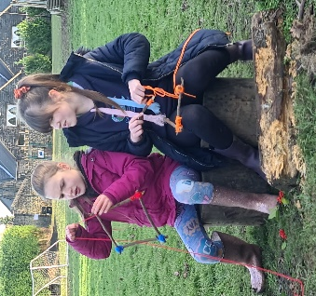
The High Green curriculum is based on that vision and understanding. Following our Rationale for Cultural Capital, we aim to provide the knowledge, experiences and skills our children need…
- To develop and grow up as competent, confident learners and communicators.
- Healthy in mind, body, and spirit.
- Secure in their sense of belonging.
- Secure in the knowledge that they make a valued contribution to society.

CORE VALUES

The four core values that form the bedrock of our school and bind the curriculum together are;
- Holistic
- Empowerment
- Relationships.
- Family and Community

AMBITIONS based on our four core values

We want every child to…

… have their own chance to shine through an HOLISTIC and inclusive approach.
… be EMPOWERED leaders of their own learning.
… enjoy safe and reciprocal RELATIONSHIPS.
…have a sense of belonging through a focus on FAMILY & COMMUNITY.

HOLISTIC
- Maintaining the whole child at the centre of the curriculum, ensuring equitable personal and emotional development.
- Developing independence and responsibility, perseverance and resilience, allowing individual success and pride in ones’ own achievements.
- Developing strengths in each child and a true sense of self-worth and self-esteem, including intellectual, spiritual, moral and physical understanding.
- Focusing on emotional intelligence and physical fitness to support mental health and well–being.
- A focus on outdoor learning with Forest Schools at the heart of developing the whole child.
- Offering a range of experiences and opportunities that allow each child to recognise their own gifts and talents.

EMPOWERMENT
- Children are given opportunities to make their own decisions and take responsibility for their own learning, developing self-challenge and self-motivation to become a life-long learner.
- The roots of all teaching and learning opportunities will be to inspire children to investigate, explore, research and question developing a true love of learning.
- Developing children’s ability to understand their own strengths and areas for development; allowing them to regulate their own progress, with effective support and guidance.

RELATIONSHIPS
- Through a range of opportunities to explore and develop relationships – personal and social, understanding the value of learning with others but also understanding the risks that new technology brings.
- Allowing children to learn through responsive and reciprocal relationships, whilst developing a deeper understanding of the value of personal and social relationships and particularly of keeping themselves safe online.

FAMILY & COMMUNITY
- Ensuring all children have a sense of belonging: understanding where they come from.
- Understanding global community and their impact at all levels, local, national, international.
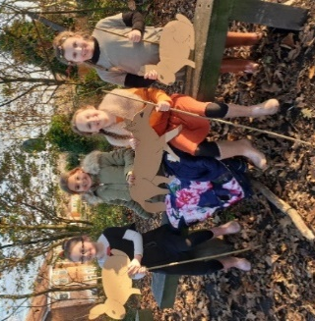
- Understanding the principle that learning begins at home.
- Enhanced home learning that sees the family as a full partner in and founder of child development. With increased understanding of learning and the curriculum, parents will be better placed to fully support their child.
- Developing a child’s understanding of…
- life in modern Britain, including British values, cultural heritage and seeing themselves as a valued member of a community.
- the concept of Diversity, so they can understand how to contribute to its future development and achieve economic wellbeing.

CURRICULUM AIMS

- To respond to our school context and Cultural Capital to ensure we directly meet the needs of our children, allowing them all to achieve success.
- To design, implement and evaluate the curriculum to ensure breadth, balance and opportunity to facilitate deeper learning opportunities.
- To provide a positive and nurturing ethos with the core values embedded in everyday life and learning.
- To provide the opportunity to explore learning in different context and environments including the secret garden, woodland, allotment, field, playground and local surrounding area, as well as visits further afield.

