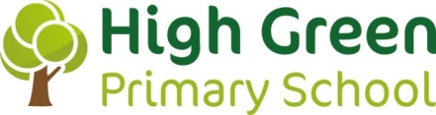
RATIONALE FOR CULTURAL CAPITAL

WHAT IS CULTURAL CAPITAL?
French sociologist Pierre Bourdeiu, originally came up with the concept of a person possessing ‘capital’. Bourdeiu explored the theory of Cultural Capital and highlights the links between an individual’s background and their access to knowledge.
OFSTED
203. Inspectors will consider the extent to which schools are equipping pupils with the knowledge and cultural capital they need to succeed in life.
It is essential knowledge that pupils need to be educated citizens, introducing them to the best that has been thought and said and helping to engender an appreciation of human creativity and achievement.
CONTEXT OF THE SCHOOL
- One form entry village school, predominantly attended by white British pupils who mostly reside within the catchment area.
- High SEND
- Low Pupil Premium/Free School Meals
- Low EAL
- Mostly dual income families
- Very low mobility

WHAT ARE WE PREPARING OUR CHILDREN FOR?

THE FUTURE OF JOBS REPORT – OCTOBER 2020 (World Economic Forum)
EMERGING JOB ROLES FOR 2025 | Top 15 skills for 2025
- Cloud Computing  - Content Production​  - Data & AI​  - Engineering  - Marketing  - People & Culture  - Product Development  - Sales | - ANALYTICAL THINKING & INNOVATION​  - ACTIVE LEARNING & LEARNING STRATEGIES ​  - COMPLEX PROBLEM-SOLVING ​  - CRITICAL THINKING & ANALYSIS ​  - CREATIVITY, ORIGINALITY & INITIATIVE ​  - LEADERSHIP & SOCIAL INFLUENCE ​  - TECHNOLOGY USE, MONITORING & CONTROL ​  - TECHNOLOGY DESIGN & PROGRAMMING ​  - RESILIENCE, STRESS TOLERANCE & FLEXIBILITY ​  - REASONING, PROBLEM-SOLVING & IDEATION ​  - EMOTIONAL INTELLIGENCE ​  - TROUBLESHOOTING & USER EXPERIENCE ​  - SERVICE ORIENTATION ​  - SYSTEMS ANALYSIS & EVALUATION ​  - PERSUASION & NEGOTIATION

Relative importance of different skill groups
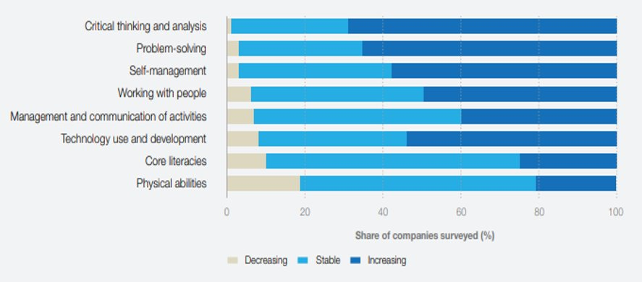

OECD SKILLS OUTLOOK 2021: Learning for Life

The report assesses the essential nature of skills in the modern world, particularly in light of the Covid-19 pandemic and the need to adapt to a fast-changing global environment. The report stresses the importance of lifelong learning and the need for schools to foster and nurture a positive attitude to lifelong learning.

Inequalities in education have also been highlighted in the report, with the global pandemic accentuated pre-existing inequalities.

Although a high proportion of young people go to university, there are also many people with low basic skills and few with high-level vocational skills (Musset and Field, 2013; Wolf, 2011). These are weaknesses that hold back productivity and hinder efforts to reduce inequality and improve social mobility (Bagaria, Bottini and Coelho, 2013).

Gender differences are also apparent across most industrialised countries. Women tend to achieve higher standards of educational attainment, with more going into tertiary education than men. However, women are much less likely to choose science, technology, engineering and maths (STEM) subjects in upper secondary or tertiary education, and they are less likely to pursue apprenticeships.

CORE VALUES & AMBITIONS

Our four core values form the basis of our approach to Cultural Capital. For children to become successful citizens, with the knowledge and skills to help them flourish and thrive,
we want every child to…

… have their own chance to shine through an HOLISTIC and inclusive approach.
… be EMPOWERED leaders of their own learning.
… enjoy safe and reciprocal RELATIONSHIPS.
…have a sense of belonging through a focus on FAMILY & COMMUNITY.

Our INTENT for Cultural Capital
Aspects of Cultural Capital flow through three key areas of school development; Quality of Education, Behaviour and Attitudes and Personal Development.
SMSC (Spiritual, Moral, Social and Cultural) also plays a key role in the development of Cultural Capital. Whilst Cultural Capital focuses on what we can do through the curriculum, SMSC is about how, through personal reflection, we use that knowledge and those experiences and skills, to help children have a deeper understanding of themselves and the world around them.
Based on the context of our school and the future jobs market, our ambition is to focus on three priorities:
- KNOWLEDGE
  - Using our shared understanding of cognitive science to ensure children retain key knowledge and move it into long term memory.
- EXPERIENCE
  - Enjoying a range of first-hand experiences that instil awe and wonder, curiosity and enquiry.
  - Understanding that a range of different experiences supports a deepening of knowledge and skills.
  - A range of experiences which are not gender, socially or racially biased and actively encourage high aspirations, social mobility and gender balances in industry.
- SKILLS
  - Developing a range of high-level skills, including interpersonal and intrapersonal to support future success in the work place.
  - A focus on STEAM to develop skills of creativity and innovation.

KEY AREAS | HOW CULTURAL CAPITAL IS DEVELOPED THROUGH SCHOOL
KNOWLEDGE | - Using understanding and application of Cognitive Science to ensure ALL children access knowledge appropriately. (Learning is adapted accordingly and split-attention effect is considered.)  - Using a range of cognitive science strategies: curriculum planning, retrieval practices, distributed learning, allowing children to use the knowledge they have acquired and commit it to long term memory. (Goals & Match Day, Mild, Spicy, Hot.)  - Enquiry approach to curriculum planning supports the deepening of substantive and disciplinary knowledge.  - Links to industrial Sheffield, summer term focus on STEAM to instil understanding of heritage around the legacy and future of engineering.  - Concepts and conceptual links are developed to deepen knowledge and understanding.  - Key facts and vocabulary developed within each subject. (Learning Maps)  - On-line Safety, RSHE, RE, assemblies – Reflection Books  - Computing – coding, handling data  - Focus on the concept of diversity, explicit in planning.  - Celebrating events: Black History Month  - Learning about inspirational people – about them and from them – within each topic.  - Class Charities – learning about them and what they do. (Range of local and global)  - Learning about their class pet, habitat, life cycle, diet. (Turtle, stick insects, guinea pigs, gold fish, axolotl, gecko, rabbit.)  - Understanding need for regular physical activity and balanced diet. CAS (Creating Active Schools Framework). WOW Walk to school scheme.
EXPERIENCES | CLASS | AUTUMN |  | SPRING | SUMMER
 | F2 | Panto  High Green Methodist Church |  | Curious Kids Town | Butterfly House, Aston
 |  | Class Charity: Support for Dogs UK |  |  | Pet: Turtle
 | Y1 | Panto  Conisborough Castle | Moorland Discovery Centre  St Marys Catholic Church |  | Yorkshire Wildlife Park
 |  | Class Charity: Bat Conservation |  |  | Pet: Stick Insects
 | Y2 | National Coal Mining Museum  St Saviours Church | Scarborough |  | Eureka Science Museum
 |  | Class Charity: Yorkshire Wildlife Park |  |  | Pet: Guinea Pigs
 | Y3 | Chester Roman Museum | Madina Mosque Sheffield  Old Moor RSPB |  | Lego Technology Day
 |  | Class Charity: Save the Children Fund |  |  | Pet: Gold Fish
 | Y4 | Murton Park (Vikings) | Speedwell & Peak Caverns |  | Harry Potter World  Sheffield Buddhist Centre.
 |  | Class Charity: Macmillan Cancer Support |  |  | Pet: Axolotl
 | Y5 | Imperial War Museum  Lowry Art Gallery  Sheffield Jewish Centre | Abbeydale Industrial Hamlet |  | National Space Museum  Sheffield Cathedral.
 |  | Class Charity: Children’s hospital Sheffield |  |  | Pet: Gecko
 | Y6 | Creswell Crags | Sikh Temple. Sheffield  Tropical House Leeds |  | PGL (Winmarleigh Hall)  Crucial Crew
 |  | Class Charity: Bluebell Wood Hospice |  |  | Pet: Rabbit
- Forest School Week for every class, every term – personal well-being.
- Importance of music, the opportunity to learn to play an instrument, experience music concerts and perform in front of others, is an important part of holistic development.
- Outdoor learning and active breaks: Woodland, Secret Garden: key to developing reciprocal relationships and well-being.
- After school clubs – sports to increase physical activity.
- Swimming – Y4
- Celebration success; awards – Writer/Reader of the week, Mathmagician, dojo’s
- Celebration Events; bowling, disco’s, Leavers Prom
- Working together to raise money for their class charity – community responsibility.
- Opportunities to travel to the city centre via public transport.
SKILLS | - Reading recognised as a skill crucial to future success: love of reading is high profile across school.  - Summer term focus on STEAM to support narrowing of the youth skills gap for the future: creativity & innovation.  - Enquiry approach to teaching & learning - developing critical and sustained shared thinking and complex problem solving.  - Homework Champions designed to promote independence and organisational skills.  - Interpersonal skills – peer reviews, focus on relationships, anti-bullying, collaboration, team work, respect and tolerance.  - Intrapersonal skills - Zones of Regulation – self regulation. Developing resilience and stress tolerance. Reflection time & assemblies.  - Through personal reflection, children’s journey towards personal growth and social maturity is developed across school. (Evidenced through Little Book of Reflection & Floor Books)  - Developing leadership skills leaders of tomorrow: Well-Being Ambassadors – looking after mental well-being, Sports Leaders – looking after physical well-being, School Council – looking after the school, Eco-Warriors – looking after the planet, Reading Champions – supporting others love of reading.  - Opportunities to develop personal skills through teaching & learning: Poem a Day – speaking in front of others, leading group work, listening, discussion & debate, collaboration, constructive peer review.  - Learning Journeys – Children identify individual Knowledge, Experiences and Skills.

