Theme/Term | Outside Inside Autumn 1 |  |  |  |  |  | Knowing Yourself Autumn 2
Writing Root Text | 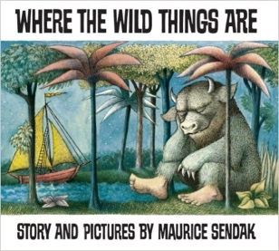  Where the Wild Things Are  Maurice Sendak |  | 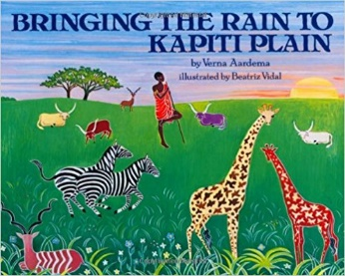  Bringing the Rain to Kapiti Plain  Verma Aardema |  | 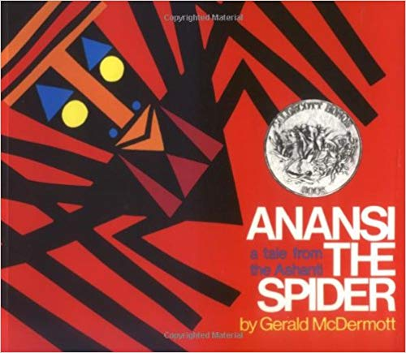  OR Anansi  Gerald McDermott |  | 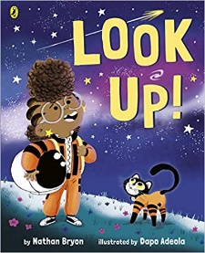  Look up!  Nathan Bryon and Dapo Adeola | 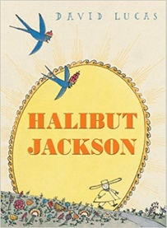  OR Halibut Jackson  David Lucas |  | 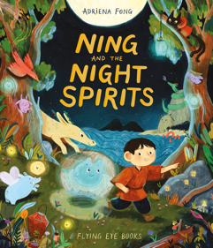  Ning and the Night Spirits  Adriena Fong |  | 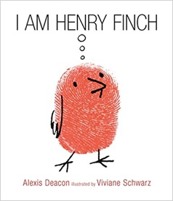  OR I am Henry Finch  Alexis Deacon
Length | 10+ sessions, 2+weeks |  | 10+ sessions, 2+weeks |  | 10+ sessions, 2+weeks |  | 10+ sessions, 2+weeks | 10+ sessions, 2+weeks |  | 10+ sessions, 2+ weeks |  | 10+ sessions, 2+ weeks
Outcomes | Own version ‘wild thing’ narratives  Labels, captions, oral re-telling, developing a new character |  | Tourist information leaflets  Labels and captions, retellings, simple explanations |  | Booklets about spiders  Labels and captions, call-and-response poems, descriptive posters, simple explanations |  | Non-chronological reports  Dialogue, diaries, re-telling (oral dictation), mini-autobiography, ship’s log | Guidebooks - How to Think  Timetables, thought-bubbles, lists, commands, letters of advice |  | Information texts about night spirits  Posters, advice letters, party invitations |  | Narrative sequels  Signs and labels, captions, invitations, thought bubbles, advertisements, letters of advice
Theme/Term | Talents & powers Spring 1 |  |  |  |  |  | Sowing a seed Spring 2
Writing Root Text | 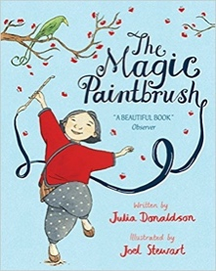  The Magic Paintbrush  Julia Donaldson and Joel Stewart |  | 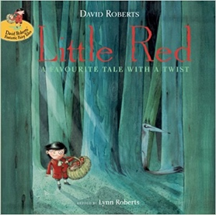  Little Red  Lynn Roberts and David Roberts |  | 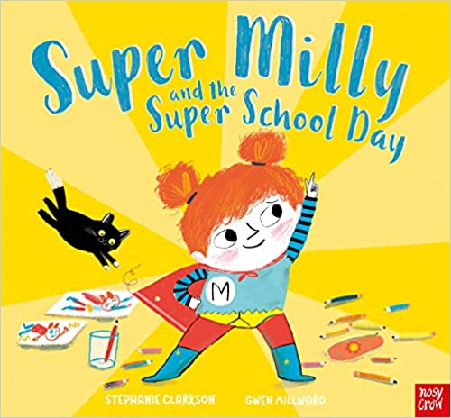  OR Super Milly and the Super School Day  Stephanie Clarkson |  | 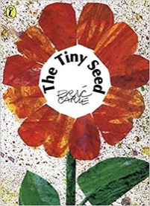  The Tiny Seed  Eric Carle |  | 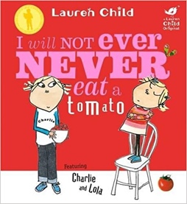  I Will Not Ever Never Eat a Tomato  Lauren Child |  | 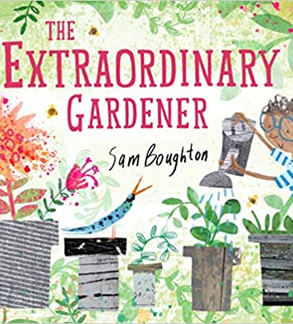  OR The Extraordinary Gardener  Sam Boughton
Length | 10+ sessions, 2+weeks |  | 10+ sessions, 2+weeks |  | 10+ sessions, 2+ weeks |  | 10+ sessions, 2+weeks |  | 10+ sessions, 2+weeks |  | 10+ sessions, 2+ weeks
Outcomes | Own version ‘overcoming’ tales  Thought bubbles, labels, oral re-telling, writing in role, thank you letters |  | Alternative character versions  Labels, notes of advice, adverts |  | Alternative character version  Letters of encouragement; a retelling; song lyrics and job applications |  | Advice leaflets  Labels and captions, advice, retellings, writing in role, narrative, letter |  | Own stories about a fussy eater  Statements, writing in role, shopping lists |  | Narrative inspired by the original text  Labels, letters of advice, instructions, narratives
Theme/Term | Celebrating self Summer 1 |  |  |  |  |  | Family & friends Summer 2
Writing Root Text | 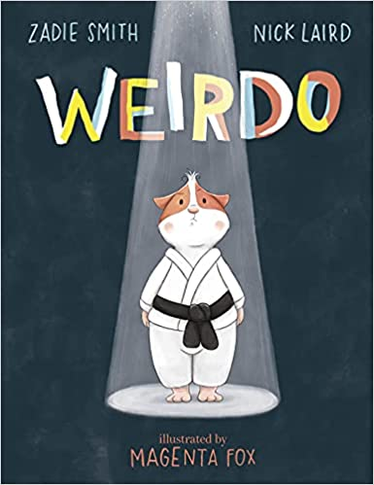  Weirdo  Zadie Smith and Nick Laird | 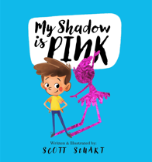  OR My Shadow is Pink  Scott Stuart |  | 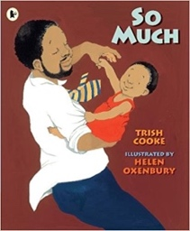  So Much  Trish Cooke and Helen Oxenbury |  | 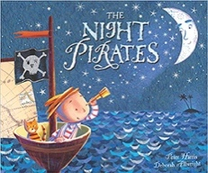  The Night Pirates  Pete Harris and Deborah Allwright | 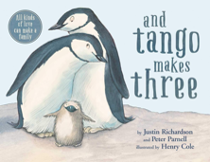  And Tango Makes Three  Justin Richardson & Peter Parnell | 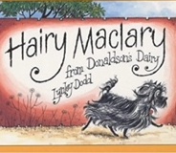  Hairy Maclary from Donaldson’s Dairy  Lynley Dodd |  | 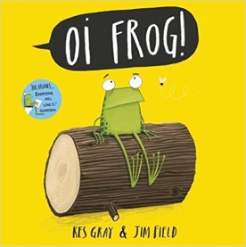  Oi! Frog  Kes Gray and Jim Field |  | 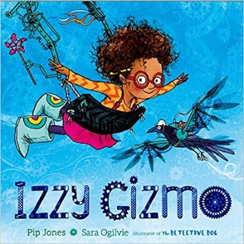  OR Izzy Gizmo  Pip Jones
Length | 10+ sessions, 2+weeks | 10+ sessions, 2+weeks |  | 10+ sessions, 2+weeks |  | 10+ sessions, 2+weeks | 10+ sessions, 2+weeks | 10+ sessions, 2+weeks |  | 10+ sessions, 2+weeks |  | 10+ sessions, 2+ weeks
Outcomes | Instructional guides to being brave  Writing in role, letters, captions and labels, narrative retellings | Leaflet  Innovated spoken rhymes, questions, notes and advice, lists, instructions |  | Own ‘So Much’ narrative poems  Past tense sentences, writing in role, performance/ narrative poetry |  | ‘How to be a pirate’ guides  Writing in role, letters, labels and captions | Alternative version narratives  Signs and lists, writing in role, letters of advice, ‘new baby’ cards | Alternative version narratives  Character description, writing in role, letters, leaflets |  | Own version rhyming narratives  Posters of rules, rhyming flipbooks, questions, captions and labels |  | Simple explanation  Signage, letters of advice, lists, labelled diagrams

