Theme/Term | Literacy Tree theme: Fictional Worlds Autumn 1 |  |  | Storybook Bears Autumn 2
LMTW | LMTW theme: Land ahoy |  |  | NESW / Powhatan People
Planning Sequence | 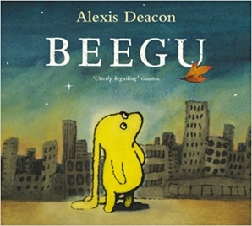  Beegu  Alexis Deacon | 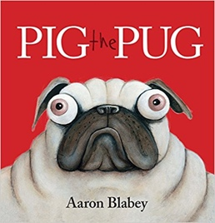  Pig the Pug  Aaron Blabey  How to be a Dog  Jo Williamson |  | 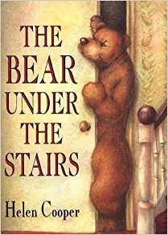  The Bear Under the Stairs  Helen Cooper |  | 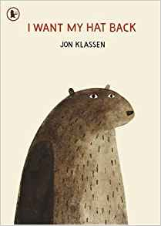  I Want My Hat Back  Jon Klassen
Length | 10 sessions, 2 weeks | 15+ sessions, 3+ weeks |  | 15 sessions, 3 weeks |  | 15 sessions, 3 weeks
Outcomes | Own version ‘alien’ narratives  Descriptions, commands, letters, nonsense-word dictionary, poems, non-fiction reports | ‘How to’ guides  Character comparisons, fact sheets, shared poetry, own version narratives |  | Information texts  Letters, retellings, own version narratives |  | Story sequels  Questions, speech bubbles, letters, lists
Theme/Term | Literacy Tree theme: Change and Relationships Spring 1 |  |  | Creation and Conservation Spring 2
LMTW | LMTW theme: Come fly with me - Arctic |  |  | Happily ever after
Planning Sequence | 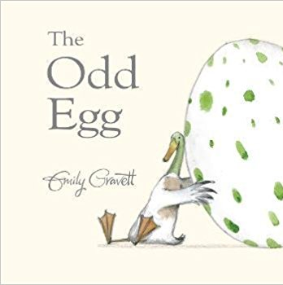  The Odd Egg  Emily Gravett | If All the World Were…  Joseph Coelho |  | Goldilocks & the Three Bears  Lauren Child  You & Me Anthony Browne  Goldilocks & Just the One Bear  Leigh Hodgkinson |  | 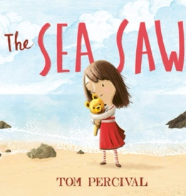  The Sea Saw  Tom Percival
Length | 10 sessions, 2 weeks | 10 sessions, 2 weeks |  | 15 sessions, 3 weeks |  | 15 sessions, 3 weeks
Outcomes | Egg-spotter’s guides (non-fiction reports)  Thought and speech bubbles, diaries, letter, certificate | Non-narrative poems  Writing in role, diaries, letters of advice, short explanations |  | Sequel stories  Wanted posters, letters, retellings from another point of view, lists of rules, character descriptions |  | Own version narrative  Writing in role; notes of advice; missing posters; diary entries; letters of thanks
Theme/Term | Literacy Tree theme: Nature and Environment Summer 1 |  |  | Beasts and Monsters Summer 2
LMTW | LMTW themes: (History character) / Light up the world / Jurassic Hunter  Way Back When – Bikes / Animal Crackers
Planning Sequence | 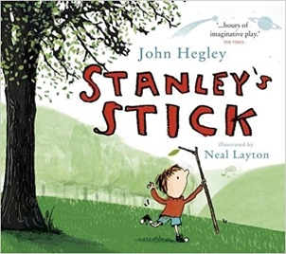  Stanley’s Stick  John Hegley and Neal Layton | 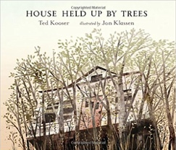  House Held Up By Trees  Ted Kooser |  | 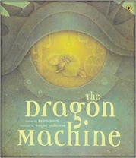  The Dragon Machine  Helen Ward |  | 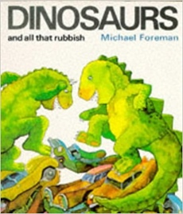  Dinosaurs and all that Rubbish  Michael Foreman
Length | 11 sessions, 2+ weeks | 15 sessions, 3 weeks |  | 15 sessions, 3 weeks |  | 10 sessions, 2 weeks
Outcomes | Own version narratives  Retellings, descriptions | News reports  Descriptive non-fiction, life-cycles, instructions for seed packets |  | Own version dragon stories  Dragon guides & encyclopaedia, letters of advice, dragon machine explanations, shopping lists, descriptions, letters |  | Pamphlets  Letters, setting descriptions, instructions, narrative retellings, pamphlets, posters
Literary Leaf Text | 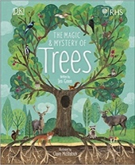  The Magic and Mystery of Trees  Jen Green |  | 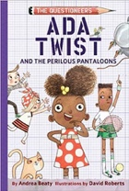  Ada Twist and the Perilous Pantaloons  Andrea Beaty |  | 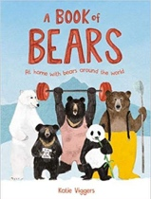  A Book of Bears  Katie Viggers
Length | 15 sessions, 3 weeks |  | 14 sessions, 2+ weeks |  | 15 sessions, 3 weeks

