Theme/Term | Literacy Tree theme: Journeys and Exploration Autumn 1 |  |  | Structures and Materials Autumn 2
LMTW | LMTW theme: Unity in the community |  |  | History characters
Planning Sequence | 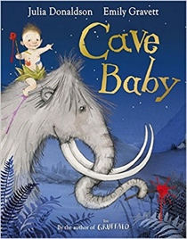  Cave Baby  Julia Donaldson and Emily Gravett | 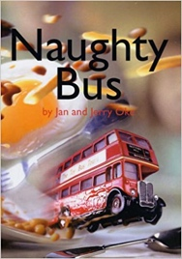  Naughty Bus  Jan Oke and Jerry Oke |  | 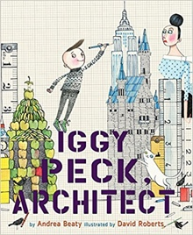  Iggy Peck, Architect  Andrea Beatty and David Roberts |  | 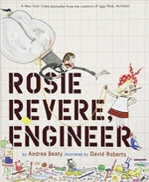  Rosie Revere, Engineer  Andrea Beatty
Length | 10+ sessions, 2+weeks | 16 sessions, 3+ weeks |  | 10 sessions, 2 weeks |  | 15 sessions, 3 weeks
Outcomes | Narrative retellings  Labels and captions, informal letters | Own adventure stories  Letters, diaries, sequels, non-chronological reports |  | Fact files  Labels, captions, character comparisons, thought and speech bubbles |  | Leaflet for local landmarks  Short explanations, writing in role, reports, adverts
Theme/Term | Literacy Tree theme: Heroes and Villains Spring 1 |  |  | Similarities and Differences Spring 2
LMTW | LMTW theme: Zero to Hero |  |  | Internation Media Station
Planning Sequence | 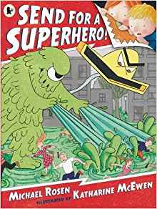  Send for a Superhero  Michael Rosen & Katharine McEwan | 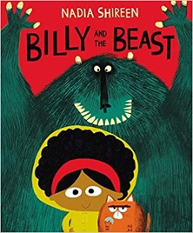  Billy and the Beast  Nadia Shireen |  | 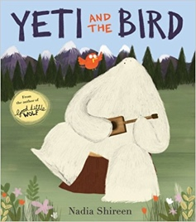  Yeti and the Bird  Nadia Shireen |  | 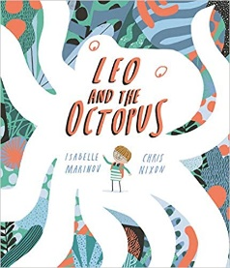  Leo and the Octopus  Isabelle Marinov
Length | 15 sessions, 3 weeks | 15 sessions, 3 weeks |  | 15 sessions, 3 weeks |  | 15 sessions, 3 weeks
Outcomes | Own version superhero narratives  Wanted posters, letters, speech bubbles, diaries, emails, character descriptions | Own version ‘defeat a monster’ narratives  Wanted posters, summaries, emails, character descriptions, recipes |  | Own version narratives about unlikely friendships  List of rules, letters, postcards, character descriptions |  | Fact file  This is Me! posters, letters of advice, factual descriptions, logbooks, scripts
Theme/Term | Literacy Tree theme: Space and Our World Summer 1 |  |  | Fantasy Journeys Summer 2
LMTW | LMTW themes: History character / Going Wild / History character
Planning Sequence | 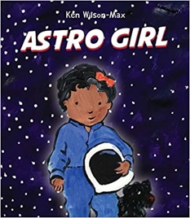  Astro Girl  Ken Wilson-Max | 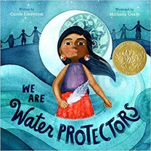  We Are Water Protectors  Carole Lindstrom |  | 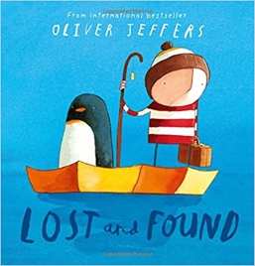  Lost and Found  Oliver Jeffers |  | 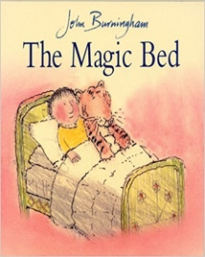  The Magic Bed  John Burningham
Length | 11 sessions, 2+ weeks | 15 sessions, 3 weeks |  | 15 sessions, 3 weeks |  | 15 sessions, 3 weeks
Outcomes | Fact files about being astronauts  Writing in role, commands, ‘how to’ guides | Environmental campaign  Descriptive non-fiction, life-cycles, character description |  | Own version ‘losing/finding’ narratives  Character descriptions, retellings, advice, instructions, non-chronological reports |  | Own version fantasy stories  Setting descriptions, additional scenes, description of magical piece of furniture, lists
Literary Leaf Text | 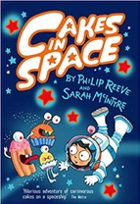  Cakes in Space  Philip Reeve |  | 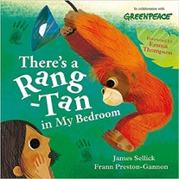  There’s a Rang-Tan in my Bedroom  James Sellick |  | 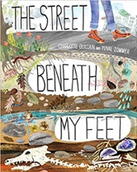  The Street Beneath my Feet  Charlotte Guillian
Length | 15 sessions, 3 weeks |  | 10 sessions, 2 weeks |  | 15 sessions, 3 weeks

