Theme/Term | Literacy Tree theme: Twisted Tales Autumn 1 |  | Creation and Conservation Autumn 2
LMTW | LMTW theme: Athens v Sparta |  | Rocky the Findosaur / Out and About
Planning Sequence | 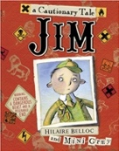  Jim, A Cautionary Tale  Hilaire Belloc | 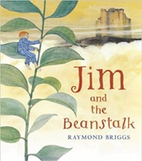  Jim and the Beanstalk  Raymond Briggs | 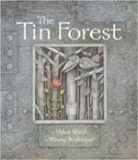  The Tin Forest  Helen Ward | 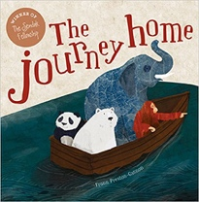  The Journey Home  Frann Preston-Gannon
Length | 10 sessions, 2 weeks | 15 sessions, 3 weeks | 10 sessions, 2 weeks | 15 sessions, 3 weeks
Outcomes | Narrative poems  Warning posters, alternative endings, performance poetry, letter of apology | Sequel stories  Narrative retellings (including dialogue), thought bubbles, informal letters | Persuasive information leaflets  Persuasive posters, information leaflets, postcards, diaries, wishes, setting descriptions | Persuasive letters  Posters, lists, postcards, wanted posters, information reports, short stories
Literary Leaf Text | Cinderella An Art Deco Fairy Tale  Lynn Roberts and David Roberts | 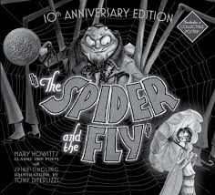  The Spider and the Fly  Mary Howitt and Tony DiTerlizzi | 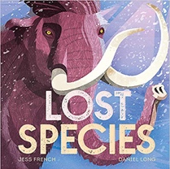  Lost Species  Jess French | 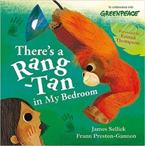  There’s a Rang-Tan in my Bedroom  James Sellick
Length | 10 sessions, 2 weeks | 10 sessions, 2 weeks | 12 sessions, 2+ weeks | 10 sessions, 2 weeks
Theme/Term | Literacy Tree theme: Bravery and Courage Spring 1 |  | Hope and Healing Spring 2
LMTW | LMTW theme: Come fly with me - Africa |  | That’s all folks!
Planning Sequence | 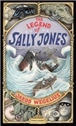  The Legend of Sally Jones  Jakob Wegelius | The Bear and the Piano  David Litchfield | The Last Garden  Rachel Ip | 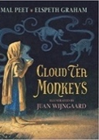  Cloud Tea Monkeys  Mal Peet & Elspeth Graham
Length | 16 sessions, 3+ weeks | 15 sessions, 3 weeks | 15 Sessions, 3 weeks | 15 sessions, 3 weeks
Outcomes | Further adventure narratives  Birth certificates, letters, books of tricks, newspapers, adverts, diaries, leaflets, telegrams, booklets, goodbye notes | Own version narratives about bravery  Letters of advice, short news reports, writing in role, retellings, information posters | Own version extended narrative  Setting descriptions, advertisement/ poster, retelling, instructional flyer, social media updates, dialogue | Non-chronological reports Descriptions, ‘how to’ guides (instructions), letters, discussions
Literary Leaf Text | Africa, Amazing Africa  Atinuke | 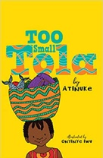  Too Small Tola  Atinuke | Earth Shattering Events  Robin Jacobs | 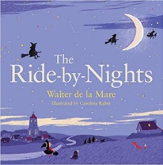  Ride-by-Nights  Walter de la Mare
Length | 15 Sessions, 3 weeks | 12 sessions, 2+ weeks | 15 Sessions, 3 weeks | 10 sessions, 2 weeks
Theme/Term | Literacy Tree theme: Relationships and Companionship Summer 1 |  | Discovery and Wonder Summer 2
LMTW | LMTW theme: 3 giant steps / Under the canopy / Lindow Man
Planning Sequence | Nen and the Lonely Fisherman  Ian Eagleton | 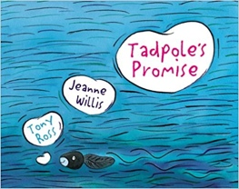  Tadpole’s Promise  Jeanne Willis | 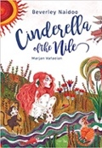  Cinderella of the Nile by Beverley Naidoo | 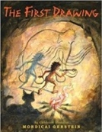  The First Drawing  Mordicai Gerstein
Length | 15 sessions, 3 weeks | 15 sessions, 3 weeks | 15 sessions, 3 weeks | 10 sessions, 2 weeks
Outcomes | Own version narrative  Lonely hearts advert character description, diary entries, message in a bottle | Own version narratives  Simple explanations, speech and thought bubbles, setting descriptions, extended explanations | Own version narratives  Descriptive passages, how to guides, letters, discussions, non-chronological reports | Own historical narratives  Character descriptions, diaries, recounts
Literary Leaf Text | 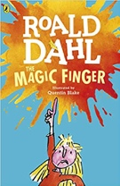  The Magic Finger  Roald Dahl | 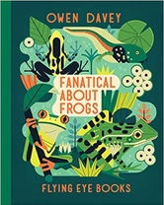  Fanatical about Frogs  Owen Davey | 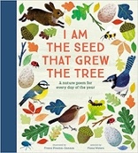  I am the Seed that Grew the Tree  Fiona Waters | 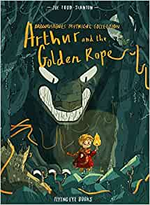  Arthur and the Golden Rope  Joe Todd Stanton
Length | 12 sessi0ns, 2+ weeks | 12 sessions, 2+ weeks | 12 Sessions, 2+ weeks | 15 sessions, 3 weeks

