Theme/Term | Literacy Tree theme: Leaders and Followers Autumn 1 |  | Dreams and Curiosity Autumn 2
LMTW | LMTW theme: Operation Pied Piper |  | (History)
Planning Sequence | 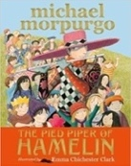  The Pied Piper of Hamelin  Michael Morpurgo | Wolves  Emily Gravett | The BFG  Roald Dahl | 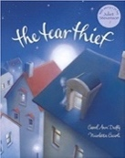  The Tear Thief  Carol Ann Duffy
Length | 15 sessions, 3 weeks | 15 sessions, 3 weeks | 15 sessions, 3 weeks | 10 sessions, 2 weeks
Outcomes | Own version myths/legends  Writing in role, information reports, adverts, formal letters | Non-chronological leaflets  Captions, information writing, character descriptions and comparisons | Own version fantasy narratives  Recount (diary entry), character descriptions, wanted posters, new chapters, instructions | Letters of explanation  Shared poems, persuasive posters, discussions
Literary Leaf Text | 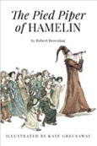  The Pied Piper of Hamelin  Robert Browning | 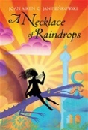  A Necklace of Raindrops  Joan Aiken | The BFG  Roald Dahl | 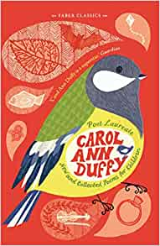  New and Collected Poems for Children  Carol Ann Duffy
Length | 10 sessions, 2 weeks | 14 sessions, 2+ weeks | 15 Sessions, 3 weeks | 10 Sessions, 2 weeks
Theme/Term | Magic and Truth Spring 1 |  | Fantasy Worlds Spring 2
LMTW | LMTW theme: A village world |  | Mobile Mystery
Planning Sequence | 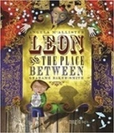  Leon and the Place Between  Angela McAllister | The Heart and the Bottle  Oliver Jeffers | 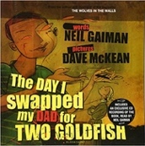  The Day I Swapped my Dad for Two Goldfish  Neil Gaiman | 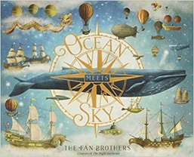  Ocean Meets Sky  Eric Fan and Terry Fan
Length | 15 sessions, 3 weeks | 17 sessions, 3+ weeks | 12 sessions, 3 weeks | 15 sessions, 3 weeks
Outcomes | Own version fantasy narratives  Persuasive posters, setting descriptions, thought bubbles/diaries, dialogue | Own version ‘dilemma’ narratives Character descriptions, narrative retellings | Own version narratives  Thought bubbles, missing scenes, diaries | Own version fantasy world narratives  Setting & character descriptions, labels, diaries, postcards, captain’s logs, instructions, dialogue
Literary Leaf Text | 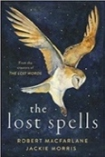  The Lost Spells  Robert MacFarlane | 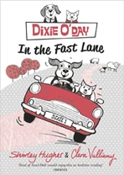  Dixie O’Day: In the Fast Lane  Clara Valliumy | 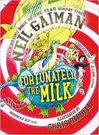  Fortunately, the Milk  Neil Gaiman | 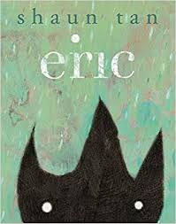  Eric  Shaun Tan
Length | 10 sessions, 2 weeks | 10 sessions, 2 weeks | 12 Sessions, 2+ weeks | 12 sessions, 2+ weeks
Theme/Term | Mystery and Discovery Summer 1 |  | Urban Metropolis Summer 2
LMTW | LMTW theme: (History) / The Dump / (History)
Planning Sequence | 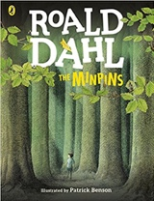  The Minpins  Roald Dahl | 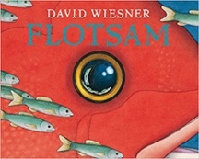  Flotsam  David Wiesner | 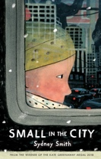  Small in the City by Sydney Smith | 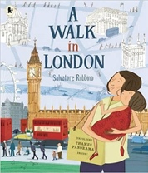  A Walk in London  Salvatore Rubbino
Length | 15 sessions, 3 weeks | 15 sessions, 3 weeks | 15 sessions, 3 weeks | 15 sessions, 3 weeks
Outcomes | Own version adventure narratives  Danger posters, setting descriptions, character descriptions, information reports, postcards | Sequels (mystery narratives)  Setting descriptions, narrative retellings, non-chronological reports, letters (informal) | Extended narrative from an alternative point of view  Setting description, poem, diary entry, dialogue, letter of advice, lost poster | A Walk in…’ guidebooks  Recounts of a trip around the local area, statements of information
Literary Leaf Text | 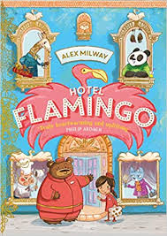  Hotel Flamingo  Alex Milway | Mr Penguin and the Lost Treasure  Alex T. Smith | 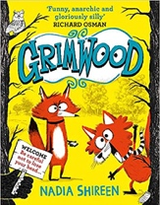  Grimwood  Nadia Shireen | 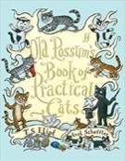  Old Possum’s Book of Practical Cats  T. S. Eliot
Length | 15 sessions, 3 weeks | 15 sessions, 3 weeks | 15 sessions, 3 weeks | 12 sessions, 2+ weeks

