Theme/Term | Literacy Tree theme: Individuality and Independence Autumn 1 |  | Lessons from History Autumn 2
LMTW | LMTW theme: Law and Order |  | May the Force be with You / Window on the World
Planning Sequence | 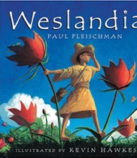  Weslandia  Paul Fleischman | 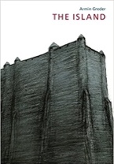  The Island  Armin Greder | 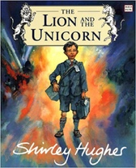  The Lion and the Unicorn  Shirley Hughes | Shackleton’s Journey  William Grill  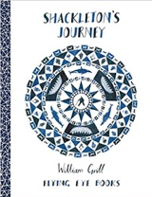
Length | 15 sessions, 3 weeks | 15 sessions, 3 weeks | 18 sessions, 3+ weeks | 15 sessions, 3 weeks
Outcomes | Imagined land narratives  Character description, informative posters, persuasive leaflets, log book | Sequel from a different perspective  Welcome guide, description, letter of advice, analysis comparison, diary entry in role, imagined conversation | Own version historical narratives  Letters, diaries, character and setting descriptions, non-chronological reports | Tutankhamun Biographies  Reports, instructions, character descriptions, diaries, newspaper, posters
Literary Leaf Text | 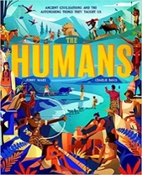  The Humans: Ancient civilisations  Jonny Marx | 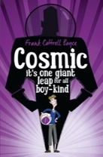  Cosmic Frank Cottrell Boyce | 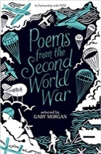  Poems from the Second World War  Gaby Morgan | 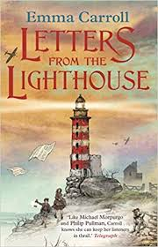  Letters from the Lighthouse  Emma Carroll
Length | 15 sessions, 3 weeks | 19 sessions, 3+ weeks | 15 sessions, 3 weeks | 16 sessions, 3+ weeks
Theme/Term | Literacy Tree theme: Finding for Freedom Spring 1 |  | Loneliness and Belonging Spring 2
LMTW | LMTW theme: Cry Freedom |  | Lightning Speed
Planning Sequence | 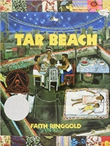  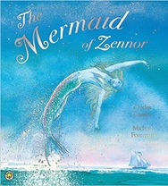  Tar Beach  Faith Ringgold | 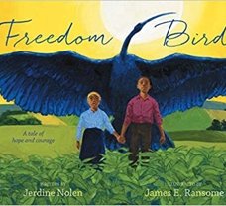  Freedom Bird  Jerdine Nolen | 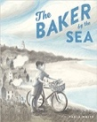  OR Baker by the Sea  Paula White | 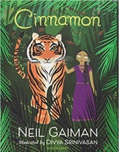  Cinnamon  Neil Gaiman
Length | 15 sessions, 3 weeks | 15 sessions, 3 weeks | 15 sessions, 3 weeks | 16 sessions, 3+ weeks
Outcomes | Narrative retelling as a play script  Poetry, setting descriptions, formal letters, dialogue (as a script) | Biographies  Writing in role, thought bubbles, dialogue, postcards, recounts, poems | Tourist brochure  Job applications, advertisements, setting descriptions, letter in role | Own version mythical tales  Diaries, informal letters, dialogue, adverts, limericks and other poetic forms
Literary Leaf Text | 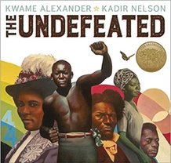  Undefeated  Kwame Alexander | 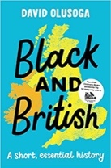  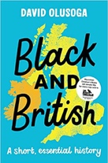  Black and British: A short, essential history  David Olusoga | 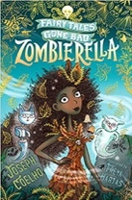  Zombierella  Joseph Coelho | 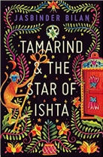  Tamarind and the Star of Ishta  Jasbinder Bilan
Length | 15 sessions, 3 weeks | 15 sessions, 3 weeks | 15 sessions, 3 weeks | 15 sessions, 3 weeks
Theme/Term | Literacy Tree theme: Sprites and Spirits Summer 1 |  | Gods and Monsters Summer 2
LMTW | LMTW theme: Saxon King / Picture our Planet / Viking Warrior
Planning Sequence | 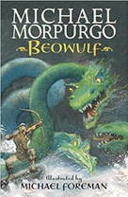  Beowulf  Michael Morpurgo | 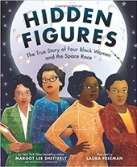  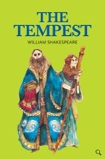  The Tempest  William Shakespeare | 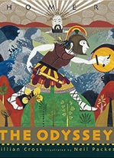  The Odyssey  Gillian Cross | 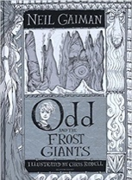  Odd and the Frost Giants  Neil Gaiman
Length | 15 sessions, 3 weeks | 14+ sessions, 3 + weeks | 20 sessions, 4 weeks | 15 sessions, 3 weeks
Outcomes | Own version legends/missing chapters Letters of advice, diaries, dialogue, character and setting descriptions, action scenes, obituaries | Playscripts  Setting descriptions, character descriptions, diaries, dialogue | Epic stories Speeches (proclamation, persuasive, soliloquy), dialogue, missing scenes, postcards, adverts | Retellings - alternative perspective  Narrative recounts, character and setting descriptions, letters, short explanations
Literary Leaf Text | 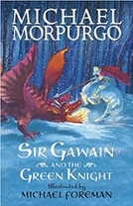  Sir Gawain and the Green Knight  Michael Morpurgo | The Polar Bear Explorers' Club  Alex Bell | 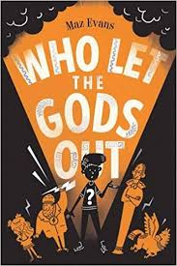  Who Let the Gods Out  Maz Evans | 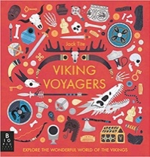  Viking Voyagers  Jack Tite
Length | 15 sessions, 3 weeks | 18 sessions, 3+ weeks | 14 sessions, 2+ weeks | 15 sessions, 3 weeks

