Theme/Term | Literacy Tree theme: Dreams and Fantasy Autumn 1 |  | Pride and Courage Autumn 2
LMTW | LMTW theme: Clash of the Titans |  | (Geog) / (Hist)
Planning Sequence | 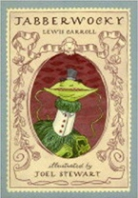  Jabberwocky  Lewis Carroll | 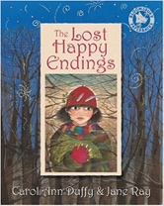  The Lost Happy Endings  Carol Ann Duffy | 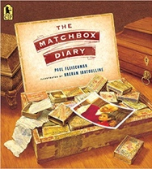  The Matchbox Diary  Paul Fleischman | 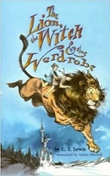  The Lion the Witch and the Wardrobe  C. S. Lewis
Length | 10 sessions, 2 weeks | 15 sessions, 3 weeks | 15 sessions, 3 weeks | 20 sessions, 4 weeks
Outcomes | Nonsense poems  Performance poetry, explanatory descriptions | Alternative perspective prequels -  Newspaper reports, extended responses to a text | Biography  Dialogue, diary entry, re-telling (oral dictation), mini-autobiography, fact file | Own version narratives (set in other worlds)  Poems, eyewitness reports, an imaginary conversations, writing in role
Literary Leaf Text | The Listeners  Walter de la Mare | 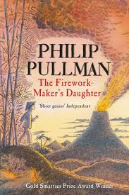  The Firework Maker's Daughter  Philip Pullman | 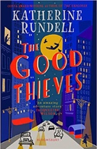  The Good Thieves  Katherine Rundell | The Lion the Witch and the Wardrobe  C. S. Lewis
Length | 10 sessions, 2 weeks | 14 sessions, 2+ weeks | 15 sessions, 3 weeks | 20 sessions, 4 weeks
Theme/Term | Literacy Tree theme: Relationships and Companionship Spring 1 |  | Humanity and Machinery Spring 2
LMTW | LMTW theme: World of Difference |  | Hot off the Press
Planning Sequence | 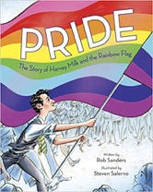  OR Pride: The Story of Harvey Milk and the Rainbow Flag  Rob Sanders | 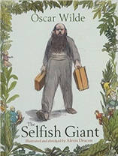  The Selfish Giant  Oscar Wilde | 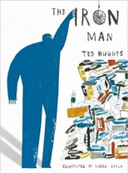  The Iron Man  Ted Hughes | 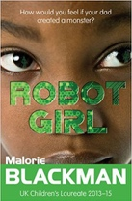  Robot Girl  Malorie Blackman
Length | 10 sessions, 2 weeks | 15 sessions, 3 weeks | 15 sessions, 3 weeks | 15 sessions, 3 weeks
Outcomes | Biographies of Harvey Milk  Thought bubbles, speech, simple leaflets | Own version narratives about kindness  Letters, first person recounts, diaries, letters, posters, reports | Mystery narratives  Character descriptions, short news reports, letters of advice, menus (using descriptive devices), poetry | Science-fiction narratives  Discussions, debates, dialogue, character comparisons, reviews
Literary Leaf Text | 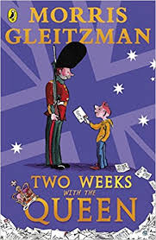  Two Weeks with the Queen  Morris Gleitzman | 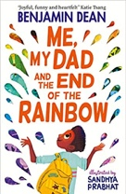  Me, My Dad and the End of the Rainbow  Benjamin Dean | 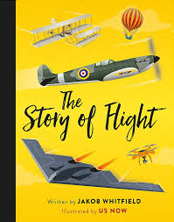  The Story of Flight  Jakob Whitfields | 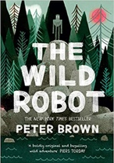  The Wild Robot  Peter Brown
Length | 16 sessions, 3+ weeks | 15 sessions, 3 weeks | 12 sessions, 2+ weeks | 15 sessions, 3 weeks
Theme/Term | Literacy Tree theme: Inventions and innovation Summer 1 |  | Mystery and Truth Summer 2
LMTW | LMTW theme: (Science) / The Bees Knees / (History)
Planning Sequence | 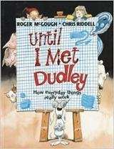  Until I Met Dudley  Roger McGough and Chris Riddell | 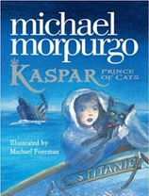  Kaspar, Prince of Cats  Michael Morpurgo | 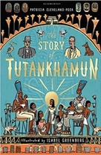  The Story of Tutankhamun  Patricia Cleveland-Peck | 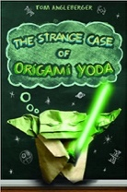  Origami Yoda  Tom Angleberger
Length | 10 sessions, 2 weeks | 15 sessions, 3 weeks | 15 sessions, 3 weeks | 15 sessions, 3 weeks
Outcomes | Two explanation texts - formal and informal  Letters, short explanatory paragraphs | Newspaper articles  Character descriptions, reports, letters, advertising leaflets, balanced reports | Non-chronological reports  Retelling, character description, book review | Discussion texts  Instructions, persuasion, diaries
Literary Leaf Text | 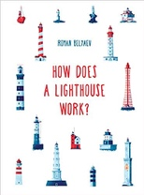  How Does a Lighthouse Work?  Roman Belyaev | 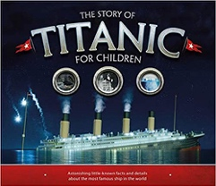  The Story of Titanic for Children Joe Fullman | 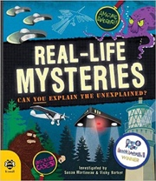  Real-life Mysteries: Can you explain the unexplained?  Susan Martineau and Vicky Barker | 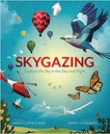  Skygazing  Anna Claybourne
Length | 12 sessions, 2+ weeks | 15 sessions, 3 weeks | 15 sessions, 3 weeks | 15 sessions, 3 weeks

