Theme/Term | Literacy Tree theme: Evolution and Inheritance Autumn 1 |  | Crime and Punishment Autumn2
LMTW | LMTW theme: Wars of the Worlds |  | In your element / True Crime
Planning Sequence | 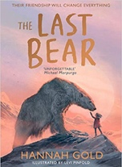  The Last Bear  Hannah Gold | 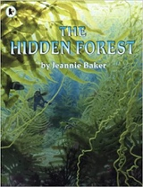  The Hidden Forest  Jeannie Baker | 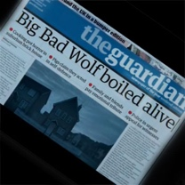  The Three Little Pigs Project  The Guardian | 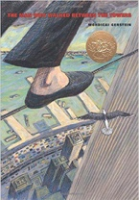  The Man Who Walked Between the Towers  Mordicai Gerstein
Length | 15 sessions, 3 weeks | 16 sessions, 3+ weeks | 11 sessions, 2+ weeks | 12 sessions, 2+ weeks
Outcomes | Newspaper article  Character profile, dialogue, monologue, logbook entry, scientific report | Balanced discussions  Research notes, non-chronological reports in the form of a letter to a character | Discussion texts  News reports, persuasive speeches, narratives from a particular point of view, interview scripts, diaries, debates | Biographies/autobiographies  Information writing (Wikipedia pages), letters of advice (formal), interviews, news report, persuasive speeches
Literary Leaf Text | 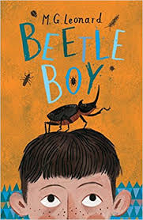  Beetle Boy  M. G. Leonard | 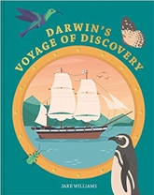  Darwin’s Voyage of Discovery  Jake Williams
Length | 15 sessions, 3 weeks | 12 sessions, 2+ weeks
Theme/Term | Literacy Tree theme: Legends, folklore and Fairy tales Spring 1 |  | Affirmation and Equality Spring 2
LMTW | LMTW theme:Come fly with me – America |  | World of Bright Ideas
Planning Sequence | 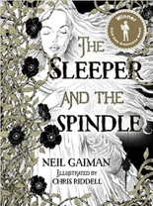  The Sleeper and the Spindle  Neil Gaiman and Chris Riddell | 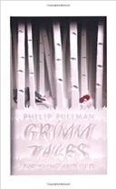  Grimm Tales for Young and Old  Phillip Pullman | 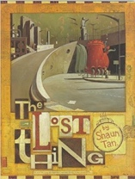  The Lost Thing  Shaun Tan | 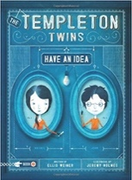  The Templeton Twins: Have an Idea  Ellis Weiner
Length | 17 sessions, 3+ weeks | 15 sessions, 3 weeks | 16 sessions, 3+ weeks | 15 sessions, 3 weeks
Outcomes | Fairytale reworkings  Warning posters, diaries, dialogue, estate agent’s descriptions, character descriptions, missing narratives | Own version traditional tales  Viewpoint retellings, character studies, monologues, character comparisons | Own version fantasy narratives  Diaries, formal letters, adverts, character and setting descriptions, non-chronological reports | Own version adventure narratives  Character analysis, opposing diary entries, informal letters, own chapters
Literary Leaf Text | 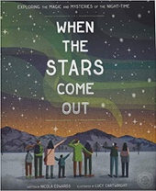  When the Stars Come Out  Nicola Edwards | Grimm Tales for Young and Old  Phillip Pullman | 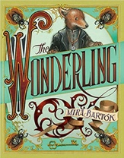  The Wonderling  Mira Bartok | 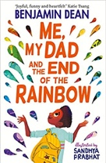  Me, My Dad and the End of the Rainbow  Benjamin Dean
Length | 12 sessions, 3 weeks | 15 sessions, 3 weeks | 15 sessions, 3 weeks | 15 sessions, 3 weeks
Theme/Term | Literacy Tree theme: Utopia and Dystopia Summer 1 |  | Fate and Fortune Summer 2
LMTW | LMTW theme: Go with the Flow / Full of Beans / British Bulldog
Planning Sequence | 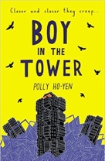  Boy in the Tower  Polly Ho-Yen | 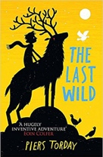  The Last Wild  Piers Torday | 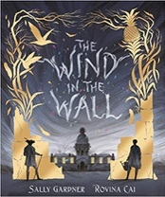  The Wind in the Wall  Sally Gardner | 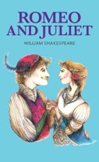  Romeo and Juliet  William Shakespeare
Length | 15 sessions, 3 weeks | 16 sessions, 3+ weeks |  | 15 sessions, 3+ weeks
Outcomes | Own version narratives (past and present tense)  Journalistic writing, formal letters, non-chronological reports | Own version dystopian narratives  Posters, retellings, formal reports, character descriptions, diaries, formal letters | Extended Gothic narrative  Posters, figurative writing, descriptions, old English letter, dialogue | Playscripts  Diaries, letters, narratives, character descriptions, balanced arguments
Literary Leaf Text | 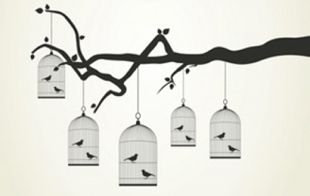  Caged Bird  Maya Angelou | 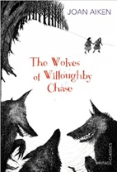  The Wolves of Willoughby Chase  Joan Aiken | 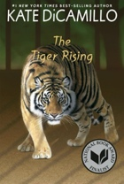  The Tiger Rising  Kate DiCamillo | 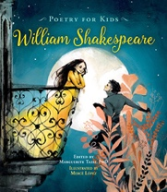  Poetry for Kids: William Shakespeare illustrated edition  William Shakespeare
Length | 10 sessions, 2 weeks | 15 sessions, 3 weeks | 18 sessions, 3+ weeks | 15 sessions, 3 weeks

