Theme/Term | Literacy Tree theme: Sprites and Spirits Autumn 1 |  | Lessons from History Autumn 2
LMTW | LMTW theme: You’re not invited |  | Been Around the World / Pharaoh Queen
Planning Sequence | 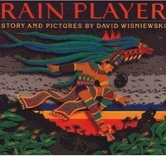  Rain Player  David Wisniewski | 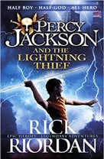  Percy Jackson  Rick Riordan | 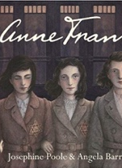  Anne Frank  Josephine Poole | 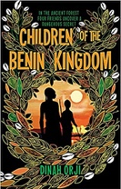  Children of the Benin Kingdom  Dina Orji
Length | 15 sessions, 3 weeks | 20 sessions, 4 weeks | 10 sessions, 2+ weeks | 15 sessions, 3 weeks
Outcomes | Analytical essays about The Maya  Instructions, posters, missing scenes, diaries, newspapers, debates | Mythical narratives  Odes, soliloquies, setting descriptions, additional chapters, reports | Newspaper articles  Letters, short descriptions, extended diary entries, obituaries, opinion pieces | Non-chronological reports  Informal letters, diaries, survival guides, eyewitness reports, story summaries
Literary Leaf Text | 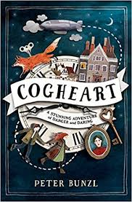  Cogheart  Peter Bunzl | 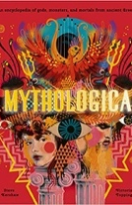  Mythologica  Dr. Stephen P. Kershaw | After the War: From Auschwitz to Ambleside  Tom Palmer | 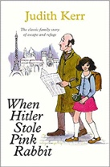  When Hitler Stole Pink Rabbit  Judith Kerr
Length | 16 sessions, 3+ weeks | 15 sessions, 3 weeks | 15 sessions, 3 weeks | 15 sessions, 3 weeks
Theme/Term | Literacy Tree theme: Migration and Movement Spring 1 |  | Inspiration and Activism Spring 2
LMTW | LMTW theme: I have a Dream |  | Mission Control
Planning Sequence | 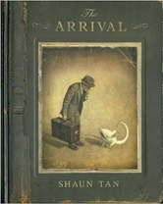  The Arrival  Shaun Tan | 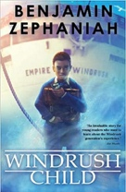  Windrush Child  Benjamin Zephaniah | 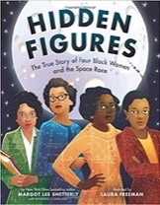  Hidden Figures  Margot Lee Shetterly | 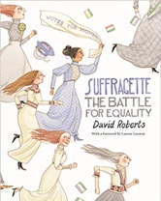  Suffragette: The Battle for Equality  David Roberts
Length | 17 sessions, 3+ weeks | 15 sessions, 3 weeks | 17+ sessions, 3+ weeks | 10 sessions, 2 weeks
Outcomes | Extended own version narratives  Letters, lists of rules, character descriptions, diaries, short playscripts, short reports, guides | Persuasive pitch to the local council  Thought bubble, informal letter, poem, diary entry, advice, informal letter | Memoirs  Reports, formal and informal letters, diaries, character descriptions, journalistic writing | Persuasive campaigns  Formal letters, diaries, balanced arguments, speeches, short news reports
Literary Leaf Text | 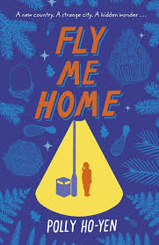  Fly Me Home  Polly Ho Yen | 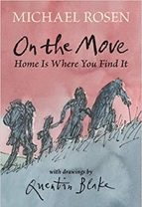  On the Move: Poems about Migration\  Michael Rosen | 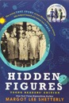  Hidden Figures Young Readers’ Edition  Margot Lee Shetterly | The Little Match Girl Strikes Back  Lauren Child
Length | 15 sessions, 3 weeks | 15 sessions, 3 weeks | 15 sessions, 3 weeks | 15 sessions, 3 weeks
Theme/Term | Literacy Tree theme: Solving Mysteries Summer 1 |  | A Sense of Place Summer 2
LMTW | LMTW theme: Time Team / Global Warning / Rescuers
Planning Sequence | 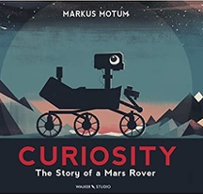  Curiosity  Markus Motum | 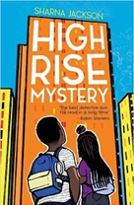  High Rise Mystery  Sharna Jackson | 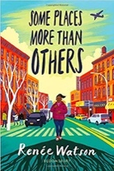  Some Places More Than Others  Renee Watson | 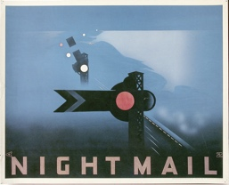  Night Mail  W H Auden
Length | 15 sessions, 3 weeks | 15 sessions, 3 weeks | 10 session, 2 weeks | 15 sessions, 3 weeks
Outcomes | Expanded explanations  NASA Proposals, information labels, short explanations, NASA logs, news reports | Extended stories Character & setting descriptions, police & newspaper report, dialogue, persuasive letters | Poems with similar structure  Summaries, analysis and performances | Poetry  Letters, diaries, information leaflets, instructions
Literary Leaf Text | 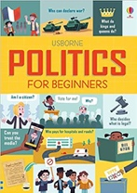  Politics for Beginners Louie Stowell | 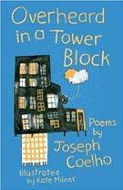  Overheard in a Tower Block  Joseph Coelho | 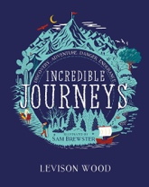  Incredible Journeys  Levison Wood | 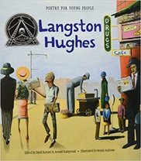  Poetry for Young People: Langston Hughes  Benny Andrews
Length | 15 sessions, 3 weeks | 10 sessions, 2 weeks | 15 sessions, 3 weeks | 15 sessions, 3 weeks

