Theme/Term | Literacy Tree theme: Outside Inside Autumn 1 |  | Literacy Tree theme: Knowing Yourself Autumn 2
LMTW | LMTW theme: Help is at Hand |  | Humpty and Friends / Way Back When – Hats
Planning Sequence | 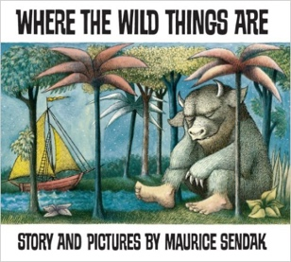  Where the Wild Things Are  Maurice Sendak | 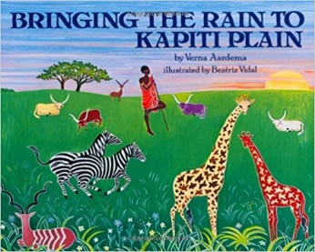  Bringing the Rain to Kapiti Plain  Verma Aardema | 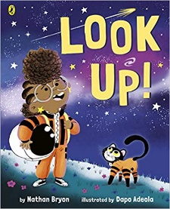  Look up!  Nathan Bryon and Dapo Adeola | 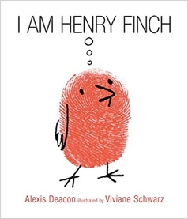  I am Henry Finch  Alexis Deacon
Length | 10+ sessions, 2+weeks | 10+ sessions, 2+weeks | 10+ sessions, 2+weeks | 10+ sessions, 2+weeks
Outcomes | Own version ‘wild thing’ narratives  Labels, captions, oral re-telling, developing a new character | Tourist information leaflets  Labels and captions, retellings, simple explanations | Non-chronological reports  Dialogue, diaries, re-telling (oral dictation), mini-autobiography, ship’s log | Guidebooks - How to Think  Timetables, thought-bubbles, lists, commands, letters of advice
Theme/Term | Literacy Tree theme: Talents & powers Spring 1 |  | Literacy Tree theme: Sowing a seed Spring 2
LMTW | LMTW theme: Under the Sea |  | What on Earth
Planning Sequence | 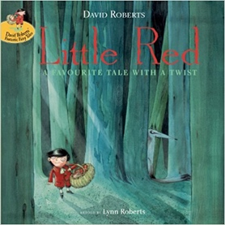  Little Red  Lynn Roberts and David Roberts | 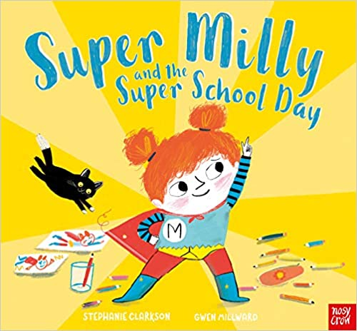  Super Milly and the Super School Day  Stephanie Clarkson | 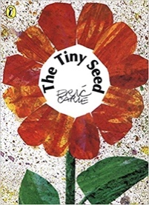  The Tiny Seed  Eric Carle | 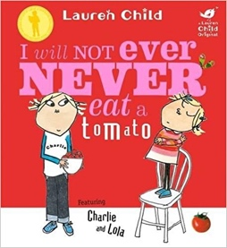  I Will Not Ever Never Eat a Tomato  Lauren Child
Length | 10+ sessions, 2+weeks | 10+ sessions, 2+ weeks | 10+ sessions, 2+weeks | 10+ sessions, 2+weeks
Outcomes | Alternative character versions  Labels, notes of advice, adverts | Alternative character version  Letters of encouragement; a retelling; song lyrics and job applications | Advice leaflets  Labels and captions, advice, retellings, writing in role, narrative, letter | Own stories about a fussy eaters  Statements, writing in role, shopping lists
Theme/Term | Literacy Tree theme: Strength of mind Summer 1 |  | Literacy Tree theme: Family & friends Summer 2
LMTW | LMTW themes: Food glorious food / Happy to be Me / If you go down to the woods  LMTW theme: Happy to be Me
Planning Sequence | 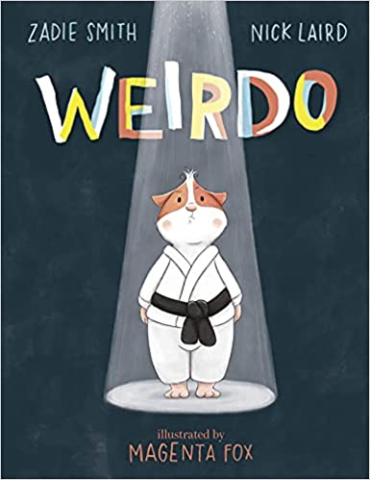  Weirdo  Zadie Smith and Nick Laird | 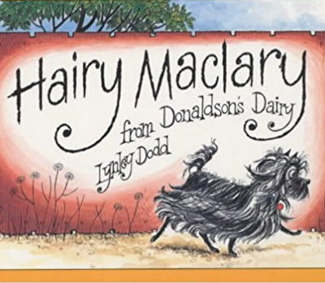  Hairy Maclary from Donaldson’s Dairy  Lynley Dodd | 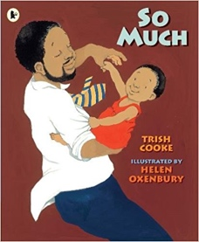  So Much  Trish Cooke and Helen Oxenbury | 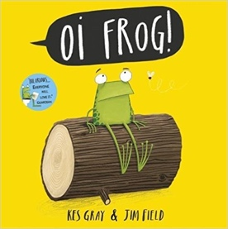  Oi! Frog  Kes Gray and Jim Field
Length | 10+ sessions, 2+weeks | 10+ sessions, 2+weeks | 10+ sessions, 2+weeks | 10+ sessions, 2+weeks
Outcomes | Instructional guides to being brave  Writing in role, letters, captions and labels, narrative retellings | Alternative version narratives  Character description, writing in role, letters, leaflets | Own ‘So Much’ narrative poems  Past tense sentences, writing in role, performance/ narrative poetry | Own version rhyming narratives  Rhyming flipbooks, questions, captions and labels

