Theme/Term | Literacy Tree theme: Outside Inside Autumn 1 |  | Knowing Yourself Autumn 2
LMTW | LMTW theme: Lets play |  | Way Back When – Bikes / Animal Crackers
Planning Sequence | 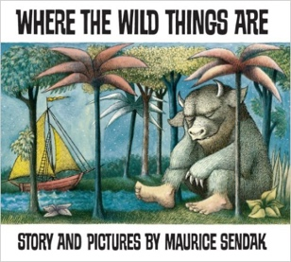  Where the Wild Things Are  Maurice Sendak | 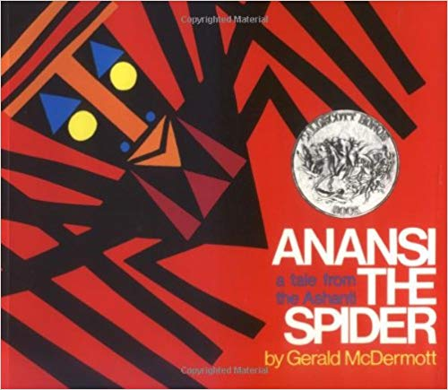  Anansi  Gerald McDermott | 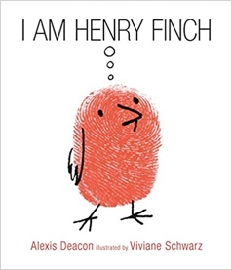  I am Henry Finch  Alexis Deacon | 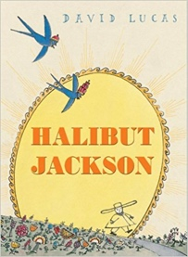  Halibut Jackson  David Lucas
Length | 10+ sessions, 2+weeks | 10+ sessions, 2+weeks | 10+ sessions, 2+weeks | 10+ sessions, 2+ weeks
Outcomes | Own version ‘wild thing’ narratives  Labels, captions, oral re-telling, developing a new character | Booklets about spiders  Labels and captions, call-and-response poems, descriptive posters, simple explanations | Guidebooks - How to Think  Timetables, thought-bubbles, lists, commands, letters of advice | Narrative sequels  Signs and labels, captions, invitations, thought bubbles, advertisements, letters of advice
Theme/Term | Talents & powers Spring 1 |  | Sowing a seed Spring 2
LMTW | LMTW theme: Come fly with me - Asia |  | Tell us a story
Planning Sequence | 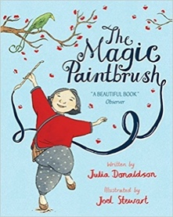  The Magic Paintbrush  Julia Donaldson and Joel Stewart | 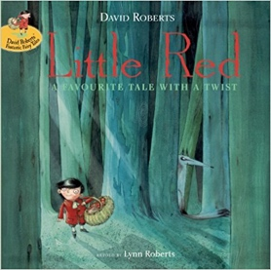  Little Red  Lynn Roberts and David Roberts | 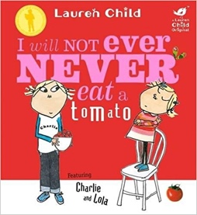  I Will Not Ever Never Eat a Tomato  Lauren Child | 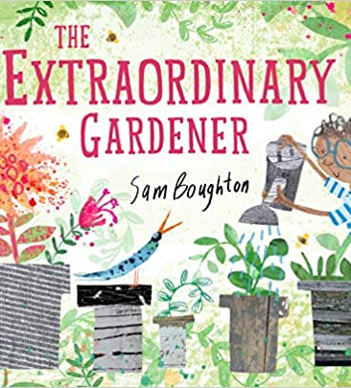  The Extraordinary Gardener  Sam Boughton
Length | 10+ sessions, 2+weeks | 10+ sessions, 2+weeks | 10+ sessions, 2+weeks | 10+ sessions, 2+ weeks
Outcomes | Own version ‘overcoming’ tales  Thought bubbles, labels, oral re-telling, writing in role, thank you letters | Alternative character versions  Labels, notes of advice, adverts | Own stories about a fussy eaters  Statements, writing in role, shopping lists | Narrative inspired by the original text  Labels, letters of advice, instructions, narratives
Theme/Term | Strength of mind Summer 1 |  | Family & friends Summer 2
LMTW | LMTW theme: Over the rainbow / No place like home / Ticket to ride
Planning Sequence | 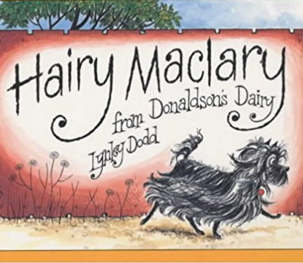  Hairy Maclary from Donaldson’s Dairy  Lynley Dodd | 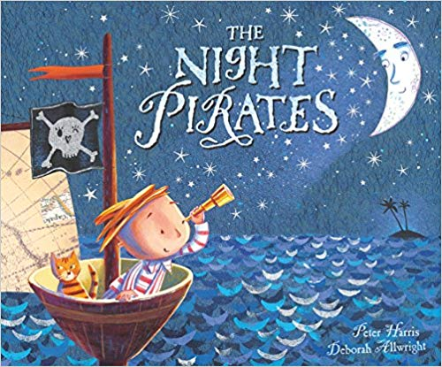  The Night Pirates  Pete Harris and Deborah Allwright | 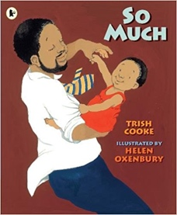  So Much  Trish Cooke and Helen Oxenbury | 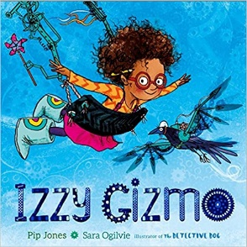  Izzy Gizmo  Pip Jones
Length | 10+ sessions, 2+weeks | 10+ sessions, 2+weeks | 10+ sessions, 2+weeks | 10+ sessions, 2+ weeks
Outcomes | Alternative version narratives  Character description, writing in role, letters, leaflets | ‘How to be a pirate’ guides  Writing in role, letters, labels and captions | Own ‘So Much’ narrative poems  Past tense sentences, writing in role, performance/ narrative poetry | Simple explanation  Signage, letters of advice, lists, labelled diagrams

