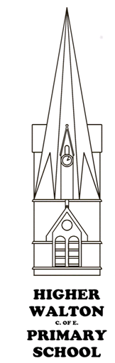
Higher Walton CE Primary School Music LTP
Cycle B  2023-24 | Autumn Term 1 | Autumn Term 2 | Spring Term 1 | Spring Term 2 | Summer Term 1 | Summer Term 2
Pathfinders  Year 1/2 | My musical heartbeat | Christmas song practice | Exploring sounds | Learning to listen | Having fun | Let’s perform together
Discoverers  Year 2/3 | Glockenspiel 1 | Christmas song practice | Glockenspiel 2 | Playing in a band | Recognising different sounds | Our big concert
Adventurers Year 3/4 | Recorder 1 | Recorder 2 | Musical structure | More musical styles | Exploring feelings when you play | Opening night
Navigators Year 5/6 | happy | Livin’ on a prayer | You’ve got a friend | Make you feel my love | Dancing in the street | Music and me

Higher Walton CE Primary School Music LTP
Cycle A  2024-25 | Autumn Term 1 | Autumn Term 2 | Spring Term 1 | Spring Term 2 | Summer Term 1 | Summer Term 2
Pathfinders  Year 1/2 | Dance, sing, play | Christmas song practice | Hey you | In the groove | Round and round | Our big concert
Discoverers  Year 2/3 | Hands, feet, heart | Christmas song practice | Three little birds | Friendship song | Zoo time | Opening night
Adventurers Year 3/4 | Blackbird | Mamma Mia | The dragon song | Bringing us together | Lean on me | The show must go on
Navigators Year 5/6 | Jazz 1 | Jazz 2 | New Year Carol | Fresh Prince | Melody and harmony in music | Do what you want to

