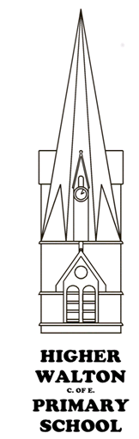
Higher Walton CE Primary School Science LTP
Cycle B  2023-24 | Autumn Term | Spring Term | Summer Term
Topic Title | Explorers | Fire! Fire! | Our home: Higher Walton
Pathfinders  Year 1 | Living Things and their habitats - animals  Animals including Humans. | Materials – identify and name, describe properties.  Living Things and their habitats – plants (naming, how they grow) | Materials – Compare suitability  Living Things and their habitats – plants (structure and needs)
Topic Title | Explorers | Fire! Fire! | Our home: Higher Walton
Discoverers  Year 2 | Living Things and their habitats - animals  Animals including Humans. | Materials – identify and name, describe properties.  Living Things and their habitats – plants (naming, how they grow) | Materials – Compare suitability  Living Things and their habitats – plants (structure and needs)
Topic Title | Rotten Romans | The Industrial revolution | Heal the world
Adventurers Year 3/4 | Rocks  States of matter | Forces and magnets  Electricity | Living things and their Habitat
Topic Title | Raiders and Traders  (Vikings and Anglo Saxons) | (World War II) | Under the Canopy  (Rivers and the Amazon)
Navigators Year 5/6 | Properties and changes of materials | Electricity  Light | Living things and their habitats  Evolution and inheritance

Higher Walton CE Primary School Science LTP
Cycle A  2024-25 | Autumn Term | Spring Term | Summer Term
Topic Title | Doctor, Doctor | I’m the king of the castle | Seaside
Pathfinders  Year 1/2 | Animals including Humans  Living things and their habitats | Materials  Plants  Living things and their habitats | Materials  Plants
Topic Title | Doctor, Doctor | I’m the king of the castle | Seaside
Discoverers  Year 2/3 | Animals including Humans  Living things and their habitats | Materials  Plants  Living things and their habitats | Materials  Plants
Topic Title | Through the ages | Cry Freedom | Awesome Egyptians
Adventurers Year 3/4 | Animals including Humans | Light  Sound | Plants
Topic Title | Temple Run  (Ancient Maya) | Space the Final Frontier | Eureka!  (Greeks)
Navigators Year 5/6 | Living things and their habitats | Earth and Space  Forces | Animals including humans

