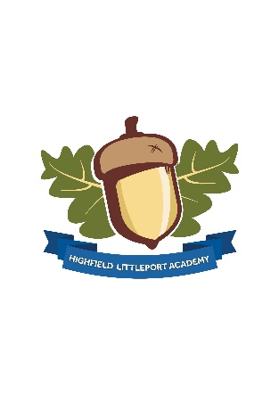

Friday 21st May 2021

**HLA News**

Dear Families,

We have had a great week here at Highfield with lots of learning and engagement happening. In our Blue pathway class I saw some fantastic communication using communication books and switches. This goes a long way to promoting students independence which is great to see.

Our Lower Green pathway classes have been continuing to focus their learning around Pirates. There has been some great work on pencil control with students tracing lines from the pirate to the treasure. Ah Ha me hearties!

As a leadership and teaching team we are continually working to improve our curriculum and ensure it is as exciting and meaningful to learners as possible. One of our students in our Upper Yellow class was delighted when I fed back to him that we were incorporating some learning around Japan and Manga Art following his suggestions into a ‘Tales from the Orient’ theme we have been working on.

The lift unfortunately is out of action again. We have put plan B into action as I type and all classes are moving downstairs who need to be until we have a permanent fix. This will all be completed by Monday. On a further note, as a school we have taken your comments about parking on board and put some plans into action. We have consulted with contractors in the last few weeks to get works completed in the car park so that things are a lot smoother at drop off and pick up times. The shelters are being removed today and we will be working on a plan in the next few weeks to organise a more efficient parking arrangement for all concerned.

Have a good weekend all,

Best wishes,

Yvonne Skillern, Head of School

**Golden Book**

**Stars of the Week**

S5 Student - Choosing to do the EXTREME level maths challenges for his LECA homework

Robins Student - Wonderful writing in a phonics lesson

Robins Student - Great Topic writing

Swallows Student - Showing kindness and patience with helping a peer in ICT

Swallows Student - Excellent focus and concentration in Maths to be able to complete missing   
 number problems using the part whole method

Swallows Student - Showing great resilience in PE to be able to improve her jumping

Sparrows Student - Coming back to school with great enthusiasm and always having a smile on his   
 face

Sparrows Student - Being kind and helpful and doing her best in all activities

Owls Student - Fantastic joining in with his friends at snack and playtimes

Swallows Student - Showing kindness and patience with helping a peer in ICT

Puffins Student - Fantastic football skills in PE

Puffins Student - Devising and making his own board game. It was fantastic

S1 Student - Showing excellent determination and resilience completing the hurdles during PE!

**Well done everyone!**

**Important Information**

* **Week commencing 5th July** we will be generating end of year progress information and reports on Evidence for Learning. These will be available to view via your personal login on your laptop or mobile device. Please contact the office if you need a password reset or help logging on. There is a helpful video on our website too.
* **Virtual parent consultations at your request on Wednesday 14th July between 3.30pm and 6pm**. Appointments will be organised shortly after half term.
* **Could we please ask that students do not bring in metal ‘chilly bottles’ and have a plastic alternative**? When thrown these can pose a significant health and safety hazard.
* A reminder for our year 11 students who are moving on to college. Please ensure you return reply slips to indicate if your child intends to leave on 25th June 2021 or stay on in school until the end of term.
* Secondary students please do not forget to complete home Covid tests on Sunday and Wednesday evenings. Please ensure you report results to both the government website and [covid@highfieldlittleport.org](mailto:covid@highfieldlittleport.org)

**Careers Information**

**Online Careers Event – Friday 28th May 10am**

If your child is in Year 9 or over, it is a good time to start thinking about different career and post-16 options with them. The Cambridgeshire Additional Needs Team are hosting a virtual Pathway to Employment event on Friday 28th May 10-11:30am. S5 pupils will be joining this in school but parents are also invited to join the virtual event if you would like further information about different career pathways for your child. You will need to register and then you will be sent a Zoom link. <https://www.eventbrite.co.uk/e/pathway-to-employment-online-skills-event-tickets-152377133107> Please also see the flyer attached for further information.

**Online Safety Tip of the Week**

Most online games and apps come with age ratings attached. Remember to check the age ratings before allowing children to use games or apps and look into the reason why is has that age rating, it might be linked directly to the content or it might be to do with how users of the game can be contacted by other users. Just because an app or game has an age rating, it doesn’t mean it is definitely appropriate for your child. Each child is different! Try exploring apps and games together and be open about your concerns. If you decide a game or an app is not appropriate, explain your reasons why. If you have any concerns about your child’s online behaviour, you can discuss this with their class teacher or our online safety lead, Tilly Newbury.

For further information, you can visit: <https://www.net-aware.org.uk/news/age-content-ratings-apps-games/>



**Student Focus**

We are working hard as a school to increase our Eco Awareness and a student in S5 has worked extremely hard to promote recycling of paper and card at school. Our challenge now is to continue his legacy after he leaves HLA at the end of this year.

We now have recycling bags in each classroom and near photocopiers and the students are actively making sure we recycle paper and card and empty it into the bin on a weekly basis. Well done everyone!

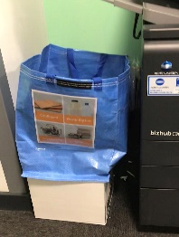

**Loving Learning at HLA…**

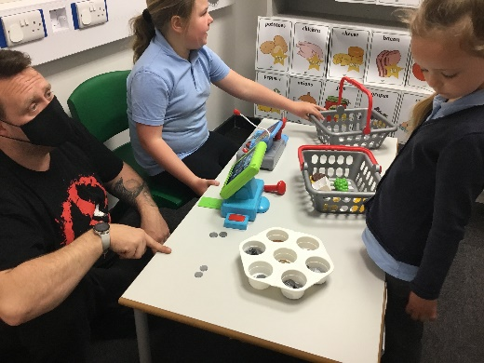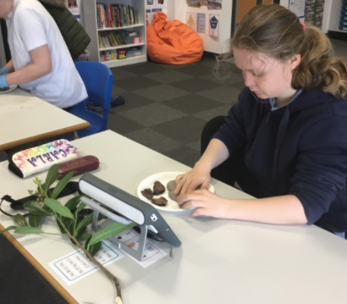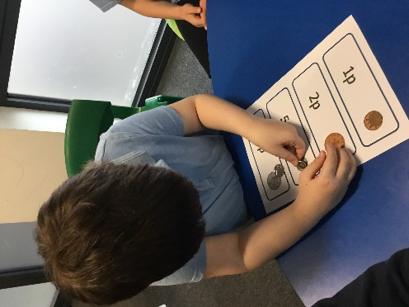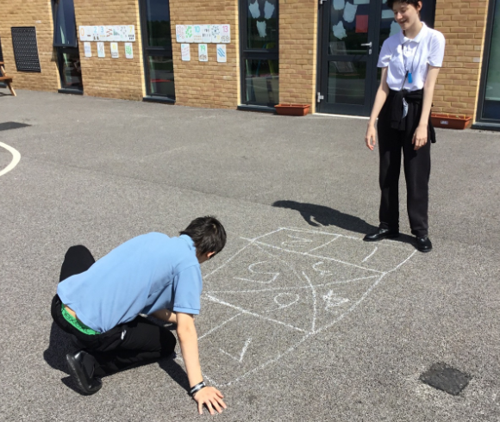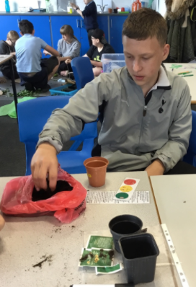

Counting money and applying skills in the shop.

Developing awareness of money by matching coins.

Creating nature themed crafts and using communication devices throughout the curriculum.

Designing engaging playground games as part of our ASDAN challenge.

Planting seeds donated from Morrisons as part of our learning about plants and animals.