Staff Handbook

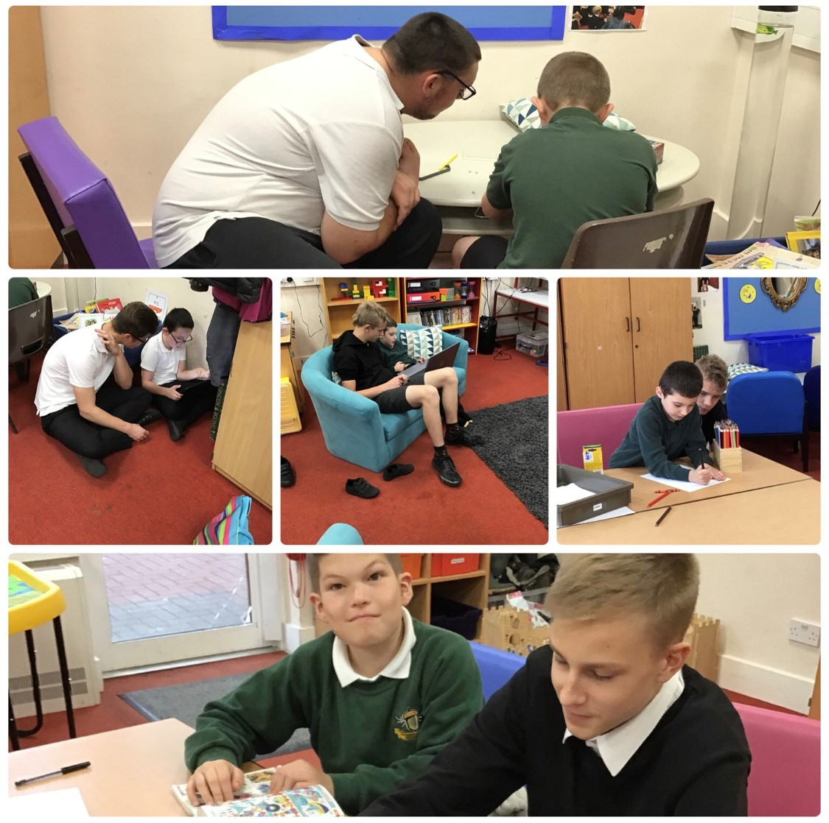

Highfield Ely Academy

“The best progress for all of our young people, whatever their starting point”

At Highfield we strive to provide a supportive, safe, nurturing and rich environment that ensures the best possible progress for all of our learners. We celebrate the small and larger steps of progress our learners make.

We continually review and develop our provision to meet the changing needs of our school population. Communication, social and emotional needs are central to providing an outstanding level of provision. We aim to provide a fun, pupil-centred and flexible curriculum that teaches skills for life and sets learners up well for their future.

INTRODUCTION

About the School

We hope that this booklet will give you as much information as you need about the day-to-day running of our school.

Special schools can seem very complex places to work because of the wide range of ages and abilities of our students and the different routines that operate in different parts of the school. However, you will find the staff at this school are friendly and always willing to help.

The information given in this handbook is not a set of rules but a summary of current practice for staff at the time of writing. It is expected that staff will adhere to these codes of practice so that the day-to-day life of the school runs smoothly.

Every person on the staff is regarded as a valuable member of the team. If you have any ideas, suggestions or concerns, the Executive Headteacher or Head of School would be pleased to hear them. We are all here to give the best possible education to the children who attend the school and to be an integral and valued asset to the community of Ely.

CHILD PROTECTION

Child Protection and Safeguarding is paramount in any school. This is especially the case for us as each individual pupil is additionally vulnerable due to their special educational needs.

A copy of the Child protection policy is given out in the induction pack to each new member of staff and Child Protection is included in the induction sessions upon each staff member commencing their role. The Head of School is the “Lead Designated Person” for Child Protection and every member of the Leadership Team in the school is also a trained Safeguarding Lead. The Head of School is also the nominated person for the Prevent Duty. If you have any concerns about a pupil’s well-being you must report it straight away using “My Concern”.

THE INDUCTION PROCESS

Our Induction process helps staff become familiar with the school, its practice and policy and what is expected of our staff team at all levels. New members of staff will have an induction session with a Department Leader, as well as a few policies to read and sign for via Google Forms. The meeting and policies will explain the way the school works and school systems, including Safeguarding, Prevent, GDPR, ‘who’s who’, absence procedures and so on.

If you have any queries that are not covered in this, please ask and we will try to help.

If you have not been given a date for your induction within 3 days of starting work, please speak to any member of the leadership team.

PATHWAYS

We have three internal learning Pathways - Blue, Green and Yellow. Students will follow one of these Pathways, where the curriculum and teaching groups are arranged to most closely meet their needs. Some students will move between Pathways during their time with us although many will stay where they are. The key is that we place students wherever they will make the best possible progress.

PERFORMANCE MANAGEMENT AND TRAINING

All staff take part in the school’s performance management cycle, which involves a professional conversation about the quality of work they do including developing what they do well further in addition to any development needs. The school has a good Continuing Professional Development offer for staff at all levels.

Staff, in discussion with their line manager, can request training they feel will help their professional development.

CONTINUING PROFESSIONAL DEVELOPMENT

We pride ourselves in how we support and develop our staff, and there are many examples of staff gaining internal promotions through the excellent support and training we provide. This includes many people making the move from support staff to a teaching role. Much of the training that staff receive is on an individually agreed basis according to their development needs and aspirations. This takes place through conversations at Appraisal, Support and Challenge meetings, Probation reviews and on an informal basis.

There are a number of books in the staff room covering a range of CPD topics including a wide range of material associated with the needs and conditions of our pupils.

Active Learning Trust offer

The Active Learning Trust has CPD opportunities for all staff. Please see their website for more information https://www.activelearningtrust.org/

NQT Programme – A variety of content spread throughout the year. NQTs are encouraged to take part across the Trust. Participation can be for the entire content or for individual sessions.

Leading Active Learning – Aimed at Teachers, we include Level 4 TAs in this as well. This course is about taking on a development project in school and sharing progress with colleagues across the Trust, reflecting on how you have lead others within this.

Teaching Leaders – This course is for Teachers who have a whole school area to lead and manage. It is aimed at strengthening skills in leading and developing their area of responsibility.

Lead Practitioner – Developing practitioners in particular areas, e.g. Science so that they can support their area of practice both in their setting but also in others schools in the Trust.

Leading Active Learning Advanced – Similar to Leading Active Learning, this is about leading an area of school development and reflecting on how you have developed as a leader. This is aimed at Middle Leaders
CLASSROOM MANAGEMENT

The School Day

Staff must be ready to begin work at 8.40am Tuesday – Friday with an 8.30am start on a Monday for whole staff briefing. The doors open for pupils at 8:45am, the school day starting at 9.00am and finishing at 3.15pm. Staff supervise pupils getting on taxis or being collected by parents for 15 minutes from 3.15 p.m.

Breaks

All staff have a break of 20 minutes, which will usually take place mid-morning. This is split into two sessions so that some staff are available to lead in break-time activities with students. Please note that whilst on the playground, all staff are expected to join in and help students participate, play and interact rather than observe.

Lunchtimes

Midday Supervisors are employed to assist the TAs and are attached to departments of the school.

Lunches are taken in two sittings: -
First sitting - Key Stages 1 and 2
Second sitting - Key Stage 3, 4 and 6th Form

Class Teachers draw up rotas for duties at lunch and break times for their staff team.

Some TAs run clubs at lunchtime. If you wish to run a club please see your Department Leader who organises these and their lunchtime duties. The school also employs Midday Supervisors who help in the dining hall and the playground.

MEETINGS

A list of staff meetings is available on the school calendar for the academic year, though this is subject to change as things develop through the year. As a general rule:

- There is a whole school briefing at 8.30am each Monday morning in the hall
- Key Stage teams and/or class teams meet on Mondays between 3.30 pm and 4.00 pm
- The Leadership team meet every Tuesday between 3.30pm and 4.30pm
- There is a teachers meeting on Wednesdays between 3.30pm and 4.15pm

Other meetings may need to take place through the year. If so, you will be informed as and when necessary.

ABSENCES FROM SCHOOL

The school relies on staff being present to run efficiently. Any absence puts pressure on others. For all teachers and support staff, if you are unable to attend school because of illness or any unforeseen event, please telephone the school on 01353 662085 by 7.45 a.m and message your line manager. The Cleaning team should telephone by 10.00 a.m. There is a 24-hour answer phone. This will give us sufficient time to make any necessary arrangements.

If you do not know when you will be able to return to work, you or someone on your behalf, are required to ring the school daily (unless you are covered by a doctor’s certificate) to keep the Head of School informed of your progress.

A self-certified sickness absence form is required if you are absent for not more than 7 days (inclusive of Saturday and Sunday and holidays). After this time a certificate from the doctor is required.

Return to work procedure
- On the morning of your return to work following sickness absence, you will be required to collect a self-certification absence and return to work form from the staff room.
- This must be completed and given your line manager who will conduct a return to work interview, to make sure you are fit for work and there are no adjustments to be made.

Special Leave of Absence
If you need leave of absence in special circumstances (e.g. medical appointment, funeral etc.) you need to gain permission from the Head of School or in their absence the Assistant Head or Executive Headteacher.

A “special leave of absence” form is available from the staffroom. This must be completed as soon as you can, prior to your requested day of absence and given to the Business Manager.

The expectation is that appointments, for example with the dentist, doctor, optician or other professionals, are arranged during out of school hours or within the school holidays. If there are emergency appointments that you need to make and they cannot be made outside of working hours, then please complete a special leave of absence form.

It is expected that where difficulties arise with childcare, duties are shared within the home. Occasionally you may have difficulty in making alternative arrangements for your family (e.g. childcare). If this occurs please speak to the Head of School beforehand, who will try to accommodate your needs if possible.

The school policy on special leave of absence gives more information on such requests for absence, e.g. where this can authorised or not, and whether any agreed leave is paid or not.

YOUR CONDUCT (also see ALT “Code of Conduct for Adults”)

All staff should conduct themselves in a professional manner at all times. The school aims to develop high standards of behaviour in children, so the behaviour of adults should be exemplary.

If matters relating to pupils need to be discussed with other professionals or parents please take care to arrange the meeting away from children and at a time, which does not disrupt the daily programme. Discussions relating to pupils which need to be shared with parents or professionals should only be undertaken by teachers and level 3 or 4 TAs with the teachers’ approval.

The school has a no smoking/vaping policy. Smoking/vaping on any area of the school site is not permitted, including in the minibuses or at any time with children present. If staff wish to smoke/vape during their breaks, they must leave the school site in order to do so. Vaping is treated in the same way as smoking.

Staff should dress in smart, professional, weather appropriate but practical clothing that is suited to the needs of the pupils they will be working with and the activities they will be doing on any particular day. Skimpy, revealing tops or skirts, or tops with inappropriate slogans are not suitable. Vest tops must have a strap width of at least 2cm. Footwear should not be open toed and should protect the foot; high heeled shoes are not appropriate. Shoes should allow the wearer to run in case of the need to keep a child safe. Jewellery should be kept to a minimum. Leggings must be accompanied by a suitable top, which covers the posterior even when bending over. Skirts or shorts worn without leggings or tights must be at least to the top of the knee. An optional staff uniform is available to buy as an alternative to wearing your own clothes. The Head of School will make a decision on appropriateness of clothing, footwear and jewellery in case of a dispute.

The Active Learning Trust has a Code of Conduct for Adults, which goes into more details of what is expected of staff. This is part of the information that is included in the Induction.

TELEPHONE USE

Teachers wishing to make school related calls are requested to use either the phone in the Teacher’s Room or Office areas. Use of mobile phones is strictly prohibited in all corridors, changing rooms and teaching areas. All mobile phones are to be turned to silent and secured in a cupboard for the duration of the school day, apart from designated staff break times.

CONTRACTED HOURS

Teachers: -
The 1265 contracted hours for teachers over a year are distributed as follows:

6 hours per school day - 1140 hrs.
6 hours for training days (5 days) - 30 hrs.
2 hours per week for staff meetings - 56 hrs.

Totalling - 1226 hrs.

The Head of School may designate time for extra staff meetings, extra-curricular activities, parents’ meetings etc. Any extra time for training will account for the remaining 39 hours. Staff are expected to arrive at school with sufficient time to prepare themselves for their day – this may depend on their role. For example, we would typically expect teachers to arrive by 8.00am and TA’s by 8.30am at the latest.

Teaching Assistants: -
Full-time TAs are contracted to work 32.5 hours per week, working times are as follows:
Monday 8.30 – 4pm, Tuesday 8.40 – 3.30pm, Wednesday 8.40 - 3.30pm, Thursday 8.40 – 3.30pm, Friday 8.40 – 3.30pm.

ADMINISTRATIVE PROCEDURES

Register Files: -
Please record attendance and dinners on SIMS as close to 9:00 and 1:15 as possible. Correspondence and messages are sent to staff in the register files which need to be checked at morning and afternoon registration.

Stock and general enquiries:
Stock may be requested by completing a classroom supply form (available from the staff room) or by emailing this to the office. Once completed this should be left at the office in the tray provided. The office will do their best to supply this to you within 2 days. This may take longer if supplies are not within the school.

Please be aware that the office’s busiest times are between 8.30am and 12.30pm. For this reason the office will not be able to supply any requests for stock between these times.

Other general enquiries are not part of this timetable but it would not be expected for staff or pupils to be coming to the office during lesson times.

Dinner Money: -
Money for school dinners is paid online via Parentpay.
A class notebook to record money sent in is an excellent way to keep a check on it and provides the all important audit trail.

Class Funds: -
Funds are collected from parents termly. This money can be used for class drinks and snacks, items teachers may wish to purchase on outings, small pieces of equipment, and treats for the children. Class funds are managed by the School Business Manager and receipts should be produced in order to claim monies owed.

Letter to parents: -
If you wish to send a letter to parents in your class please let your Department Lead know.

PETTY CASH AND CLAIMS FOR REIMBURSEMENT

Items purchased on behalf of the school and paid for with your personal money should be claimed back by:-

- Completing a Petty Cash claim form (found in the staffroom).
- Stapling the receipt to the voucher and submitting it to the Business Manager.
- For expenditure a reimbursement will be issues via BACS.
- No reimbursements will be paid without a receipt or invoice.

CATERING AND SITE STAFF

This includes the staff that work in the kitchen, the midday supervisors, the cleaners and the site supervisor. The cleaners have a difficult task keeping us in order. Please could you help them by making sure windows are locked shut and blinds closed at the end of day for security reasons. Also, please ensure that rooms and sink areas are as clear and tidy as possible.

HEALTH AND SAFETY

All staff are responsible for Health and Safety in school, though the Executive Head and Local Governing Body have overall responsibility. Please be alert to issues of health and safety as we are all responsible for maintaining a safe working environment for our students and each other. Please refer to the Statement of General Policy on Health, Safety and Welfare located on the Health and Safety Board in the Staff Room. Staff should report any concerns to one of the Health and Safety representatives, whose names are on the H & S poster in the staff room.

SCHOOL SECURITY

The school is equipped with electronic alarm systems for intruders and fire. There is also a magnetic, entry card system on external doors and several internal doors. The playgrounds are fenced and secure. Staff need to be vigilant at all times and challenge visitors should they not be wearing a visitor’s lanyard. You should never give your lanyard to a pupil. When passing through a fobbed door, do not allow an unaccompanied child to pass without an adult.

FIRST AID

A child needing First Aid must be taken to a qualified First Aider. Any accident must be recorded using an Accident/Injury Record Sheet located in the First Aid Room. A child’s parent/carer will be informed by telephone should the accident be of a serious nature, otherwise a standard letter will be sent home with the child.

All class-based staff will attend medical training which covers a range of subjects including epilepsy, asthma, and administration of medication. Staff who work closely with pupils with specific medical needs are specially trained to on their individual medical needs. Other staff have had more comprehensive first aid training through school and are identified as school first aiders.

Photos of current First Aiders are displayed in various places around school, including on the back of staff toilet doors.

BUSINESS CONTINUITY PLAN

The school has a Business Continuity Plan (kept securely in the school office). In the event of an emergency, this informs the school leadership team. It is important that all staff keep their contact details up to date ( in case it is necessary to make contact outside of school hours) and calmly follow instructions in the event of an emergency.
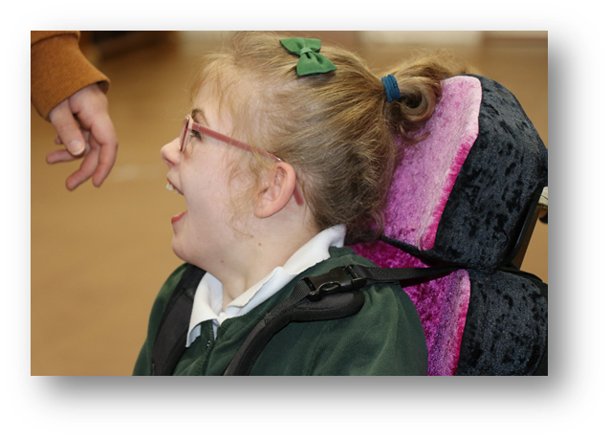

STEPS

STEPS is a therapeutic approach to behaviour management. It focuses on adults building positive relationships with young people and provides us with excellent tools to better understand how we can best help the children we are working with. This will be covered more in your induction.

POSITIVE HANDLING

In addition to STEPS, all class staff are trained in Team Teach, a positive handling strategy which is nearly all about de-escalating situations through giving space, calm talking, and time to calm. It is also about the teaching of safe holds when all else fails as part of an agreed Individual behaviour plan.

KEY MOVERS

There are trained members of staff in each department who are “Key Movers.” They are available for help and advice on lifting and moving individual children and can carry out risk assessments as necessary. The co-ordinators are Irena Gibbs and Emma Ashton.

INCIDENTS

It is important to report any incident that has been dangerous to a child or member of staff, using an Incident/Accident Form. This should be done as soon as possible. Forms are kept in the staff room. Once filled out they should be given to the School Business Manager.

ANNUAL REVIEWS

A meeting is held annually when each child’s EHCP (Education, Health and Care Plan) is reviewed. Parents and professionals are invited. A programme of meetings is distributed at the beginning of the year and stored on the school calendar.

A report of the pupil’s achievements and progress linked to their EHCP Outcomes are required for this meeting and written by the pupil’s class teacher. Teachers should ensure that this is submitted at least two weeks before the review date.

At the review the pupil’s learning priorities for the coming year are identified which are linked to the child’s Education Health Care Plan outcomes.

ASSESSMENT

On entry to the school within the first 6 weeks, all children will be assessed using teacher assessment plus end of Key Stage tasks if appropriate. Throughout the school pupils are then assessed on progress towards their Education, Health and Care Plan “outcomes”, as well as against their curriculum targets. Progress is discussed with parents regularly as well as the pupil where appropriate. Progress is recorded using a piece of software called Evidence for Learning.

SCHOOL POLICIES

School Policies are kept on the shared drive. Hard copies are located in the main staff room once ratified.

SPECIALIST ROOMS

A timetable for the use of all the specialist rooms is drawn up at the beginning of the school year. It is stored on the shared drive and hard copies kept on the doors of the actual rooms. If any changes need to be made please negotiate with other staff.

VISITS AND VOLUNTARY CONTRIBUTIONS

Each class has regular use of a minibus for outings and visits. Always ensure that staff and pupils are signed out at the main reception; please remember to sign in again on your return.

Any teacher planning an educational visit must seek approval from their department leader, using the form provided.

The Head of School is the Education Visits Coordinator (EVC), whose role is to give guidance to trip leaders and to give permission for these trips.

The criteria for visits that need permission are found on the shared Drive. Good practise for organising trips would include the following:

- Checking suitability of the destination.
- Having a clear educational and social subjective.
- Consideration of appropriate staff levels and skills e.g. first aid trained, spare driver.
- Ensuring there is an up to date and relevant risk assessment. (if not write one before the visit, liaising with the EVC).
- Have a plan B (most problems occur when Plan A goes wrong and there has been no thought to alternatives) e.g. wet weather plan.
- A permission form handed to the EVC at least two weeks before the trip.
- The catering staff are informed via a notification slip in the office, buses confirmed, and parental consent if appropriate.
- Cost implications considered. If you have concerns about the costs, please talk them through with the EVC before embarking on a financial commitment.
- Complying with current policy, there is a copy of “Educational visits and journeys” in the policies file in the staff room.

Pupils and staff gain much pleasure and benefit from Educational Visits. Through good planning a visit leader will ensure that everyone enjoys a worthwhile and safe experience.

Voluntary contributions

If a school outing requires funding, a request for a voluntary contribution from parents can be made. The school can subsidise children if absolutely necessary, however this can’t be a replacement for good organisation of the visit in the planning stages. Please speak to the Head of School if you need help or advice.

Parents are asked to make a voluntary contribution to the School Fund at the beginning of each term. This money should be recorded in Class Funds records controlled by the School Business Manager.

START / END OF DAY ARRANGEMENTS

At the beginning of the school day an internal beeper/alarm will sound at 8.43am to summon staff to the front door. The doors open at 8.45am. There will be taxis, minibuses and parents/carers waiting. There will be one staff member on ‘outside duty’ who will oversee the safe arrival and departure of vehicles. There will be another staff member on the internal door, making sure that no one enters who shouldn’t. All staff greet children as they enter. Some staff remain in classrooms to welcome students but many TA’s are expected to come and help students in from their transport.

At the end of the day, pupils are either collected by their parents/carers or by educational transport in the form of a taxi or minibus. Some older students make their own way home where agreed with parents/carers.

There will be one staff member overseeing the safe arrival and departure of vehicles. There will be another staff member in the hall, organising which children can be taken to their taxis. All students who are going home on educational transport and most staff should go to the Hall. Teachers and TA’s are assigned to a taxi and the children in it. They will accompany the children from the hall to the taxi and check that the child is safely belted in. It is important that both staff and pupils wait quietly during taxi call to ensure the safe and efficient departure of pupils.

Other staff are assigned to support those pupils being collected by parents or carers. In this case one member of staff is outside. It is their role to note and relay which parents or carers are ready to collect pupils. Another member of staff will announce this. All other staff present should support pupils in the waiting classroom and ensure the transition to their waiting parent or carer goes smoothly.

If you require additional assistance for a large or difficult group please ask your colleagues for help. Please return to the hall or the waiting classroom once your transport has gone until all staff have been dismissed.

IN-VAC / FIRE PRECAUTIONS

Invac
In case of the need to “invacuate”, the same alarm will be heard that can be heard at the start of the day to call staff to the front door. This is different to the fire alarm. Teachers and TA’s are to stay in the room they are in, lock doors, close blinds, cover glass panels on doors and move students and adults away from doors and windows. Stay where you are until an “all clear” note is passed under the door.

Fire
Fire extinguishers and break glass systems are situated in strategic places throughout the school. Fire exits are clearly marked. Please make yourselves aware of these.

A fire drill takes place once a term.

ANY PERSON DISCOVERING FIRE should activate the nearest alarm.

A MEMBER OF THE OFFICE TEAM rings 999 on hearing the alarm.

If the fire is in the kitchen the SCHOOL COOK activates the nearest alarm.

All double doors will go to green, and open without fob, upon the fire alarm sounding.

On hearing the fire alarm:-

All persons should leave the building by the nearest available exit, closing all doors behind them, (physically disabled people should be evacuated as quickly as possible by means of either their wheelchair, the use of an evacuation slide or as a last resort by being carried), and proceed to the nearest assembly point where pupils and staff will gather in class groups. A roll class will then be taken and when safe to do so, staff and pupils will re-enter the building.

The Teacher should take their laminated register sheet, located next to the door with them, if they are in their own classroom. Class bags containing another copy of the laminated register sheet will be brought out by office staff, along with visitor details.

No-one should stop to collect personal belongings, and under no circumstances should anyone re-enter the building until authorised to do so. Once the children are outside each teacher should check that all their pupils and staff have evacuated, using the laminated register sheet as a guide. Once completed they should hold their hand in the air, and wait to be checked off by the School Business Manager.

The School Business Manager will communicate by means of walkie talkie with the other Fire Marshalls to check that all staff, pupils and visitors have safely evacuated from the school. The Site Supervisor will check with the School Business Manager that all persons are accounted for, and will await the arrival of the Fire Service if needed and respond to and relay instructions.

No-one should leave the Assembly Point until instructed to do so by the School Business Manager.

SAFETY ARRANGEMENTS FOR PUPILS WITH PMLD AND/OR PHYSICAL NEEDS

If you are looking after a pupil with PMLD and/or physical needs, it is very important to inform the class teacher where you are going.

If you are in one of the PMLD changing toilets and your pupil is in a state of undress or needs to be hoisted, then hit the alarm and the flashing light will indicate that someone needs assistance.

Meanwhile place a clean towel on their wheelchair (no time to fit a clean pad), sit the pupil in the chair and cover them with a blanket or dressing gown. Leave the building by the nearest exit and make your way to the playground.

All staff need to be aware that there may be colleagues who need assistance. Use your common sense and tell each other what you are doing.The first priority must always be to evacuate the building as quickly and safely as possible.

