My body

* Marvellous me- whole body awareness
* TAC PAC
* Hydrotherapy
* Spa sessions
* Music and Movement
* Swimming
* Yoga
* Soft play
* Rebound therapy
* ASDAN – older students
* Sensory PE sessions – celebrating me and my body

Home learning opportunities:

* Sharing achievements from school when you get home
* Where appropriate -talking about past events and changes in the family e.g. siblings being born, holidays
* Look at old photo albums together
* PECs symbols to help with communication.
* Sharing photos of experiences on class DOJO.

WOW experiences:

Celebrating ourselves party

My play

* Sensory exploration- I like to find
* Parachute songs and games
* Sensory music
* Soft play – rolling, reaching, climbing – celebrating what our body can do.

My thinking:

* Sensory art- All about me – exploring and making mirrors, paper plate selfies, hand prints.
* Sensory exploration- I can find – in sensory trays
* Birthday cards for friends
* Birthday display – decorating balloon or cupcake templates
* Using a mirror to locate body parts

Interventions:

TEACCH

Attention Autism

Music therapy

Hydro

Eye gaze

Rebound therapy

My communication:

* Sensory story- Magic carpet- Birthday party.
* Sensory story – birthday ball
* Massage- Emotions massage
* Music and movement
* Bonfire night sensory story and songs
* Remembrance day sensory story and songs
* Christmas sensory story and songs
* ASDAN-older students
* Music and Music therapy
* Singing hands

My communication key texts: (useful for basis of sensory stories)

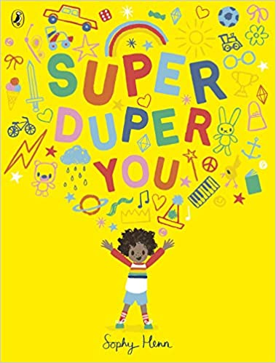

[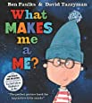](https://www.amazon.co.uk/What-Makes-Me-Ben-Faulks/dp/1408867257/ref=pd_bxgy_img_2/260-8899479-7925211?_encoding=UTF8&pd_rd_i=1408867257&pd_rd_r=e5035e96-60e3-4d60-90f1-d0d32c2816f7&pd_rd_w=iuDCh&pd_rd_wg=tni2U&pf_rd_p=e8ef9fae-c7f9-4aa1-a614-5107fe6f0338&pf_rd_r=X183G24RKQKWSP26JJWR&psc=1&refRID=X183G24RKQKWSP26JJWR)

[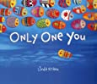](https://www.amazon.co.uk/Only-One-You-Linda-Kranz/dp/1589797485/ref=pd_bxgy_img_3/260-8899479-7925211?_encoding=UTF8&pd_rd_i=1589797485&pd_rd_r=e5035e96-60e3-4d60-90f1-d0d32c2816f7&pd_rd_w=iuDCh&pd_rd_wg=tni2U&pf_rd_p=e8ef9fae-c7f9-4aa1-a614-5107fe6f0338&pf_rd_r=X183G24RKQKWSP26JJWR&psc=1&refRID=X183G24RKQKWSP26JJWR)

[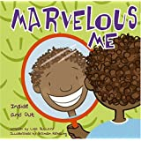](https://www.amazon.co.uk/Marvelous-Me-Inside-Out-about/dp/140480157X/ref=pd_sbs_14_19?_encoding=UTF8&pd_rd_i=140480157X&pd_rd_r=e5035e96-60e3-4d60-90f1-d0d32c2816f7&pd_rd_w=oRBDa&pd_rd_wg=tni2U&pf_rd_p=2773aa8e-42c5-4dbe-bda8-5cdf226aa078&pf_rd_r=X183G24RKQKWSP26JJWR&psc=1&refRID=X183G24RKQKWSP26JJWR)

My Independence

* Personal care – Focus on teeth brushing, face washing, hand washing and hair brushing.
* Sensory cooking- exploring the ingredients, focus on senses (smell, touch, taste the ingredients). Make a celebration cake or biscuits
* Learning to be more independent with my personal care
* ASDAN-older students

**Autumn Term – Marvellous Me**