Communication at Highfield Ely Academy

Makaton Signing
SALT Therapy

Talking Box Activities

Attention Autism
Talking Partners @ Primary
Communication Passports
Play Circle Activities

The Picture CommunicationSystem
General AAC
Intensive Interaction
LEGO Club

Eye Gaze
Objects of Reference

Communication at Highfield Ely Academy

by Sarah Bradshaw-Hughes

What the Communication TA can offer

This brochure outlines provisions that are on offer to assist students in their communication development at Highfield Ely Academy. The aim is to help, support and develop with guidance and advice from Professionals such as the Speech and Language Therapists (SLTs) and a wide range of communication resources. We help plan, assess, advise and deliver support using training, skills and experience.

Talking Box Activities
Talking Boxes are assorted items focussed around a particular topic or theme, stored in a box - hence the name - which are used to help develop early communication skills. Skills include developing attention, anticipation, listening skills, understanding language, using key words, understanding different concepts and promote talking/signing. They are differentiated into various levels and targets according to the student. Some students can work on their own or others benefit in a group session with peers. The activity is designed to take place without interruptions and usually takes place on carpet squares on the floor or can be done around a table, each student having a 1:1 TA to assist.

An example of Talking Boxes is ‘farm animals’. Different animals are brought out one by one using key words/sign and making the animal sounds. The activities are extended and differentiated specific to the student. The activities are repeated each session and the student will begin to have the anticipation of what is going to happen, improve their listening skills and promote talking and signing.

If this is something you think a student in your class would benefit from, please refer them by using the Communication Referral Form, and give to the Communication TA, who will discuss with the SLTs.

Play Circle Activities
Play Circles are mixed activities, presented in a particular order, stored in bags which are used to encourage communication skills. These skills include imitation, making eye contact, making choices, listening skills, anticipation, finger pointing, body awareness and turn taking. The activity usually takes place on carpet squares on the floor or can be done around a table, each student having a 1:1 TA to assist, designed to take place without interruptions.

One example of this is ‘Teddy Time’. Every student has a bag and inside this is a teddy, a cup, a toothbrush, a flannel, a brush and a hat. A student is asked to choose between two items and then all the other students join in by using the same item. Everyone does the correct action to the teddy with the chosen item. This activity focuses on co-operation, anticipation, imitation, symbolic play and the use of basic language. The activities are repeated each session and the student will begin to have the anticipation of what is going to happen next, improve their listening skills, turn taking skills and promote talking and choice making.

If this is something you think a student in your class would benefit from, please refer them by using the Communication Referral Form, and give to the Communication TA, who will discuss with the SLTs.

Makaton Signing (including Sing and Sign) – Language Programme using signs

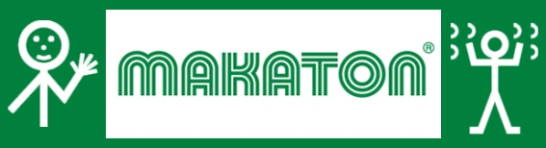

Makaton is a language programme using signs and symbols to help develop speech, language, social, emotional and academic skills and help with communication difficulties. It is designed to support spoken language and the signs are used with speech in spoken word order.

Makaton is highly flexible as it can be personalised to the students’ needs and used at a level suitable for them. For those who have experienced the frustration of being unable to communicate meaningfully or effectively, Makaton can be a revelation and a bridge to greater confidence and self-esteem.

It is aimed at students who have:
Autism,
Cerebral Palsy,
Communication difficulties,
Down Syndrome,
Deafness/hearing/mental impairment,
Various learning delays.

Makaton is used for teaching communication, language and literacy skills with students who are at an early stage of communication and language development. This structured approach can also help students who are learning English as an additional language, helping them to communicate straightaway, while also supporting their learning.

At present, Highfield Ely Academy has a Local Makaton Tutor: the Communication TA, who receives regular updates and attends a 2 yearly study day.

Makaton is regularly used at Highfield Ely Academy to support all students’ communication, language and literacy skills e.g. sing and sign sessions. It also supports integration, as it allows students to communicate with each other, learn and play together more easily. However to supplement Makaton signing we have chosen to use Communicate in Print symbols to support signing rather than Makaton’s own symbols.

If you have a student who would benefit from Makaton please refer them by using the Communication Referral Form, and give to the Communication TA. If you have any questions or training requirements relating to Makaton signing please do not hesitate to ask - we are here to help.

Speech and Language Therapy (SALT)

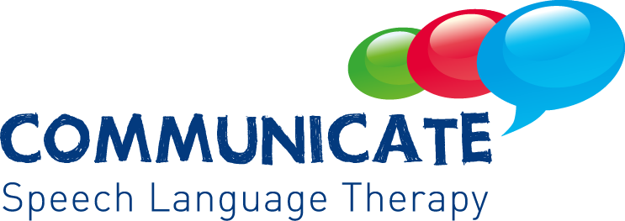

Speech and Language Therapy provides treatment, support and care for students who have difficulties with communication, or with eating, drinking and swallowing. Speech and Language Therapists (SLTs) are qualified allied health professionals.

SLTs play an important role in supporting schools to meet the needs of students in supporting good practice across universal, targeted and specialist approaches. They have a distinct role in assessing, planning, delivering and evaluating support for students with a range of speech, language and communication needs. These include students with learning/physical difficulties, language delay, hearing impairment, cleft palate, stammering, and autism/social interaction difficulties. SLTs play a key role in diagnosis of students with different speech, language and communication needs.

Some of the ways in which SLTs support here at Highfield Ely Academy are if students have difficulty:

- Putting sentences together so that they can be understood,
- Remembering words and their meanings,
- Understanding what others say,
- Pronunciation,
- Using the wrong sounds in speech and not improving followed the expected development pattern,
- Social interaction and confidence in communicating,
- Listening and concentration,
- Using language.

SLTs work directly with the students, families, carers, teachers and TAs to carry out assessments and provide students with tailored support, by planning personalised therapy programmes which meets each student’s communication needs. This is called an 'Individual Treatment Programme'.

The Communication TA at Highfield Ely Academy can provide a vital role by:

- Supporting the SLTs, and are guided by them, by organising extra sessions for students/groups to carry out their Individual Treatment Programmes,
- Regular meetings with the SLTs,
- Supporting good practice in the classroom,
- Working with others to support targeted interventions and support for students.

Please let the Communication TA/SLTs know if we can help or support any students in your class by using the Communication Referral Form.

The Picture Communication System – An approach for development of verbal communication using picture cards

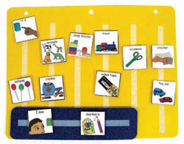

The Picture Communication System allows students who have little or no communication abilities a means of communicating non-verbally. It is a stepping stone to effective communication. Students using picture communication are taught to approach another person and give them a picture of a desired item in exchange for that item or a basic want or need. By doing so, the student is able to initiate communication and can reduce their frustration and social isolation. The student can use this method to communicate a request, a thought, or anything that can reasonably be displayed or symbolised on a picture card. The approach works well in the home or in the classroom. Gradually the student can learn to use the cards to put words together to form sentences which is the development of verbal communication. It is a program designed for mainly autistic students.

There are six phases to the system:

Phase 1 – The Physical Exchange
The student learns to exchange single pictures for items or activities they really want.
Phase II – Distance and Persistence
Still using single pictures, the student learns to generalise this new skill by using it in different places, with different people and across distances. They are also taught to be more persistent communicators.
Phase III – Picture Discrimination
The student learns to select from two or more pictures to ask for their favourite thing. These are placed in a communication book, a ring binder with Velcro strips where pictures are stored and easily removed for communication.
Phase IV – Sentence Structure
The student learns to construct simple sentences on a detachable sentence strip using an ‘I want’ picture followed by a picture of the item being requested.
Phase V – Answering Questions “What do you want?”
The student learns to use the system to answer the question, “What do you want?”
Phase VI - Commenting
Now the student is taught to comment in response to questions such as, ‘What do you see?’ ‘What do you hear?” and ‘What is it?’ They learn to make up sentences starting with I see, I hear, I feel and It is a, etc.

Many staff at Highfield Ely Academy have had formal training. The Communication TA is happy to support its use or any training requirements/issues/resources you may have with the assistance/advice from the SLTs.

Objects of Reference – Pre-intentional step of Communication

Objects of Reference are objects used to represent a person, activity or event. Over time the student learns that the object stands for that person, activity or event. Objects of Reference are used to help a student understand what is happening in their environment and also to help make choices. A student who cannot understand or express an idea through formal communication such as speech, signing, writing or pointing to symbols/photos, may be able to use an object which will mean the same thing.

The Object of Reference may not be the exact item used for the activity but will encourage the student to cope with slightly more abstract or symbolic information. They can be displayed in different ways so that the student can see, feel and begin to understand a sequence of events, e.g. a paintbrush might represent an art session or bells to represent a music session. Here at Highfield Ely Academy we use the coat hook system to display Objects of Reference. The sequence of objects can be increased as the students understanding develops.

The Objects of Reference are kept in a bag and it is very important to use them consistently with the student every time a new activity is about to start. They are not toys to be played with but learning tools. At Highfield Ely Academy we have 30 Objects of Reference. Most classes have a set of these shared objects in a bag, with 6 classes using the coat hook system.

The bags should be checked regularly to ensure the items are not missing or broken; please see the Communication TA for resources. If you think a student in your class would benefit from Objects of Reference please refer them using the Communication Referral Form and give to the Communication TA. If you would like any training on how to use Objects of Reference please ask.

Talking Partners @ Primary – A Literacy Intervention Programme

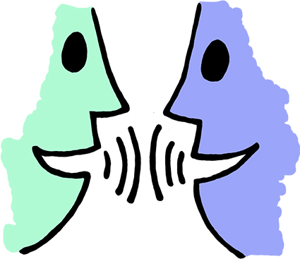

It is a program designed to improve the way students communicate across the curriculum, enabling them to be independent and skilful speakers and listeners. It is a targeted intervention.

By providing opportunities to practise and rehearse target language through a range of focused activities, students develop their independent skills to become good communicators. Talking Partners is a structured oral language program providing part of an integrated approach to raise levels of achievement by improving students speaking and listening skills. It also helps students to become more confident and competent users of English. It encourages them to listen more actively and talk for a range of purpose and draws particular attention to the links between oracy and literacy.

The program is designed for students aged from 4-11 whom:
Lack skills and confidence as speakers and listeners,
EAL learners,
Emotional literacy,
SEN,
BESD (mild - behaviour)
Gifted and talented,
Strand of group and 1:1 provision.

Trained partners (usually experienced level 3 TAs and above attend a 2 day intensive training course) work with groups of 3 pupils for 20 minutes 3 times a week for 10 weeks using activities that have been specifically designed to support the development of oral language skills required for academic success.

If you think this is something that a student in your class would benefit from, please fill in a Communication Referral Form and give it to the Communication TA.

Intensive Interaction – An interaction approach to teach the fundamentals of communication
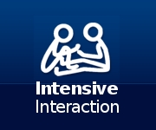

Intensive Interaction is an approach for teaching communication skills to students who have autism, SLD (severe learning difficulties), PMLD (profound and multiple learning difficulties) and who are still at an early stage of communication development. The approach focuses on teaching the fundamentals of communication. Intensive Interaction goes some way to “opening the doors” for the students who are very non-communicative and do not initiate. This process can also be a pre-cursor to developing more complex communication skills.

Intensive Interaction is extremely practical. The only equipment needed is a person to be the interaction partner. The approach works by gradually developing enjoyable and relaxed interaction sequences between the interaction partner and the student doing the learning. These interaction sequences are repeated frequently and with time grow in duration, complexity and sophistication. As this happens, the fundamentals of communication are gradually rehearsed and learnt in a free-flowing manner. The style of the interaction partner is relaxed, non-directive and responsive. Basically the student leads and directs with the interaction partner responding to and joining in with their behaviour. Much of the development of Intensive Interaction is based on research on the way in which babies begin to learn to communicate during their first year.

Ultimately we are looking for the student to:
- Accept our presence,
- Allow some presence in personal space,
- Attend to another person,
- Allow and use some touch,
- Engage in eye contact,
- Use facial expression,
- Focus on body language and facial expression,
- Take turns in communicative behaviour,
- Take turns using vocalisation which may start to have meaning,
- Experiment with communication,
- Learn cause and effect.

For good progress to occur, the activities should happen frequently (daily, day after day) with the repetition of successful activities this provides the basis for the gradual increase in time, content and complexity of those activities.

The Communication TA can offer you support with the assistance of the SLTs in this technique for students. If you have a student in your class who would benefit from Intensive Interaction please refer them using the Communication Referral Form and give to the Communication TA.

LEGO Club – Group intervention to promote social communication skills

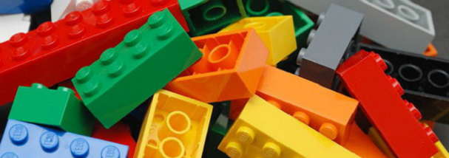

LEGO based therapy involves building LEGO models in small groups or pairs where the students have different roles and work together. The students are encouraged to practice turn taking, listening, sharing, compromise, joint problem solving and general social communication skills. It is a group intervention to help promote social competence in students with autism and related conditions. The sessions are structured and rule governed and students take it in turns to play one of three roles, and emphasis is placed on promoting positive social behaviour.

Students would take on one of the following roles:

Engineer – this student has the set of directions and initially has to request the bricks required from the supplier and then direct the builder to make the finished product.

Parts Supplier – this student has the LEGO bricks and supplies the engineer with the required items on request.

Builder – this student is given the set of bricks and follows the instructions of the engineer in order to create the product.

Sessions last for 30 minutes and would be delivered once weekly over the course of the academic year with targeted groups of students.

The intervention is highly motivating to students because they are interested in building, and therefore they are more willing to work together as a group. The shared focus on building enables students to learn and practice social skills within a social environment they feel comfortable in.

The ASD TA runs these sessions. If you have a student in your class who would benefit please complete a referral form and pass it onto the ASD TA.

General Augmentative and Alternative Communication (AAC) – General Communication using Aids

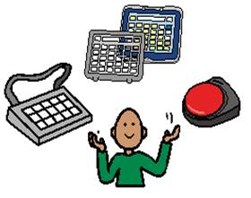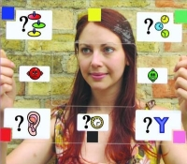

Augmentative and Alternative Communication (AAC) is the term used to describe various methods of communication that can ‘add-on’ to speech and are used to get around problems with ordinary speech. AAC includes simple systems such as pictures, gestures and pointing, as well as more complex techniques involving powerful computer technology. The different types of AAC include:

No-tech communication. This does not involve any additional equipment - it is sometimes referred to as ‘unaided communication’ e.g. body language, gestures, pointing, eye pointing, facial expressions, vocalisations and signing.
Low-tech communication systems. These do not need a battery to function and include, pen and paper to write messages or draw, alphabet and word boards, communication charts or books with pictures, photos and symbols, e-Tran boards for eye pointing or Objects of Reference. This is sometimes referred to as ‘aided communication’ because additional equipment is required.
High-tech communication systems need power from a battery or mains. Most of them speak and/or produce text. They range from simple buttons/switches or pages that speak when touched, to very sophisticated systems. Some high-tech communication systems are based on familiar equipment such as mobile devices, tables and laptops, others use equipment specifically designed to support communication. This is sometimes referred to as ‘aided communication’ because additional equipment is required.

The Communication TA has attended a training course run by the ACE centre, for awareness of the range of AAC systems available and helps identify who can benefit from AAC communication. The Communication TA can assist to find the most suitable AAC for students depending on their abilities, needs and personal preferences. There are many options available so the Communication TA would involve the services of the SLTs and any specialist advice service e.g. ACE Centre, in order to recognise the most appropriate AAC system for that student. If you have a student that would benefit from AAC intervention, please fill in a Communication Referral Form and give to the Communication TA.

Attention Autism – An attention building programme

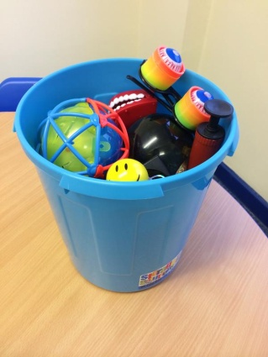

This programme is a highly motivating and creative approach to building attention and early communication and social interaction skills. It is a 4 stage program which starts with:

Stage 1 - ‘the bucket’ and builds attention through highly appealing visual activities.
Stage 2 - looks to build on the attention skills by making the session last a little longer, but still be motivating.
Stage 3 - the students learn how to shift their attention to their own individual participation and then back to the group.
Stage 4 - teaches focus from a group demonstration to completing a task individually and then returning to the group to celebrate the work achieved.

As the title suggests it is aimed at students on the autistic spectrum.

Training has been completed by many Teachers, TA’s, the Communication TA and ASD TA.

The benefits can be hugely rewarding for students. The intervention is usually taught in a group session with peers and gives them the opportunity to learn social skills which don’t always come naturally to them.

Time commitments are dependent on the level of need of the students. Some students may benefit from having the intervention every day; others may only need it 2 – 3 times a week. If you have a student who would benefit from this programme, please fill in a Communication Referral Form and give it to the Communication TA.

Eye Gaze – Computer Eye Tracking Device

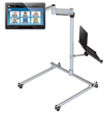

For many students who have difficulty physically using a computer, eye gaze technology can offer a quick and easy to understand way to help them communicate and promote choice making.

Eye gaze or eye tracking is a way of accessing your computer or communication aid using a mouse that you control with your eyes with amazing accuracy. The item you are looking at can be chosen by dwelling (staring at the screen for a length of time), blinking or clicking with a switch. The eye gaze system works by having lights and cameras that are constantly sending and receiving information. The camera picks up light reflections from your pupils and translates the movement of your eyes into mouse cursor movements. It takes only seconds to complete an initial calibration.

It is useful for students who find accessing a computer or communication aid physically difficult using standard or other access methods. It is used by students with conditions such as Motor Neurone Disease (ALS), Cerebral Palsy, Muscular Dystrophy and profound or multiple disabilities PMLD.

Eye gaze gives students the opportunity to play their favourite games, promote choice making and even access their favourite websites.

At Highfield we have several eye gaze units which students can access. Members of staff including a Teacher and several TAs have been trained to use the eye gaze equipment. The Communication TA can also help in supporting the use of this equipment with students.

Communication Passports

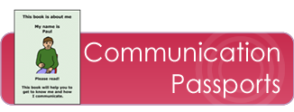

A communication passport provides a practical and personal approach to passing on important information about a student who has complex communication difficulties and who cannot easily convey this information themselves.

A communication passport is a way of supporting a student with communication difficulties across transitions, drawing together complex information (including the students own views, as much as possible) and detailing it into a clear, positive and accessible format. This helps others to get to know the student which then helps them to interact/respond consistently to help the student make sense of events and get the best out of what communication abilities they do have.

A communication passport is a vital tool in ‘joined-up’ inter-agency planning and working. It promotes partnership with families, and is an excellent way of implementing and recording views of the student. The communication passport belongs to the student – not to staff or family, though they may help them to use it appropriately and update it. Passports are especially important at times of transition, when new people come into the students’ life and information may not be passed on. They are also helpful when new or temporary staff or volunteers meet the student, helping them quickly to acquire key information. The process of creating a passport can help in the process of assessing the student and their needs and any gaps that might arise.

At Highfield School we have Communication Passports for those students who are non-verbal and cannot convey their needs. They are planned with families and class teachers and are updated at the beginning of every school year by the Communication TA. If you have a student who needs a Communication Passport please let the Communication TA know and one will be generated for them.

At present, May 2019, staff who have received training in the above programmes are:

Makaton – Sarah Bradshaw-Hughes (Communication TA)

Talking Partners @ Primary - Yvonne Skillern (Head Teacher Highfield Littleport), Sarah Bradshaw-Hughes (Communication TA)

Lego Club – Jo Heesom (Teacher) and Jade Graham (ASD TA)

General AAC – Sarah Bradshaw-Hughes (Communication TA)

Attention Autism – Jo Heesom (Teacher) and Sarah Bradshaw-Hughes (Communication TA)

Eye Gaze – Yvonne Skillern (Head Teacher), Theresa Mears (Resources), Sarah Rose and Emma Ashton (TAs)

Communication referral forms can be found in the Staff Room.

