WOW experiences:

Trip to an arable farm

Pizza making at Pizza Express

Hold our own European market

World Food tasting afternoon

My play

Developing Play Skills

* Participating in turn taking games
* Choosing a friend to play with
* Choosing a friend to cook with

Creativity

* Potato printing
* Food messy play – custard, baked beans etc!
* Sensory walk with different foods
* Dried pasta pictures
* Macaroni necklaces
* Pancake faces

My thinking;

Number

* Counting fruit and vegetables
* Adding food items

Measurement

* Emptying and filling containers with water, flour, pasta etc
* Weighing ingredients and comparing weights
* Comparing and measuring cooking times
* Sorting potatoes by size/weight

Money

* Greengrocers or supermarket role play
* Recognising value of coins
* Learning some typical prices for everyday items
* Adding amounts of coins
* Adding up a shopping list

My Independence

* Developing basic cooking skills, cutting, mixing etc.
* Following a basic recipe with independence- e.g. make a sandwich
* Following instructions for serving and clearing a meal
* Designing and making a healthy balanced meal
* Food hygiene
* Using home-grown fruit and vegetables
* Cooking food from different cultures or festivals
* Chinese New Year
* Pancake Day
* Easter

My body and well being

* Tasting and playing with different foods
* Explore healthy and unhealthy foods
* What do we need to keep healthy?
* Healthy lifestyles – exercise
* How does exercise make us feel?
* Exploring food groups – busythings
* Make your plate – a balanced diet plate
* Exercise challenge - how does the heart rate change?
* Create your own ‘Joe Wicks’ PE session!

Interventions:

TEACCH

Attention Autism

Swimming

St Mary’s coffee morning

Speech and Language groups

Lego Therapy

My communication:

* Learning the story through Talk4Writing
* Reading/performing aloud
* Ordering the story using pictures and words
* Writing about our favourite food
* Colourful semantics
* Reading recipes
* Writing recipes – instruction texts
* Filming a cookery show!
* Team work – giving instructions to a peer blindfolded
* Blindfolded taste test – descriptive language
* Acrostic poems for describing a particular food
* Common food spellings
* Writing a shopping list

**Spring Term – Food Glorious Food**

My communication key texts:

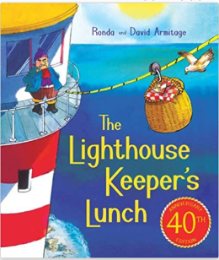

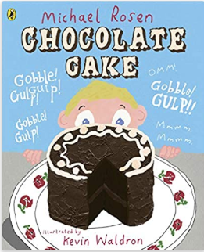

My world:

* Exploring foods from around the world
* Chinese New Year
* Pancake Day
* Easter – egg blowing
* Exploring seasons and weather – when do different fruits and vegetables grow best?
* Visiting the market or supermarket for seasonal fruit and veg
* Looking at countries that our food comes from

Home learning opportunities:

* Help with supermarket shopping
* Follow a recipe to cook a meal
* Help set the table and clear up after a meal
* Help find the right coins to pay for shopping
* Weighing and measuring ingredients
* Write a shopping list