My play

* Sensory exploration with food
* Fruit/ veg printing
* Pasta threading
* Turn taking and sharing activities
* Choosing a friend to play with

Home learning opportunities:

* Shopping for recipe items
* Cooking with family
* Preparing the table for a meal
* Tidying away after cooking or a meal
* Washing and drying up
* Growing own herbs or vegetables
* Visiting an arable farm
* Trying foods from around the world

My communication:

* Using PECs/ communication books or large picture cards to request, comment and communicate
* Sensory Stories including sensory vocabulary
* Massage stories inc. Pumpkin soup and the Tiger who came to tea.
* Songs and rhymes about food
* ASDAN
* Following symbol recipes with support
* Sensory writing experiences, mark-making in food substances

My thinking:

* Art- fruit/ veg printing, food art, pasta art, etc.
* Sensory exploration – in food substances
* Showing curiosity about different food products
* Observing changes when mixing, melting or cooking food products
* Encountering and recognising food images
* Encountering or participating in number songs
* Encountering big/ small, heavy/ light, full/ empty
* Encountering counting objects/ pictures

My body

* Massage stories- Pumpkin soup, the tiger who came to tea.
* TAC PAC
* Swimming
* PE and Trampolining
* Action rhymes and games
* Tasting different foods inc. food from different cultures
* Develop preferences for food- making choices
* Healthy and unhealthy food
* Messy play with food
* Mark making activities in food substances
* Fine motor activities, eg. pasta threading

My World

* Visiting new places, experiences new things- cafes, supermarkets, etc.
* Exploring different food from around the world
* Experiencing a range of different cultural/ religious celebrations and the food involved

My Independence

* Personal care – Focus on teeth brushing and hair brushing
* Cooking- developing basic skills
* Developing food preferences- tasting new foods
* Following instructions
* Making food art
* Learning to be more independent with my personal care
* Independent transitions around school
* ASDAN

My communication key texts.

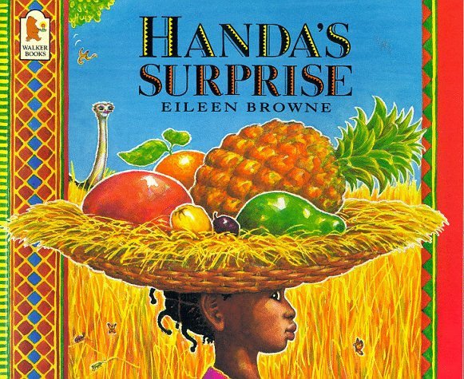 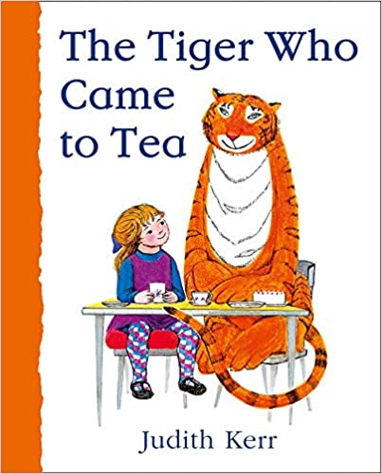

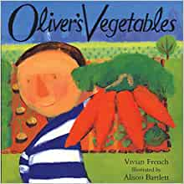 

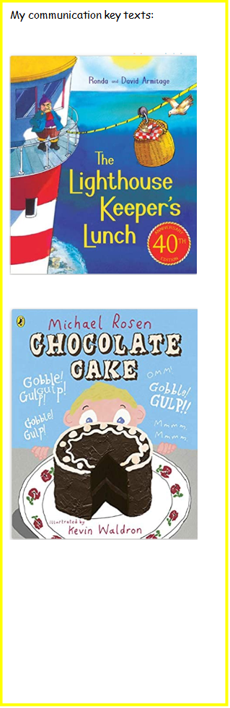 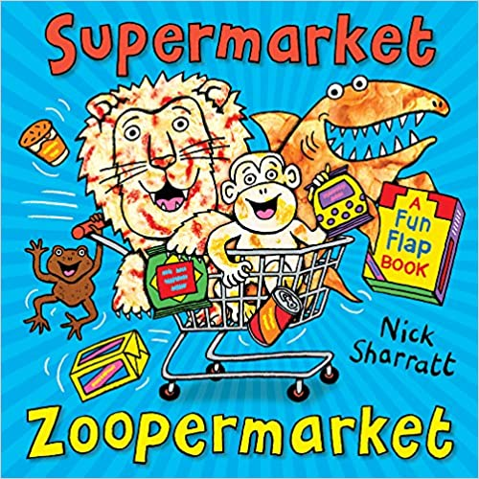

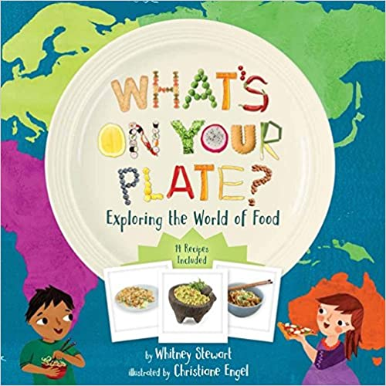 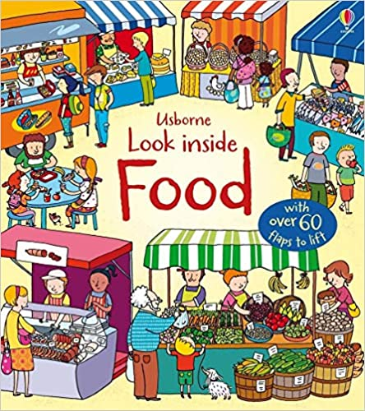

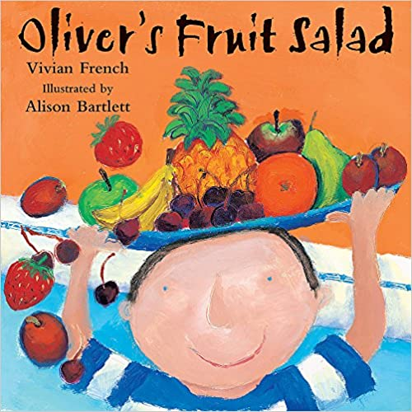 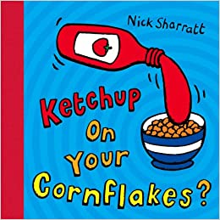

Interventions:

TEACCH

Attention Autism

Identiplay

Swimming

Music therapy

Rebound

Outdoor Learning

WOW experiences:

Visiting arable areas

Visit local cafes

Shopping for class cooking sessions

**Spring Term – Fabulous Food**