My Independence

Firefighter dressing competition – how quickly can you dress to head out for an emergency?

Travel skills – emergency services have to get to places fast. Practise basic map and travel skills

Road safety to avoid emergencies while out and about.

Simple first aid and calling for help.

Key Texts:

Half Term 1

The Lighthouse Keeper’s rescue – Ronda and David Armitage.

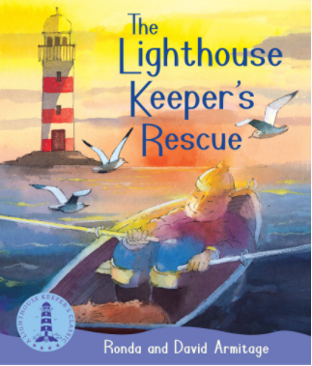

Half Term 2

A day in the Fire station – Richard Scarry

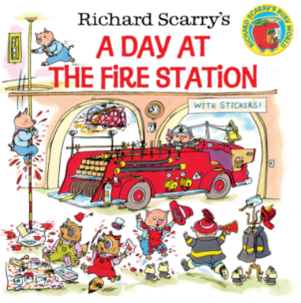

My World:

Practising road safety on walks in the community

Recognising key people who help us

Learn about the roles of the different emergency services – how can you tell the difference?

When would you call fire service/police/ambulance?

How would you call them?

Order emergency processes

Build emergency vehicles – puzzles, lego etc

My play

Rescue role play.

Fire service/police/ambulance/lifeboat role

Water play

Superhero dressing up/role play

Small world toys – emergency services – link to communication

My body and well being

Keeping safe in different situations.

Fire fighter training – physical skills and health needs

Emotions – what are the feelings of the person in trouble – before, during and after? What about the rescuers?

Swimming – and associated safety rules.

My thinking;

Problem solving

Beebot as a firefighter – has to get round a map to get to a burning building! How will he get there?

Science skills

Experiments around fire and rescue

Different extinguishers

Fire safe materials

Number

Word problems linked to emergency situations

Counting or adding firemen, buckets of water, etc

Measuring lengths of hoses, fire engines etc.

Time

Measuring length of time to put out a fire, get out of a building in an emergency, etc

Reading times on clocks – linked to a fire fighter’s day etc

**Spring Term – To The Rescue**

WOW moments

Visit to the fire station

Police in – dog?

Home learning opportunities:

Check your fire alarms at home

Find some topical youtube videos

Make sure you know where the plasters are kept at home and when to use them

Set up a teddy hospital or fire station role play

Go for a walk/drive and look for emergency services in your areas.

Interventions:

Themed TEACCH tasks

My communication:

Calling for help – emergency script and role play

Colourful semantics – increase vocabulary through describing emergency scenes.

Writing a story about an emergency

Instruction writing for what to do if a fire alarm goes off

Character description of a superhero

Comic book – read, Vocab, settings, write one

Creative writing – what happens next? Emergency scenarios

Giving and following instructions in every day mini emergencies!

Safety checklist – avoiding an emergency