My World:

Famous landmarks around the world.

Famous landmarks in the local area.

Climate – compare 2 places – could link to research or sensory experience.

Geographical vocabulary and features – mountains, lakes, beach, cliff, ocean etc.

Maps and globes – find out where places are. Annotate a globe according to the interests of the class – eg animals, food, family etc.

Celebrate festivals from around the world.

My Independence

Folding clothes and packing a suitcase.

Making a list of things you need to take on holiday

Travel skills.

Preparing and tasting food from around the world.

Different clothes for different climates

Key Texts:

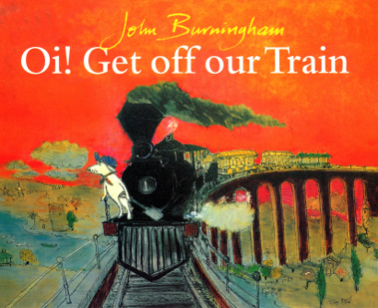

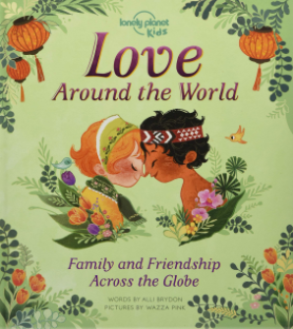

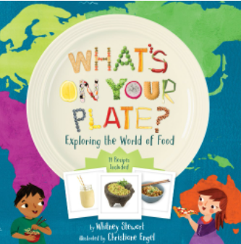

My play

Role play – packing a suitcase, going on holiday, pilot, ship captain etc

Role play – travel agent.

Likes and dislikes – all different – that’s ok.

Creative tasks which reflect different cultures.

Music and instruments from different cultures

My body and well being

Teach respect and tolerance for different nationalities.

Learn dance styles from different cultures.

Sense of being part of the wider world – sense of belonging.

Look at growing up in different part of the world – how is this different to us?

Animal life cycles

My thinking;

Problem solving

Packing for a holiday – what would you need for a weekend, week, fortnight – different climates etc.

Jungle/Adventure/explorer role play – crossing rivers etc

Science skills

Link to animals and their habitats.

Link to earth and space.

Shape

Patterns linked to different cultures.

Shapes in famous buildings.

Number

Travel agent – how much will the holiday cost?

Timetables – bus/train/plain etc.

Counting objects on the beach, in the jungle, etc.

Money role play with different currencies

Measuring while making different foods

**Summer Term – Around the World**

WOW moments

Trip to the zoo or sealife centre

‘Around the World Day’ – experience food, dance, culture for different countries

Home learning opportunities:

Have a themed evening where you cook a meal from a different country

Look at old holiday photos and find where you went on a map or globe

Have an afternoon out to somewhere you’ve never been before

Interventions:

My communication:

Travelling – share holiday snaps and memories.

Postcards – read, write and send.

Penpals?

Tour guide – video or booklet – link to visit to a landmark – e.g. Ely Cathedral.

Communication/scripts around buying a ticket.

Learn how to say hello in different languages.

Colourful semantics – describing scenarios from around the world

Setting descriptions – focus on adjectives

List poems – ‘Ten things in my suitcase’

Character descriptions from around the world texts

Vocabulary to describe particular settings

Conversations about scenarios from text

Reading stories from different cultures