Behaviour Policy
Adam Daw
October 2021
Review October 2023

Overview
At Highfield schools we use the “Steps” approach to behaviour management. Steps is a therapeutic approach to behaviour that prioritises the pro-social feelings of everyone within the school community. We aspire for equity rather than equality for all of our learners. We aim to help our pupils develop internal discipline in order to create long lasting behavioural change.

Key words and phrases used in this policy
Unsocial behaviour | Not doing as instructed, but not to the detriment of others.
Antisocial behaviour | Behaviour that causes harm to an individual, the community or to the environment. Antisocial behaviour is likely to cause injury, harassment, alarm or distress.  This is behaviour that violates the rights of another person.
Prosocial behaviour | Behaviour which is positive, helpful, and intended to promote social acceptance. Prosocial behaviour is characterised by a concern for the rights, feelings and welfare of other people.
Educational consequences | Educational consequences provide the student with the skills and incentives to behave differently faced with the same set of circumstances reoccurring.
Protective consequences | Removal of a freedom in order to manage harm.
Difficult behaviour | Antisocial behaviour which is not dangerous.
Dangerous behaviour | Antisocial behaviour which will imminently result in injury to self or others, damage to property or behaviour that would be considered criminal if the person was the age of criminal responsibility.

Staff Guidance
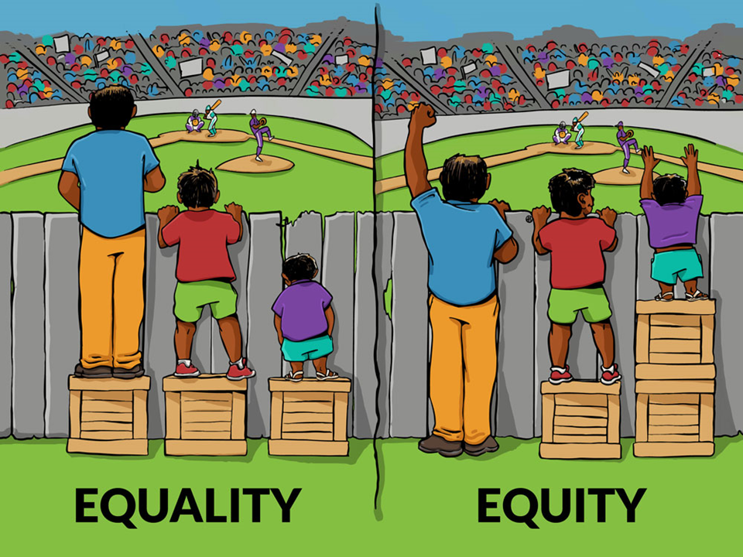
All staff who work directly with students will be trained in the Steps approach. This will take place within 6 weeks of their start date. A short online test which must be passed will immediately follow training. We will hold refresher training annually. School Governors will also undertake Steps training.
Staff must:
- Keep detailed, clear records of incidents of dangerous behaviour and report immediately to their Department Leader. An incident form must be completed on the same day
- Use Roots and Fruits/Anxiety mapping and other tools accurately and consistently as instructed
- Be aware of and follow the IBP of any students in their class
- Use language, tone of voice, body language and positioning as instructed in their training
- Not model any behaviour that goes against their Steps training ie. no public telling off or shaming students
- Speak to a line manager if there are any aspects of Steps that they do not understand or if they have not been trained within 6 weeks of starting employment

Parents and Carers
Parents and Carers will be informed of any concerns around their child’s behaviour by the class teacher. They will be encouraged to work with school staff to help their child develop prosocial behaviours.
Consequences
There must always be an educational consequence to any behaviour that is not prosocial. Staff should be able to show how a consequence has helped the student develop new skills or new ways of thinking through discussion, debrief activity or rehearsing.
Sometimes a protective consequence is needed immediately until we have been successful with educational consequences. Protective consequences are solely actions to ensure no further harm occurs in the short term.
What must be avoided are consequences that have no relation to a behaviour. For example, making a student miss break time for not completing homework is not appropriate. Making a student miss break time because they have hit a fellow student and you are not convinced that they can be safe during break time is a very sensible protective consequence of their actions.
Rewards and Praise
We encourage lots of praise and this can be seen around school throughout any day. This might take the form of comments from staff, Class Dojo messages, postcards home, phone calls, certificates etc. Awards are not given out in public apart from on special occasions. There are no public displays in school which could indicate or suggest that one student is performing better or worse than others.
We do not use rewards to motivate learners. Our aim is that students will develop pro-social behaviours without the need for a reward. All students have timetables which include several experiences throughout every day that we know they will enjoy. We do not deprive students of items or activities they enjoy unless it would be unsafe to do otherwise.

Record Keeping
Staff who witness an incident of dangerous behaviour must complete an incident form or ensure that a colleague has done so. This must be completed on the same day of the incident and discussed with the Department Leader.
Any physical restraint must be recorded in the red book in the Head’s office. Parents and carers must be notified by phone and by statutory letter if physical restraint takes place. This must happen on the same day as the restraint.
Physical Intervention
There will be times in school where a member of staff needs to intervene physically to keep learners safe. This may be as light touch as a guiding hand on an elbow to move someone out of harm. There are other times when a learner’s behaviour has become so dangerous, either to themselves, other people or school property that they need to be restrained. This is always a last resort and it is expected that all other options such as finding a safe space for the student to be alone have been exhausted. We follow Team Teach instructions for safe physical restraint and only staff who are trained may restrain students.
Physical restraint is never to be used as a punishment – it is purely a protective measure in a dangerous situation.
Seclusion
Seclusion is never used as a regular behaviour management strategy; however, we recognize that as an emergency, one off response, it may need to be employed if all else fails and a dynamic risk assessment has been completed by a senior member of staff. This will only be used where other strategies have been tried and failed or judged to be unsafe and there is significant risk of harm to the young person, other pupils, staff or property. It is important to note that due to perimeter fencing, fobbed doors and areas such as the science lab which present safety risks, students are unable to access many areas without staff being present to allow them in. Any incident of seclusion will be reviewed by Senior Managers via an incident form. There will be a collaborative discussion with staff involved to reflect and plan to reduce the likelihood of future incidents.
Bullying
Bullying by anyone, to anyone is never tolerated and is picked up very quickly by staff at all levels. Bullying is covered within our curriculum. Any instances of bullying are logged under “My Concern” and dealt with swiftly by teachers. We use professional judgement to decide the most appropriate approach/consequence with each child, taking their additional needs into account. Parents and carers of all learners involved in bullying will be made aware immediately.

Peer-on-peer sexual abuse
We take the same approach to peer-on-peer sexual abuse as we do to bullying (see above).
Exclusion
We recognise the harm that exclusion does and we work with pupils and their parents or carers to avoid it. Only the Executive Head or Head of School can take the decision to exclude. Exclusion is only ever used as a last resort and as a protective consequence to keep either the pupil, their peers or staff safe until a solution can be found. Parents are sent the formal statutory exclusion letter we are required to send but this will be preceded by a phone call from a Senior Leader to discuss the reason for the exclusion and any next steps. Any exclusion will be followed with a reintroduction meeting prior to the student returning. This meeting is designed to help the student begin attending safely. This may take place in person or online – we will endeavour not to inconvenience parents unnecessarily.

