PROVIDER ACCESS
POLICY

Highfield Ely

this policy was  Approved: | Spring 2023
this policy will be reviewed: | Spring 2024
member of staff with responsibility for review: | Rebecca butland

Introduction
This policy statement sets out the school’s arrangements for managing the access of providers to the school for the purpose of giving them information about the provider’s education or training offer. This complies with the school’s legal obligations under Section 42B of the Education Act 1997.

Pupil entitlement
All pupils in years 7 to 13 are entitled:
- to find out about technical education qualifications and apprenticeships opportunities, as part of a careers programme which provides information on the full range of education and training options available at each transition point;
- to hear from a range of local providers about the opportunities they offer, including technical education and apprenticeships – through options events, assemblies and group discussions and taster events;
- to understand how to make applications for the full range of academic and technical courses.

For pupils of compulsory school age these encounters are mandatory and there will be a minimum of two encounters for pupils during the ‘first key phase’ (year 7 to 9) and two encounters for pupils during the ‘second key phase’ (year 10 to 11). For pupils in the ‘third key phase’ (year 12 to 13), particularly those that have not yet decided on their next steps, there are two more provider encounters available during this period, which are optional for pupils to attend.

At Highfield Ely Academy, students work towards achieving a range of qualifications but not at the level of T Levels or those needed for apprenticeships or technical training. However, whilst students are at Highfield Ely Academy, they will, where appropriate, be able to meet a range of providers from relevant colleges as well as visitors to the school and experience visits out into the community to develop social and cultural capital.

These provider encounters will be scheduled during main school hours and the provider will be given a reasonable amount of time to, as a minimum:
- share information about both the provider and the approved technical education qualification and apprenticeships that the provider offers
- explain what career routes those options could lead to
- provide insights into what it might be like to learn or train with that provider (including the opportunity to meet staff and pupils from the provider)
- answer questions from pupils.
Meaningful provider encounters
One encounter is defined as one meeting/session between pupils and one provider. We are committed to providing meaningful encounters to all pupils using the “Making it meaningful” checklist.
Meaningful online engagement is also an option, and we are open to providers that are able to provide live online engagement with our pupils.

Previous providers
In previous terms/years we have invited the following providers from the local area to speak to our pupils:
- Cambridge Regional College
- College of West Anglia
- Impington Village College
- Red2Green
- The Helping Hands Group
- Papworth Trust

Destinations of our pupils
Last year our pupils moved to range of providers in the local area after school:

Intended Destination | Number of Students
Bespoke Package | 2
Cambridge Regional College | 3
College of West Anglia | 1
Comberton Village College | 0
Cottenham 6th Form | 0
Elective Home Education | 0
Impington Village College – Specialist Post 16 | 2
LINC 19-25 | 0
Helping Hands | 0
NEET | 0
Riverwalk, Bury St Edmunds | 0
West Suffolk College | 0
Total Number of Leavers | 8

Management of provider access requests
Procedure
A provider wishing to request access should contact:
Adam Daw, Head of School
Telephone: 01353 662085
Email: head@highfield.cambs.sch.uk

Opportunities for access
The school offers the six provider encounters required by law and a number of additional events, integrated into the school careers programme. We will offer providers an opportunity to come into school to speak to pupils or their parents or carers.
Please speak to our Careers Leader (Rebecca Butland rbutland@highfield.cambs.sch.uk) to identify the most suitable opportunity for you.

 | Autumn Term | Spring Term | Summer Term
Year 7 and 8 | - Trips and visits to business in the local area to experience LMI  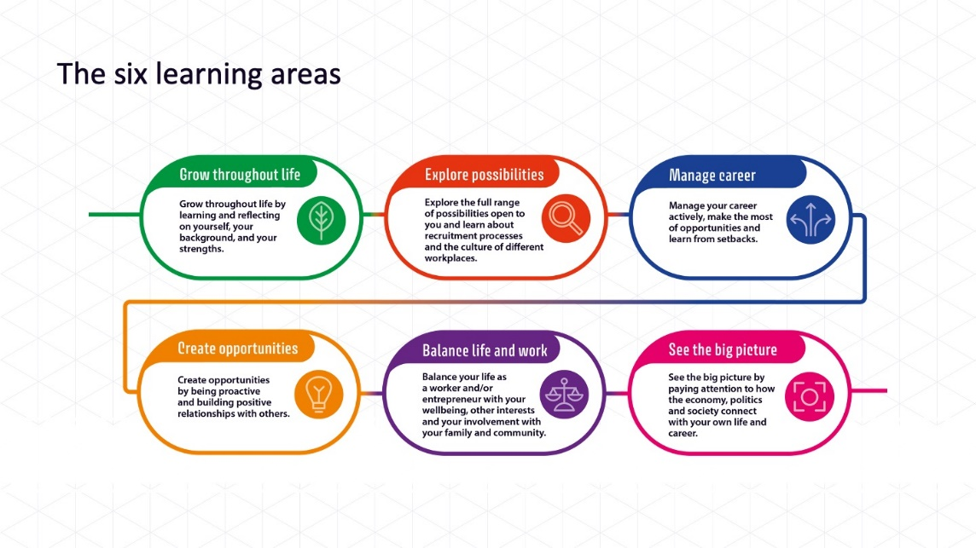  - Opportunities and experiences through the 6 areas of learning from the school’s strategic plan, based on the CDI Primary Framework
Year 9 | - Post 16 event – Careers Fair with local colleges and providers.  - Partnerships with companies such as STEMPoint East  - Regular trips and visits to our community
Year 10 | - Post 16 event – Careers Fair with local colleges and providers  - Careers Fair at the local Cathedral. | - College coffee morning  - Internal work experience  - Visits from businesses | - College coffee morning  - Internal work experience  - Visits from businesses
Year 11 | - Post 16 event – Careers Fair with local colleges and providers.  - Careers Fair at the local Cathedral.  - Meetings with careers adviser  - Careers Interview  - Post 16 applications  - Weekly sessions at Cambridge Regional College  - Louise Brock (14-25 Additional Needs transition coordinator) in school regularly and working alongside young person and family. | - Post-16 interviews  - Louise Brock (14-25 Additional Needs transition coordinator) in school regularly and working alongside young person and family.  - Meetings with the Careers Leader | - Confirmation of post-16 education and training destinations for all pupils  - Louise Brock (14-25 Additional Needs transition coordinator) in school regularly and working alongside young person and family.  - Meetings with the Careers Leader  - External Work Experience
Year 12, 13 and 14 | - Post 19 event – Careers Fair with local colleges and providers.  - Taster days at future placements  - Meeting with Careers Leader where relevant  - Louise Brock (14-25 Additional Needs transition coordinator) in school regularly and working alongside young person and family.  - Visits from local business  - Community visits

Premises and facilities
The school will make the main hall, classrooms or private meeting rooms available for discussions between the provider and students, as appropriate to the activity. The school will also make available AV and other specialist equipment to support provider presentations. This will all be discussed and agreed in advance of the visit with the Head of School. Providers are welcome to leave a copy of their prospectus or other relevant course literature with the Head of School. This will then be shared with staff and parents as appropriate
Information about careers events, open days and other college information will be shared with Parents/Carers and students via the school’s communication platform, Class Dojo.

